**Introduction to end-to-end analytics using Microsoft Fabric**

**Introduction**

Completed100 XP

* 1 minute

Microsoft Fabric is an end-to-end analytics platform that provides a single, integrated environment for data professionals and the business to collaborate on data projects. Fabric provides a set of integrated services that enable you to ingest, store, process, and analyze data in a single environment.

Microsoft Fabric provides tools for both citizen and professional data practitioners, and integrates with tools the business needs to make decisions. Fabric includes the following services:

* Data engineering
* Data integration
* Data warehousing
* Real-time intelligence
* Data science
* Business intelligence

This module introduces the Fabric platform, discusses who Fabric is for, and explores Fabric services.

**Next unit: Explore end-to-end analytics with Microsoft Fabric**

[**Next**](https://learn.microsoft.com/en-us/training/modules/introduction-end-analytics-use-microsoft-fabric/2-explore-analytics-fabric/)

**Explore end-to-end analytics with Microsoft Fabric**

Completed100 XP

* 5 minutes

Scalable analytics can be complex, fragmented, and expensive. With Microsoft Fabric, you don't have to spend all of your time combining various services from different vendors. Instead, you can use a single product that is easy to understand, set up, create, and manage. Fabric offers persona-optimized experiences and tools in an integrated user interface.

In addition to a simple, shared user experience, Fabric is a unified *software-as-a-service* (SaaS) offering, with all your data stored in a single open format in OneLake. OneLake is accessible by all of the analytics engines in the platform. Fabric offers scalability, cost-effectiveness, accessibility from anywhere with an internet connection, and continuous updates and maintenance provided by Microsoft.

**Explore OneLake**

*OneLake* is Fabric's lake-centric architecture that provides a single, integrated environment for data professionals and the business to collaborate on data projects. Fabric's OneLake architecture facilitates collaboration between data team members and saves time by eliminating the need to move and copy data between different systems and teams. OneCopy is a key component of OneLake that allows you to read data from a single copy, without moving or duplicating data.

Think of it like OneDrive for data; OneLake combines storage locations across different regions and clouds into a single logical lake, without moving or duplicating data. Similar to how Office applications are prewired to use your organizational OneDrive, all the compute workloads in Fabric are preconfigured to work with OneLake. Fabric's data warehousing, data engineering (lakehouses and notebooks), data integration (pipelines and dataflows), real-time intelligence, and Power BI all use OneLake as their native store without needing any extra configuration.

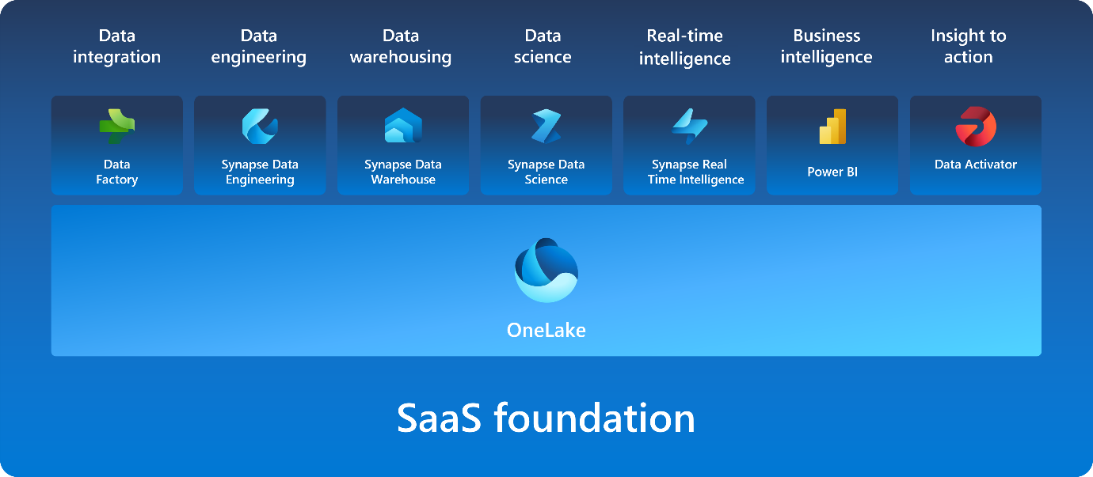

OneLake is built on top of *Azure Data Lake Storage* (ADLS) and data can be stored in any format, including Delta, Parquet, CSV, JSON, and more.

What this means is that all of the compute engines in Fabric automatically store their data in OneLake. Data that is stored in OneLake is then directly accessible by all of the compute engines without needing to be moved or copied. For tabular data, the analytical engines in Fabric write data in delta-parquet format and all engines interact with the format seamlessly.

One important feature of OneLake is the ability to create shortcuts, which are embedded references within OneLake that point to other files or storage locations. Shortcuts allow you to quickly source your existing cloud data without having to copy it, and enables Fabric experiences to derive data from the same source to always be in sync.

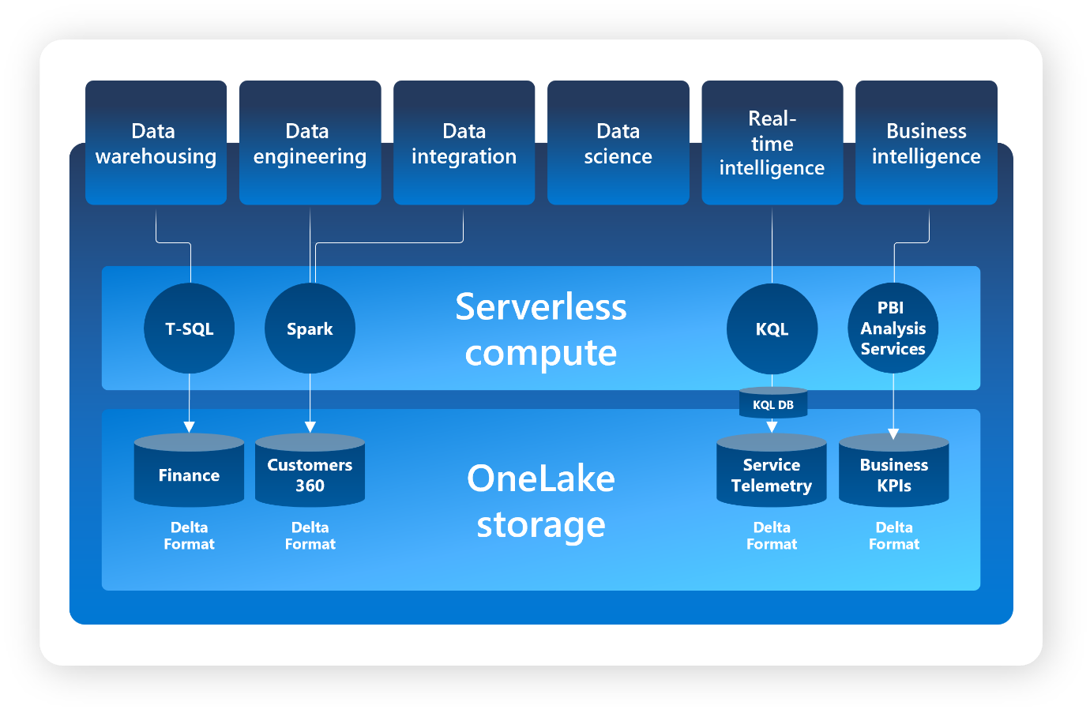

**Explore Fabric's experiences**

Fabric offers a set of analytics experiences that are designed to accomplish specific tasks and work together seamlessly. Fabric's experiences include:

* **Synapse Data Engineering**: data engineering with a Spark platform for data transformation at scale.
* **Synapse Data Warehouse**: data warehousing with industry-leading SQL performance and scale to support data use.
* **Synapse Data Science**: data science with Azure Machine Learning and Spark for model training and execution tracking in a scalable environment.
* **Synapse Real-Time Intelligence**: real-time intelligence to query and analyze large volumes of data in real-time.
* **Data Factory**: data integration combining Power Query with the scale of Azure Data Factory to move and transform data.
* **Power BI**: business intelligence for translating data to decisions through interactive reports.

Fabric provides a comprehensive data analytics solution by unifying all these experiences on a single platform.

**Explore workspaces**

Fabric uses workspaces to contain the different items created across the different experiences. Each organization can customize how to separate and control access to the items. Some possibilities include a dedicated workspace for lakehouse development and a separate workspace for the production lakehouse.

In Microsoft Fabric, workspaces serve as logical containers that help you organize and manage your data, reports, and other assets. They provide a clear separation of resources, making it easier to control access and maintain security. Each workspace can have its own set of permissions, ensuring that only authorized users can view or modify the contents. This structure supports collaboration within teams while maintaining strict access control, which is crucial for both business and IT users.

Workspaces in Microsoft Fabric also offer settings to manage compute resources and integrate with Git for version control. You can configure compute settings to optimize performance and cost, ensuring that your resources are used efficiently. Git integration allows you to track changes, collaborate on code, and maintain a history of your work, which is essential for development and data management. Additionally, workspaces support features like data lineage and impact analysis, providing a comprehensive view of data flow and dependencies, which enhances transparency and decision-making.

**Explore security and governance**

Fabric's OneLake is centrally governed and open for collaboration. Data is secured and governed in one place, which allows users to easily find and access the data they need. Fabric administration is centralized in the *admin center*.

In the admin center you can manage groups and permissions, configure data sources and gateways, and monitor usage and performance. You can also access the Fabric admin APIs and SDKs in the admin center, which you'd use to automate common tasks and integrate Fabric with other systems.

**Note**

For more information about Fabric administration, see [**What is Microsoft Fabric admin**](https://learn.microsoft.com/en-us/fabric/admin/microsoft-fabric-admin).

Your Fabric tenant is natively integrated with Microsoft Purview Information Protection. Fabric uses Microsoft Purview Information Protection’s sensitivity labels to help your organization classify and protect sensitive data, from ingestion to export

**Data teams and Microsoft Fabric**

Completed100 XP

* 3 minutes

Microsoft Fabric's unified data analytics platform makes it easier for data professionals to work together on data projects. Fabric removes data silos and the need for access to multiple systems, enhancing collaboration between data professionals.

**Traditional roles and challenges**

In a traditional analytics development process, data engineers and data analysts face several challenges. Data engineers perform complex data processing and then curate and serve data sources so data analysts can display data effectively for the business. This process requires extensive communication and coordination between the two roles, often leading to potential delays and misinterpretations.

Data analysts need to perform extensive downstream data transformations before creating Power BI reports. This time-consuming process often lacks context, making it difficult for analysts to connect with data directly.

Data scientists also struggle to integrate native data science techniques with existing data systems, which are often complex and cumbersome. As a result, data scientists find it challenging to provide data-informed insights efficiently.

**Evolution of collaborative workflows**

Microsoft Fabric transforms the analytics development process by unifying tools into a SaaS platform, allowing flexibility for different roles to perform necessary skills without duplicating efforts.

**Data engineers** can now ingest, transform, and load large amounts of data into OneLake and present it in whichever data store makes most sense. Data loading patterns are simplified using pipelines and architectures, such as medallion, can be easily configured using workspaces.

**Data analysts** gain greater context and streamline processes, transforming data upstream with Data Factory and connecting with data more directly using DirectLake mode.

**Data scientists** Integrate native data science techniques more easily and use Power BI's interactive reporting to provide data-informed insights.

**Analytics engineers** bridge the gap between data engineering and data analysis by curating data store assets, ensuring data quality, and enabling self-service analytics.

**Low-to-no-code users** and **citizen developers** can now discover curated data through the OneLake hub, and further process and analyze it to suit their needs without being dependent on data engineers or duplicating data.

**Next unit: Enable and use Microsoft Fabric**

[**Previous**](https://learn.microsoft.com/en-us/training/modules/introduction-end-analytics-use-microsoft-fabric/2-explore-analytics-fabric/)

**Enable and use Microsoft Fabric**

Completed100 XP

* 6 minutes

Before you can explore the end-to-end capabilities of Microsoft Fabric, it must be enabled for your organization. You might need to work with your IT department to enable Fabric for your organization. The permissions required to enable Fabric are either:

* *Fabric admin (formerly Power BI admin)*
* *Power Platform admin*
* *Microsoft 365 admin*

**Enable Microsoft Fabric**

If you have admin privileges, you can access the **Admin center** from the **Settings** menu in the upper right corner of the Power BI service. From here, you enable Fabric in the **Tenant settings.**

Admins can make Fabric available to either the entire organization or specific groups of users, who can be organized based on their Microsoft 365 or Microsoft Entra security groups. Admins can also *delegate* the ability to enable Fabric to other users, at the capacity level.

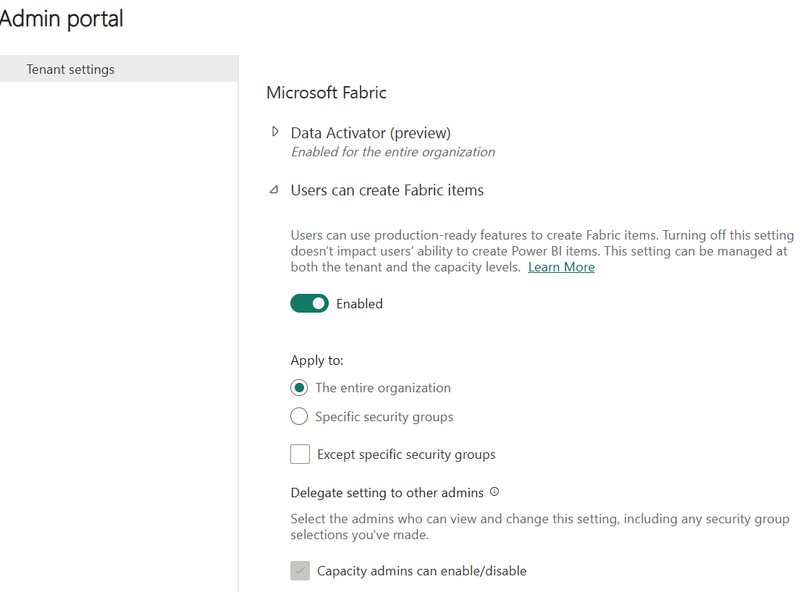

**Note**

If your organization isn't using Fabric or Power BI today, you can sign up for a [**free Fabric trial**](https://learn.microsoft.com/en-us/fabric/get-started/fabric-trial) to explore the different workloads.

**Create workspaces**

Workspaces are collaborative environments where you create and manage items like lakehouses, warehouses, and reports. All data is stored in OneLake, and is accessed through workspaces. Items are displayed in a list or lineage view, which is a visual representation of the dependency between items.

In the *Workspace settings*, you can configure the license type to use Fabric features. There are several other settings you can configure in this area, some of which include:

* OneDrive access for the workspace
* Azure Data Lake Gen2 Storage connection
* Integration with Git for version control
* Spark workload settings

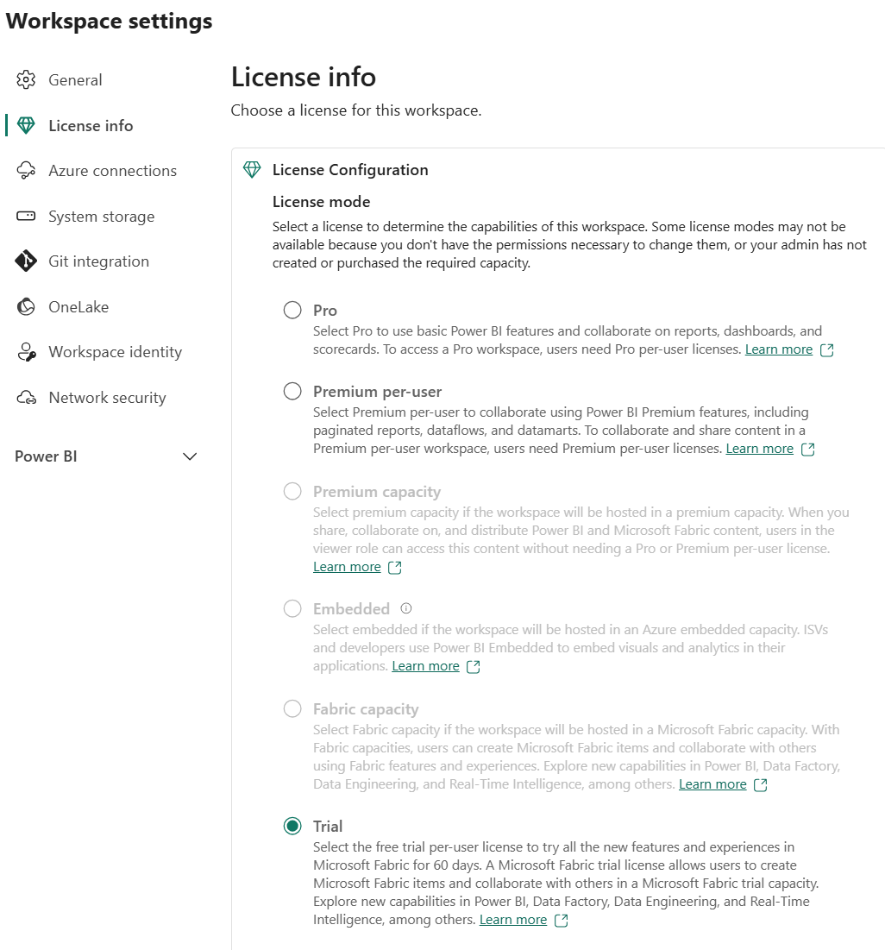

To grant access to a workspace, choose one of the four available roles. These roles have access to all items in a workspace. Workspace access is typically granted to collaborators, and it's recommended to grant access to specific items depending on the business need.

**Note**

Learn more about workspaces in the [**Fabric documentation**](https://learn.microsoft.com/en-us/fabric/get-started/workspaces).

**Discover data with OneLake data hub**

The OneLake data Hub in Microsoft Fabric helps users easily find and access various data sources within their organization. Users explore and connect to data sources, ensuring they have the right data for their needs. Users only see items shared with them. Here are some considerations when using OneLake Hub:

* Narrow results by domains (if implemented).
* Filter by workspaces in Explorer.
* Explore default groups: *All data*, *My data*, *Endorsed in your org*, and *Favorites*.
* Filter further by keyword or item type.

[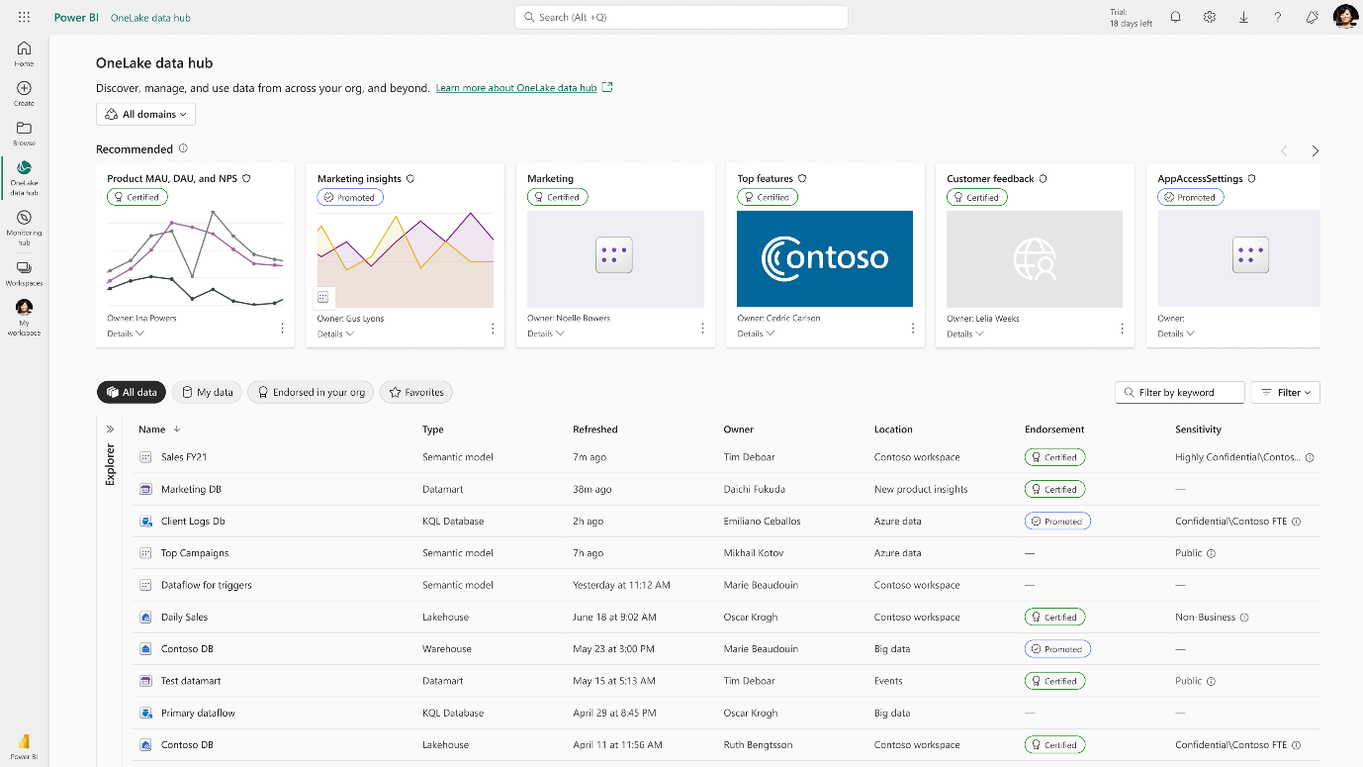](https://learn.microsoft.com/en-us/training/wwl/introduction-end-analytics-use-microsoft-fabric/media/onelake-data-hub.png#lightbox)

**Create items in Fabric**

After you create your Fabric enabled workspace, you can start creating items in Fabric. You can create items in Fabric using the **Create** menu in the upper left corner of the Power BI service.

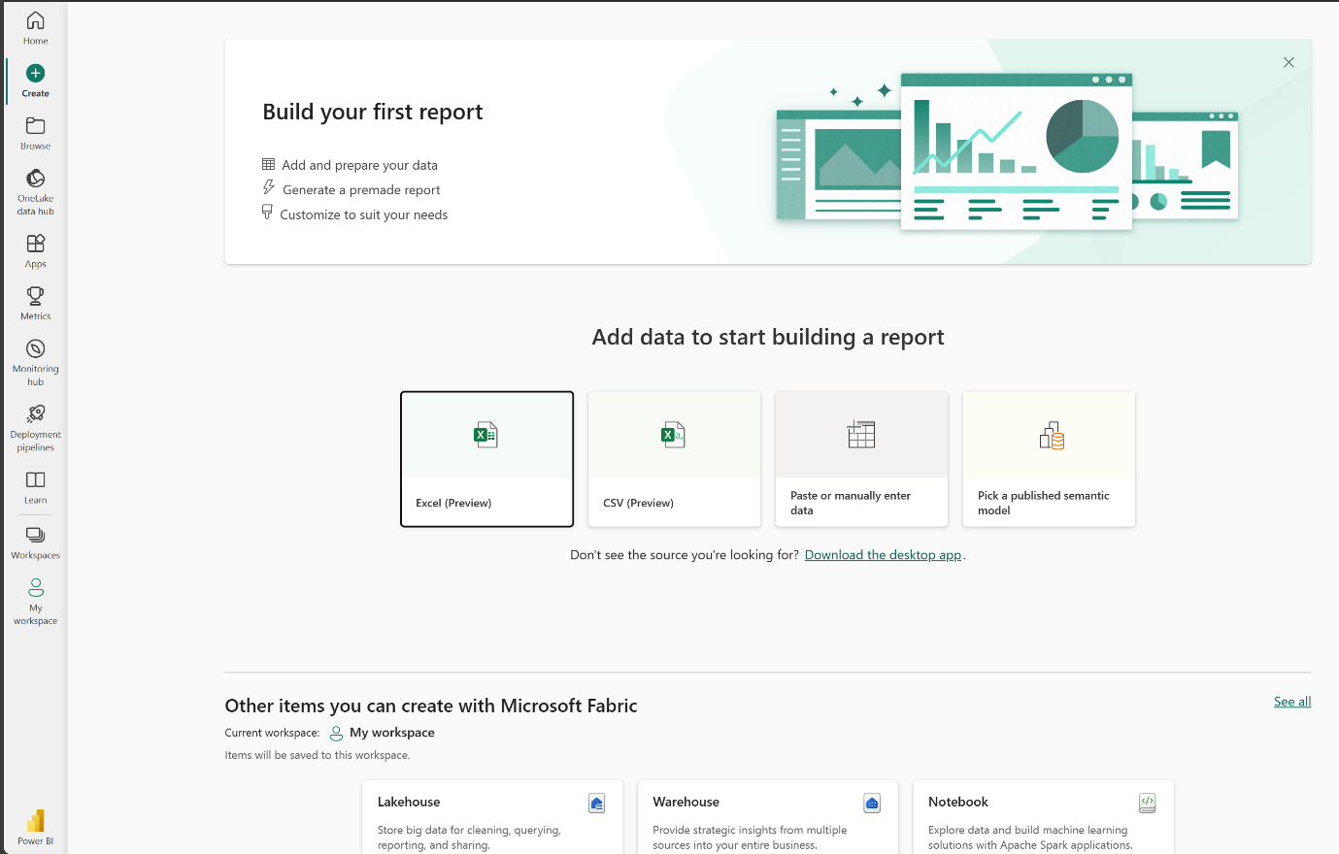

**Explore Fabric workloads**

Fabric workloads refer to the different capabilities included in Fabric. You can switch between workloads using the workload switcher in the bottom left corner of the navigation pane.

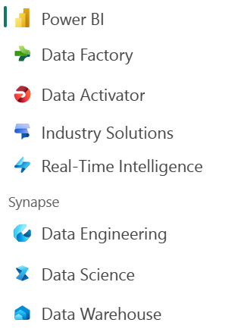

You might notice that Fabric workloads look similar to other Microsoft data offerings. Fabric is built on Power BI and Azure Data Lake Storage, and includes capabilities from Azure Synapse Analytics, Azure Data Factory, Azure Databricks, and Azure Machine Learning. What makes Fabric unique is that it brings these capabilities together in a single, SaaS integrated experience without the need for access to Azure resources.

**Next unit: Knowledge Check**

**Knowledge Check**

200 XP

* **Module assessment**
* 5 minutes

Top of Form

**Knowledge Check**

Completed200 XP

* **Module assessment**
* 5 minutes

 Answer 100% of questions correctly in order to pass. [**Retake**](https://learn.microsoft.com/en-us/training/modules/introduction-end-analytics-use-microsoft-fabric/5-knowledge-check)

Dismiss alert

Top of Form

**1.**

**Which of the following is a key benefit of using Microsoft Fabric in data projects?**

It allows data professionals to work on data projects independently, without the need for collaboration.

It requires duplication of data across different systems and teams to ensure data availability.

It provides a single, integrated environment for data professionals and the business to collaborate on data projects.

**Correct. Fabric's OneLake provides a single, integrated environment for data professionals and the business to collaborate on data projects.**

**2.**

**What is the default storage format for Fabric's OneLake?**

Delta

**Correct. The default storage format for OneLake is Delta Parquet, an open-source storage layer that brings reliability to data lakes.**

JSON

CSV

**3.**

**Which of the following Fabric experiences is used to move and transform data?**

Data Science

Data Warehousing

**Incorrect. The Data Warehouse experience enables data professionals to build data warehouses.**

Data Factory

**Correct. The Data Factory experience combines Power Query with the scale of Azure Data Factory to move and transform data.**

Bottom of Form

**Summary**

Completed100 XP

* 2 minutes

Data professionals are increasingly expected to be able to work with data at scale, and to be able to do so in a way that is secure, compliant, and cost-effective. At the same time, the business wants to use that data more effectively and quickly to make better decisions. Microsoft Fabric is a collection of tools and services that enables organizations to do just that. In this module, you learned about Fabric's OneLake storage, what workloads that are included in Fabric, and how to enable and use Fabric in your organization.

**Get started with lakehouses in Microsoft Fabric**

**Introduction**

**Completed100 XP**

* **1 minute**

**The foundation of Microsoft Fabric is a lakehouse, which is built on top of the OneLake scalable storage layer and uses Apache Spark and SQL compute engines for big data processing. A lakehouse is a unified platform that combines:**

* **The flexible and scalable storage of a data *lake***
* **The ability to query and analyze data of a data ware*house***

**Imagine your company has been using a data warehouse to store structured data from its transactional systems, such as order history, inventory levels, and customer information. You collect unstructured data from social media, website logs, and external sources that are difficult to manage and analyze using the existing data warehouse infrastructure. Your company's new directive is to improve its decision-making capabilities by analyzing data in various formats across multiple sources, so the company chooses Microsoft Fabric.**

**In this module, we explore how a lakehouse in Microsoft Fabric provides a scalable and flexible data store for files and tables that you can query using SQL.**

**Next unit: Explore the Microsoft Fabric lakehouse**

[**Next**](https://learn.microsoft.com/en-us/training/modules/get-started-lakehouses/2-fabric-lakehouse/)

**Explore the Microsoft Fabric lakehouse**

**Completed100 XP**

* **5 minutes**

**A lakehouse presents as a database and is built on top of a data lake using Delta format tables. Lakehouses combine the SQL-based analytical capabilities of a relational data warehouse and the flexibility and scalability of a data lake. Lakehouses store all data formats and can be used with various analytics tools and programming languages. As cloud-based solutions, lakehouses can scale automatically and provide high availability and disaster recovery.**

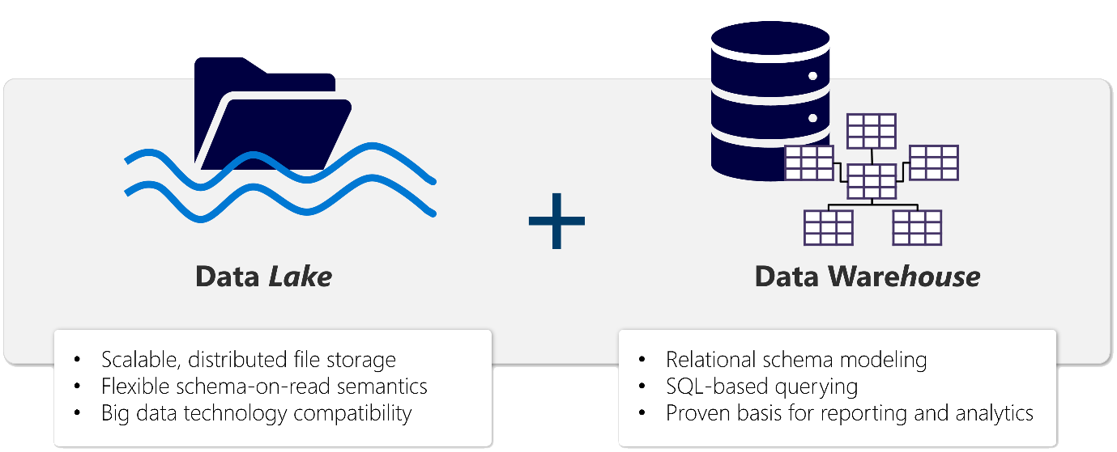

**Some benefits of a lakehouse include:**

* **Lakehouses use Spark and SQL engines to process large-scale data and support machine learning or predictive modeling analytics.**
* **Lakehouse data is organized in a *schema-on-read format*, which means you define the schema as needed rather than having a predefined schema.**
* **Lakehouses support ACID (Atomicity, Consistency, Isolation, Durability) transactions through Delta Lake formatted tables for data consistency and integrity.**
* **Lakehouses are a single location for data engineers, data scientists, and data analysts to access and use data.**

**A lakehouse is a great option if you want a scalable analytics solution that maintains data consistency. It's important to evaluate your specific requirements to determine which solution is the best fit.**

**Load data into a lakehouse**

**Fabric lakehouses are a central element for your analytics solution. You can follow the ETL (Extract, Transform, Load) process to ingest and transform data before loading to the lakehouse.**

**You can ingest data in many common formats from various sources, including local files, databases, or APIs. You can also create Fabric shortcuts to data in external sources, such as Azure Data Lake Store Gen2 or OneLake. Use the Lakehouse explorer to browse files, folders, shortcuts, and tables and view their contents within the Fabric platform.**

**Ingested data can be transformed and then loaded using either using Apache Spark with notebooks or Dataflows Gen2. Use Data Factory pipelines to orchestrate your different ETL activities and land the prepared data into your lakehouse.**

**Note**

**Dataflows Gen2 are based on Power Query - a familiar tool to data analysts using Excel or Power BI that provides visual representation of transformations as an alternative to traditional programming.**

**You can use your lakehouse for many reasons, including:**

* **Analyze using SQL.**
* **Train machine learning models.**
* **Perform analytics on real-time data.**
* **Develop reports in Power BI.**

**Secure a lakehouse**

**Lakehouse access is managed either through the workspace or item-level sharing. Workspaces roles should be used for collaborators because these roles grant access to all items within the workspace. Item-level sharing is best used for granting access for read-only needs, such as analytics or Power BI report development.**

**Fabric lakehouses also support data governance features including sensitivity labels, and can be extended by using Microsoft Purview with your Fabric tenant.**

**Note**

**For more information, see the**[**Security in Microsoft Fabric**](https://learn.microsoft.com/en-us/fabric/security/security-overview)**documentation.**

**Next unit: Work with Microsoft Fabric lakehouses**

**Work with Microsoft Fabric lakehouses**

**Completed100 XP**

* **6 minutes**

**Now that you understand the core capabilities of a Microsoft Fabric lakehouse, let's explore how to work with one.**

**Create and explore a lakehouse**

**When you create a new lakehouse, you have three different data items automatically created in your workspace.**

* **The lakehouse contains shortcuts, folders, files, and tables.**
* **The Semantic model (default) provides an easy data source for Power BI report developers.**
* **The SQL analytics endpoint allows read-only access to query data with SQL.**

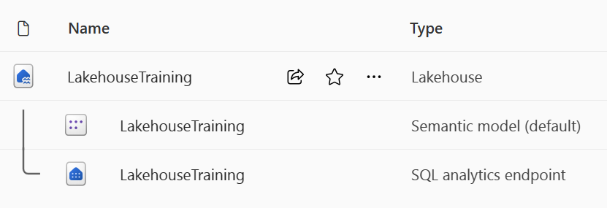

**You can work with the data in the lakehouse in two modes:**

* **lakehouse enables you to add and interact with tables, files, and folders in the lakehouse.**
* **SQL analytics endpoint enables you to use SQL to query the tables in the lakehouse and manage its relational semantic model.**

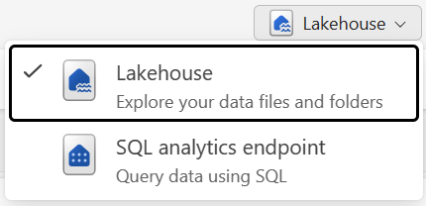

**Ingest data into a lakehouse**

**Ingesting data into your lakehouse is the first step in your ETL process. Use any of the following methods to bring data into your lakehouse.**

* **Upload: Upload local files.**
* **Dataflows Gen2: Import and transform data using Power Query.**
* **Notebooks: Use Apache Spark to ingest, transform, and load data.**
* **Data Factory pipelines: Use the Copy data activity.**

**This data can then be loaded directly into files or tables. Consider your data loading pattern when ingesting data to determine if you should load all raw data as files before processing or use staging tables.**

**Spark job definitions can also be used to submit batch/streaming jobs to Spark clusters. By uploading the binary files from the compilation output of different languages (for example, .jar from Java), you can apply different transformation logic to the data hosted on a lakehouse. Besides the binary file, you can further customize the behavior of the job by uploading more libraries and command line arguments.**

**Note**

**For more information, see the**[**Create an Apache Spark job definition**](https://learn.microsoft.com/en-us/fabric/data-engineering/create-spark-job-definition)**documentation.**

**Access data using shortcuts**

**Another way to access and use data in Fabric is to use *shortcuts*. Shortcuts enable you to integrate data into your lakehouse while keeping it stored in external storage.**

**Shortcuts are useful when you need to source data that's in a different storage account or even a different cloud provider. Within your lakehouse you can create shortcuts that point to different storage accounts and other Fabric items like data warehouses, KQL databases, and other lakehouses.**

**Source data permissions and credentials are all managed by OneLake. When accessing data through a shortcut to another OneLake location, the identity of the calling user will be utilized to authorize access to the data in the target path of the shortcut. The user must have permissions in the target location to read the data.**

**Shortcuts can be created in both lakehouses and KQL databases, and appear as a folder in the lake. This allows Spark, SQL, Real-Time intelligence and Analysis Services to all utilize shortcuts when querying data.**

**Note**

**For more information on how to use shortcuts, see [OneLake shortcuts documentation](https://learn.microsoft.com/en-us/fabric/onelake/onelake-shortcuts) in the Microsoft Fabric documentation.**

**Next unit: Explore and transform data in a lakehouse**

**Explore and transform data in a lakehouse**

**100 XP**

* **6 minutes**

**Transform and load data**

**Most data requires transformations before loading into tables. You might ingest raw data directly into a lakehouse and then further transform and load into tables. Regardless of your ETL design, you can transform and load data simply using the same tools to ingest data. Transformed data can then be loaded as a file or a Delta table.**

* **Notebooks are favored by data engineers familiar with different programming languages including PySpark, SQL, and Scala.**
* **Dataflows Gen2 are excellent for developers familiar with Power BI or Excel since they use the PowerQuery interface.**
* **Pipelines provide a visual interface to perform and orchestrate ETL processes. Pipelines can be as simple or as complex as you need.**

**Analyze and visualize data in a lakehouse**

**After data is ingested, transformed, and loaded, it's ready for others to use. Fabric items provide the flexibility needed for every organization so you can use the tools that work for you.**

* **Data scientists can use notebooks or Data wrangler to explore and train machine learning models for AI.**
* **Report developers can use the semantic model to create Power BI reports.**
* **Analysts can use the SQL analytics endpoint to query, filter, aggregate, and otherwise explore data in lakehouse tables.**

**By combining the data visualization capabilities of Power BI with the centralized storage and tabular schema of a data lakehouse, you can implement an end-to-end analytics solution on a single platform.**

**Exercise - Create a Microsoft Fabric lakehouse**

**Completed100 XP**

* **30 minutes**

**In this exercise, explore Microsoft Fabric lakehouse tasks like creating a lakehouse, importing data, querying tables with SQL, and generating reports. The exercise emphasizes the importance of the lakehouse as a central component in data engineering, warehousing, and analytics, enabling users to effectively manage and analyze their data within the lakehouse environment.**

**Note**

**You need a Microsoft Fabric trial license with the Fabric preview enabled in your tenant. See**[**Getting started with Fabric**](https://learn.microsoft.com/en-us/fabric/get-started/fabric-trial)**to enable your Fabric trial license.**

**Launch the exercise and follow the instructions.**

**Knowledge check**

**Completed200 XP**

* **Module assessment**
* **3 minutes**

**Great job! You passed the module assessment.**

**Dismiss alert**

**Top of Form**

**1.**

**What is a Microsoft Fabric lakehouse?**

**A relational database based on the Microsoft SQL Server database engine.**

**A hierarchy of folders and files in Azure Data Lake Store Gen2.**

**An analytical store that combines the file storage flexibility of a data lake with the SQL-based query capabilities of a data warehouse.**

**Correct. Lakehouses combine data lake and data warehouse features.**

**2.**

**You want to include data in an external Azure Data Lake Store Gen2 location in your lakehouse, without the requirement to copy the data. What should you do?**

**Create a Data pipeline that uses a Copy Data activity to load the external data into a file.**

**Create a shortcut.**

**Correct. A shortcut enables you to include external data in the lakehouse.**

**Create a Dataflow Gen2 that extracts the data and loads it into a table.**

**3.**

**You want to use Apache Spark to interactively explore data in a file in the lakehouse. What should you do?**

**Create a notebook.**

**Correct. A notebook enables interactive Spark coding.**

**Switch to the SQL analytics endpoint mode.**

**Create a Dataflow Gen2.**

**Bottom of Form**

**Summary**

**Completed100 XP**

* **1 minute**

**In this module, we explored how lakehouses fit into a data analytics solution using Microsoft Fabric. Lakehouses provide data engineers and analysts with the combined benefits of data lake storage and a relational data warehouse. You can use a lakehouse as the basis of an end-to-end data analytics solution that includes data ingestion, transformation, modeling, and visualization.**

**Fabric lakehouses provide value as a Software-as-a-Service data store that provides all of the benefits with less administration.**

**For more information, see the**[**Data Engineering in Microsoft Fabric**](https://learn.microsoft.com/en-us/fabric/data-engineering/)**documentation.**

**Use Apache Spark in Microsoft Fabric**

**Introduction**

**Completed100 XP**

* **1 minute**

**Apache Spark is an open-source framework for large-scale data processing and analytics. Apache Spark is integrated into Microsoft Fabric to provide a big data platform for analytics.**

**Fabric Spark clusters provide a powerful, in-memory distributed framework for at-scale data processing. In Microsoft Fabric, Spark can be used together with other analytics services such as lakehouses, notebooks, and data pipelines.**

**In this module you explore how to use Spark with notebooks to ingest, process, and analyze data in a Fabric lakehouse.**

**Prepare to use Apache Spark**

**Completed100 XP**

* **3 minutes**

**Apache Spark is a distributed data processing framework that enables large-scale data analytics by coordinating work across multiple processing nodes in a cluster, known in Microsoft Fabric as a *Spark pool*. Put more simply, Spark uses a "divide and conquer" approach to processing large volumes of data quickly by distributing the work across multiple computers. The process of distributing tasks and collating results is handled for you by Spark.**

**Spark can run code written in a wide range of languages, including Java, Scala (a Java-based scripting language), Spark R, Spark SQL, and PySpark (a Spark-specific variant of Python). In practice, most data engineering and analytics workloads are accomplished using a combination of PySpark and Spark SQL.**

**Spark pools**

**A Spark pool consists of compute *nodes* that distribute data processing tasks. The general architecture is shown in the following diagram.**

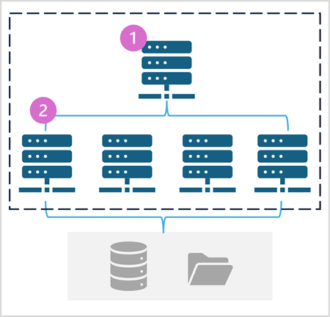

**As shown in the diagram, a Spark pool contains two kinds of node:**

1. **A *head* node in a Spark pool coordinates distributed processes through a *driver* program.**
2. **The pool includes multiple *worker* nodes on which *executor* processes perform the actual data processing tasks.**

**The Spark pool uses this distributed compute architecture to access and process data in a compatible data store - such as a data lakehouse based in OneLake.**

**Spark pools in Microsoft Fabric**

**Microsoft Fabric provides a *starter pool* in each workspace, enabling Spark jobs to be started and run quickly with minimal setup and configuration. You can configure the starter pool to optimize the nodes it contains in accordance with your specific workload needs or cost constraints.**

**Additionally, you can create custom Spark pools with specific node configurations that support your particular data processing needs.**

**Note**

**The ability to customize Spark pool settings can be disabled by Fabric administrators at the Fabric Capacity level. For more information, see**[**Capacity administration settings for Data Engineering and Data Science**](https://learn.microsoft.com/en-us/fabric/data-engineering/capacity-settings-overview)**in the Fabric documentation.**

**You can manage settings for the starter pool and create new Spark pools in the Data Engineering/Science section of the workspace settings.**

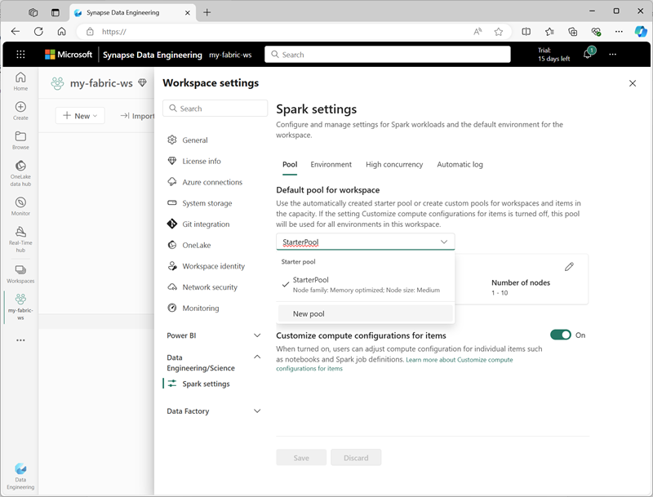

**Specific configuration settings for Spark pools include:**

* **Node Family: The type of virtual machines used for the Spark cluster nodes. In most cases, *memory optimized* nodes provide optimal performance.**
* **Autoscale: Whether or not to automatically provision nodes as needed, and if so, the initial and maximum number of nodes to be allocated to the pool.**
* **Dynamic allocation: Whether or not to dynamically allocate *executor* processes on the worker nodes based on data volumes.**

**If you create one or more custom Spark pools in a workspace, you can set one of them (or the starter pool) as the default pool to be used if a specific pool is not specified for a given Spark job.**

**Tip**

**For more information about managing Spark pools in Microsoft Fabric, see**[**Configuring starter pools in Microsoft Fabric**](https://learn.microsoft.com/en-us/fabric/data-engineering/configure-starter-pools)**and**[**How to create custom Spark pools in Microsoft Fabric**](https://learn.microsoft.com/en-us/fabric/data-engineering/create-custom-spark-pools)**in the Microsoft Fabric documentation.**

**Runtimes and environments**

**The Spark open source ecosystem includes multiple versions of the Spark *runtime*, which determines the version of Apache Spark, Delta Lake, Python, and other core software components that are installed. Additionally, within a runtime you can install and use a wide selection of code libraries for common (and sometimes very specialized) tasks. Since a great deal of Spark processing is performed using PySpark, the huge range of Python libraries ensures that whatever the task you need to perform, there's probably a library to help.**

**In some cases, organizations may need to define multiple *environments* to support a diverse range of data processing tasks. Each environment defines a specific runtime version as well as the libraries that must be installed to perform specific operations. Data engineers and scientists can then select which environment they want to use with a Spark pool for a particular task.**

**Spark runtimes Microsoft Fabric**

**Microsoft Fabric supports multiple Spark runtimes, and will continue to add support for new runtimes as they are released. You can use the workspace settings interface to specify the Spark runtime that is used by default environment when a Spark pool is started.**

**Tip**

**For more information about Spark runtimes in Microsoft Fabric, see**[**Apache Spark Runtimes in Fabric**](https://learn.microsoft.com/en-us/fabric/data-engineering/runtime)**in the Microsoft Fabric documentation.**

**Environments in Microsoft Fabric**

**You can create custom environments in a Fabric workspace, enabling you to use specific Spark runtimes, libraries, and configuration settings for different data processing operations.**

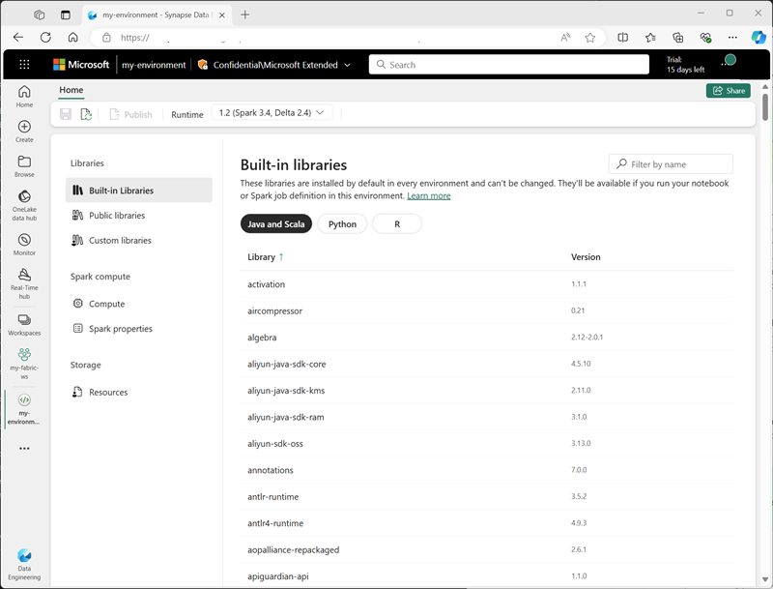

**When creating an environment, you can:**

* **Specify the Spark runtime it should use.**
* **View the built-in libraries that are installed in every environment.**
* **Install specific public libraries from the Python Package Index (PyPI).**
* **Install custom libraries by uploading a package file.**
* **Specify the Spark pool that the environment should use.**
* **Specify Spark configuration properties to override default behavior.**
* **Upload resource files that need to be available in the environment.**

**After creating at least one custom environment, you can specify it as the default environment in the workspace settings.**

**Tip**

**For more information about using custom environments in Microsoft Fabric, see**[**Create, configure, and use an environment in Microsoft Fabric**](https://learn.microsoft.com/en-us/fabric/data-engineering/create-and-use-environment)**in the Microsoft Fabric documentation.**

**Additional Spark configuration options**

**Managing Spark pools and environments are the primary ways in which you can manage Spark processing in a Fabric workspace. However, there are some additional options that you can use to make further optimizations.**

**Native execution engine**

**The *native execution engine* in Microsoft Fabric is a vectorized processing engine that runs Spark operations directly on lakehouse infrastructure. Using the native execution engine can significantly improve the performance of queries when working with large data sets in Parquet or Delta file formats.**

**To use the native execution engine, you can enable it at the environment level or within an individual notebook. To enable the native execution engine at the environment level, set the following Spark properties in the environment configuration:**

* **spark.native.enabled: true**
* **spark.shuffle.manager: org.apache.spark.shuffle.sort.ColumnarShuffleManager**

**To enable the native execution engine for a specific script or notebook, you can set these configuration properties at the beginning of your code, like this:**

**JSONCopy**

**%%configure**

**{**

**"conf": {**

**"spark.native.enabled": "true",**

**"spark.shuffle.manager": "org.apache.spark.shuffle.sort.ColumnarShuffleManager"**

**}**

**}**

**Tip**

**For more information about the native execution engine, see**[**Native execution engine for Fabric Spark**](https://learn.microsoft.com/en-us/fabric/data-engineering/native-execution-engine-overview)**in the Microsoft Fabric documentation.**

**High concurrency mode**

**When you run Spark code in Microsoft Fabric, a Spark session is initiated. You can optimize the efficiency of Spark resource usage by using *high concurrency mode* to share Spark sessions across multiple concurrent users or processes. When high concurrency mode is enabled for Notebooks, multiple users can run code in notebooks that use the same Spark session, while ensuring isolation of code to avoid variables in one notebook being affected by code in another notebook. You can also enable high concurrency mode for Spark jobs, enabling similar efficiencies for concurrent non-interactive Spark script execution.**

**You enable high concurrency mode, use the Data Engineering/Science section of the workspace settings interface.**

**Tip**

**For more information about high concurrency mode, see**[**High concurrency mode in Apache Spark for Fabric**](https://learn.microsoft.com/en-us/fabric/data-engineering/high-concurrency-overview)**in the Microsoft Fabric documentation.**

**Automatic MLFlow logging**

**MLFlow is an open source library that is used in data science workloads to manage machine learning training and model deployment. A key capability of MLFlow is the ability to log model training and management operations. By default, Microsoft Fabric uses MLFlow to implicitly log machine learning experiment activity without requiring the data scientist to include explicit code to do so. You can disable this functionality in the workspace settings.**

**Spark administration for a Fabric capacity**

**Administrators can manage Spark settings at a Fabric capacity level, enabling them to restrict and override Spark settings in workspaces within an organization.**

**Tip**

**For more information about managing Spark configuration at the Fabric capacity level, see**[**Configure and manage data engineering and data science settings for Fabric capacities**](https://learn.microsoft.com/en-us/fabric/data-engineering/capacity-settings-management)**in the Microsoft Fabric documentation.**

**Next unit: Run Spark code**

**Run Spark code**

**Completed100 XP**

* **3 minutes**

**To edit and run Spark code in Microsoft Fabric, you can use *notebooks*, or you can define a *Spark job*.**

**Notebooks**

**When you want to use Spark to explore and analyze data interactively, use a notebook. Notebooks enable you to combine text, images, and code written in multiple languages to create an interactive item that you can share with others and collaborate.**

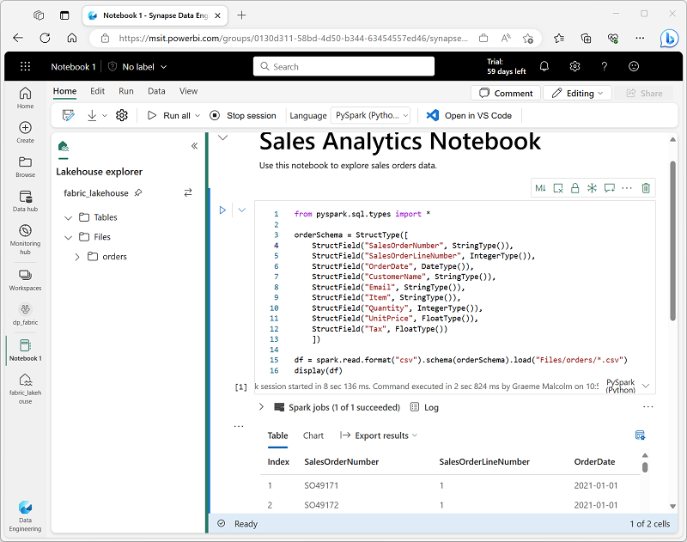

**Notebooks consist of one or more *cells*, each of which can contain markdown-formatted content or executable code. You can run the code interactively in the notebook and see the results immediately.**

**Code and markdown cells**

**Notebooks cells contain either code or markdown text, but not both. To convert an existing code cell to markdown, select M. To convert a markdown cell to code, select </>.**

**Markdown cells include a text toolbar to allow you to format text and add images. The ability to add markdown cells to a notebook is powerful. It allows you to add explanations about your code, document why certain things are being done, why, and what you are trying to achieve. Not only does this feature make a notebook more useful later, but also improves collaboration.**

**Code languages**

**PySpark (a Spark-specific implementation of Python) is the default language for Microsoft Fabric notebooks, but you can also select Scala (a Java-based interpreted language)), Spark SQL, or SparkR. Most data engineering and analytics workloads are accomplished using a combination of PySpark and Spark SQL.**

**You can change the default language for a notebook (affecting all code cells), or you can use a *magic* command in a cell to override the default language for just that cell. For example, the %%sql magic command in the following code changes the programming language for the cell to Spark SQL:**

**PySparkCopy**

**%%sql**

**SELECT YEAR(OrderDate) AS OrderYear,**

**SUM((UnitPrice * Quantity) + Tax) AS GrossRevenue**

**FROM salesorders**

**GROUP BY YEAR(OrderDate)**

**ORDER BY OrderYear;**

**Use *%%pyspark* to change the programming language back to PySpark. Or *%%spark* to change the programming language to Scala. The drop-down menu in the bottom right of the cell can also be used to add a magic command.**

**Note**

**Magic commands are case sensitive.**

**Code in notebook is usually run interactively, either by running individual cells or by running all cells in the notebook. You can also schedule a notebook to be run non-interactively.**

**Spark job definitions**

**If you want to use Spark to ingest and transform data as part of an automated process, you can define a Spark job to run a script on-demand or based on a schedule.**

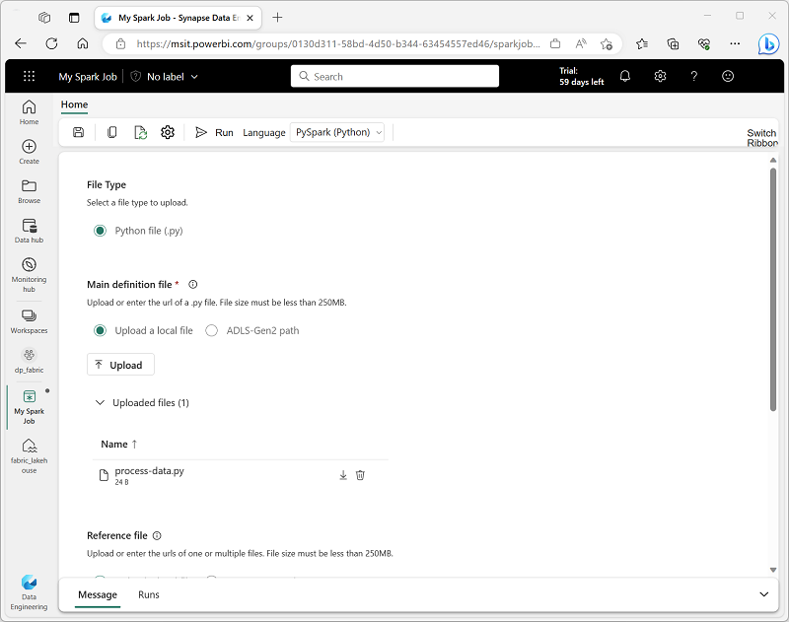

**To configure a Spark job, create a Spark Job Definition in your workspace and specify the script it should run. You can also specify a reference file (for example, a Python code file containing definitions of functions that are used in your script) and a reference to a specific lakehouse containing data that the script processes.**

**You can also specify command line arguments, which enable you to vary the behavior of the script depending on the arguments passed to it. This approach can be useful when the same Spark job will be used in multiple contexts (for example, you could use a single script to load data from files into tables, varying the file path and table name when you run it).**

**Scheduling notebook and job execution**

**You can define a schedule for a notebook or Spark job definition to have it run unattended at a specific interval. This approach may be useful for simple automated tasks that can be scripted and which are not part of a more complex data ingestion or processing workload. In most production environments, a more manageable solution is to include the notebook or Spark job definition in a *pipeline*, where it can be integrated into a more complex orchestration solution.**

**Note**

**When you run code in a notebook or a Spark job definition interactively, the code runs in the security context of the currently logged in user. When run using a schedule, the code assumes the identity of the user who created the schedule. When run in a pipeline, the code uses the identity of the user who owns the pipeline.**

**Regardless of how the code is run, you must ensure that the identity used in the security context has sufficient permissions to access any resources referenced by the code, including tables or files in a lakehouse.**

**Next unit: Connect to data sources and ingest data**

[**Previous**](https://learn.microsoft.com/en-us/training/modules/use-apache-spark-work-files-lakehouse/2-spark/)

**Connect to data sources and ingest data**

**Completed100 XP**

* **3 minutes**

**You can use a Fabric notebook to connect to data held in Azure blob storage, an Azure SQL Database, and other storage options. By connecting to a data source, you can use the data in analytical processes even through it isn't stored in a Fabric lakehouse. You can also use Spark code to filter and process the data before loading it into the lakehouse, enabling you to use Spark as a powerful tool for data ingestion into your Fabric analytics environment.**

**Connect to Azure blob storage**

**The following PySpark code connects to data held in Azure blob storage, reads data into a DataFrame, and then displays the data.**

**PythonCopy**

**# Azure Blob Storage access info**

**blob_account_name = "azureopendatastorage"**

**blob_container_name = "nyctlc"**

**blob_relative_path = "yellow"**

**# blob_sas_token = "add your SAS token here"**

**# Construct the path for connection**

**wasbs_path = f'wasbs://{blob_container_name}@{blob_account_name}.blob.core.windows.net/{blob_relative_path}'**

**# WASBS path for connection including SAS token**

**# wasbs_path = f'wasbs://{blob_container_name}@{blob_account_name}.blob.core.windows.net/{blob_relative_path}?{blob_sas_token}'**

**# Read parquet data from Azure Blob Storage path**

**blob_df = spark.read.parquet(wasbs_path)**

**# Display the Azure Blob DataFrame**

**display(blob_df)**

**Note**

**This example shows how to connect to data held in Azure Open Datasets, which does not require a SAS token. To connect to your own data, you will need to generate a SAS token and add it to the code in the appropriate places indicated in the comments.**

**Configure alternate authentication**

**The previous example connects to the source data with a SAS token, before reading the data into a DataFrame. Depending on where your data is stored, you might need to use a different authentication type, such as Service Principal or OAuth. Here's an example connecting to an Azure SQL Database with a Service Principal:**

**PythonCopy**

**# Azure SQL Database connection info**

**server_name = "your_server_name.database.windows.net"**

**port_number = 1433 # Default port number for SQL Server**

**database_name = "your_database_name"**

**table_name = "YourTableName" # Database table**

**client_id = "YOUR_CLIENT_ID" # Service principal client ID**

**client_secret = "YOUR_CLIENT_SECRET" # Service principal client secret**

**# Build the Azure SQL Database JDBC URL with Service Principal**

**jdbc_url = f"jdbc:sqlserver://{server_name}:{port_number};database={database_name};encrypt=true;trustServerCertificate=false;hostNameInCertificate=*.database.windows.net;loginTimeout=30;Authentication=ActiveDirectoryServicePrincipal"**

**# Properties for the JDBC connection**

**properties = {**

**"user": client_id,**

**"password": client_secret**

**}**

**# Read table from Azure SQL Database using Entra ID Service Principal**

**sql_df = spark.read.jdbc(url=jdbc_url, table=table_name, properties=properties)**

**# Display the Azure SQL dataframe**

**display (sql_df)**

**Tip**

**For more information about connecting using Microsoft Entra authentication, see**[**Connect using Microsoft Entra authentication**](https://learn.microsoft.com/en-us/sql/connect/jdbc/connecting-using-azure-active-directory-authentication)**.**

**Write data into a lakehouse file**

**After connecting to your data and loading it into a dataframe, you can save it into a lakehouse. For example, the following code saves a dataframe in *Parquet* format, which supports structured, semi-structured, and unstructured data. Parquet has an optimized columnar storage structure, and efficient compression capabilities.**

**PythonCopy**

**# Write dataframe to Parquet file format**

**parquet_output_path = "Files/your_folder/your_file_name"**

**df.write.mode("overwrite").parquet(parquet_output_path)**

**print(f"DataFrame has been written to Parquet file: {parquet_output_path}")**

**Note**

**Fabric lakehouses also support other file formats, including delimited text, JSON, Delta, Avro, ORC, and others.**

**Write to a Delta table**

**Delta tables are a key feature of Fabric lakehouses because they support ACID transactions, a transaction log, and more. You can ingest and load your external data into a Delta table via notebooks. Delta tables are based on Parquet with the addition of a log file. Lakehouse tables are saved in Delta format, as indicated by the triangular Delta (Δ) icon next to the table name in the Fabric user interface.**

**The following code saves a Delta table:**

**PythonCopy**

**# Write dataframe to Delta table**

**delta_table_name = "your_delta_table_name"**

**df.write.format("delta").mode("overwrite").saveAsTable(delta_table_name)**

**# Confirm load as Delta table**

**print(f"DataFrame has been written to Delta table: {delta_table_name}")**

**Tip**

**Learn more about Delta tables in**[**Work with Delta Lake tables in Microsoft Fabric**](https://learn.microsoft.com/en-us/training/modules/work-delta-lake-tables-fabric/)**.**

**Optimize Delta table writes**

**Spark is a parallel-processing framework, with data stored on one or more worker nodes, which means it scales well for large data. However, unless managed, Spark can store a large number of small data files, known as the *small file problem*, which can degrade query performance. *V-Order* and *Optimize write* are optimization options that are enabled by default in Fabric.**

* **V-Order enables faster and more efficient reads by various compute engines, such as Power BI, SQL, and Spark. V-order applies special sorting, distribution, encoding, and compression on parquet files at write-time.**
* **Optimize write improves the performance and reliability by increasing files sizes, and so reducing the number of files written. It's useful for scenarios where the Delta tables have suboptimal or nonstandard file sizes, or where the extra write latency is tolerable.**

**Tip**

**Learn more about**[**Delta Lake table optimization and V-Order**](https://learn.microsoft.com/en-us/fabric/data-engineering/delta-optimization-and-v-order)**.**

**Next unit: Work with data in a Spark dataframe**

[**Previous**](https://learn.microsoft.com/en-us/training/modules/use-apache-spark-work-files-lakehouse/3-spark-code/)

**Work with data in a Spark dataframe**

**Completed100 XP**

* **5 minutes**

**In the previous unit, you learned how to connect to a data source, load data into a *dataframe*, and optionally save the dataframe to a lakehouse as a file or table. Now let's explore the dataframe in a little more detail.**

**Natively, Spark uses a data structure called a *resilient distributed dataset* (RDD); but while you *can* write code that works directly with RDDs, the most commonly used data structure for working with structured data in Spark is the dataframe, which is provided as part of the *Spark SQL* library. Dataframes in Spark are similar to those in the ubiquitous *Pandas* Python library, but optimized to work in Spark's distributed processing environment.**

**Note**

**In addition to the Dataframe API, Spark SQL provides a strongly-typed *Dataset* API that is supported in Java and Scala. We'll focus on the Dataframe API in this module.**

**Loading data into a dataframe**

**Let's explore a hypothetical example to see how you can use a dataframe to work with data. Suppose you have the following data in a comma-delimited text file named products.csv in the Files/data folder in your lakehouse:**

**csvCopy**

**ProductID,ProductName,Category,ListPrice**

**771,"Mountain-100 Silver, 38",Mountain Bikes,3399.9900**

**772,"Mountain-100 Silver, 42",Mountain Bikes,3399.9900**

**773,"Mountain-100 Silver, 44",Mountain Bikes,3399.9900**

**...**

**Inferring a schema**

**In a Spark notebook, you could use the following PySpark code to load the file data into a dataframe and display the first 10 rows:**

**PythonCopy**

**%%pyspark**

**df = spark.read.load('Files/data/products.csv',**

**format='csv',**

**header=True**

**)**

**display(df.limit(10))**

**As you learned previously, the %%pyspark line at the beginning is called a *magic*, and tells Spark that the language used in this cell is PySpark. In most cases, PySpark is the default language; and we'll generally stick to it in the examples in this module. However, for completeness, here's the equivalent Scala code for the products data example:**

**ScalaCopy**

**%%spark**

**val df = spark.read.format("csv").option("header", "true").load("Files/data/products.csv")**

**display(df.limit(10))**

**The magic %%spark is used to specify Spark within a Scala code cell. Notice that the Scala implementation of the dataframe behaves similarly to the PySpark version.**

**Both of these code samples would produce output like this:**

**Expand table**

| **ProductID** | **ProductName** | **Category** | **ListPrice** |
| --- | --- | --- | --- |
| **771** | **Mountain-100 Silver, 38** | **Mountain Bikes** | **3399.9900** |
| **772** | **Mountain-100 Silver, 42** | **Mountain Bikes** | **3399.9900** |
| **773** | **Mountain-100 Silver, 44** | **Mountain Bikes** | **3399.9900** |
| **...** | **...** | **...** | **...** |

**Specifying an explicit schema**

**In the previous example, the first row of the CSV file contained the column names, and Spark was able to infer the data type of each column from the data it contains. You can also specify an explicit schema for the data, which is useful when the column names aren't included in the data file, like this CSV example:**

**csvCopy**

**771,"Mountain-100 Silver, 38",Mountain Bikes,3399.9900**

**772,"Mountain-100 Silver, 42",Mountain Bikes,3399.9900**

**773,"Mountain-100 Silver, 44",Mountain Bikes,3399.9900**

**...**

**The following PySpark example shows how to specify a schema for the dataframe to be loaded from a file named product-data.csv in this format:**

**PythonCopy**

**from pyspark.sql.types import \***

**from pyspark.sql.functions import \***

**productSchema = StructType([**

**StructField("ProductID", IntegerType()),**

**StructField("ProductName", StringType()),**

**StructField("Category", StringType()),**

**StructField("ListPrice", FloatType())**

**])**

**df = spark.read.load('Files/data/product-data.csv',**

**format='csv',**

**schema=productSchema,**

**header=False)**

**display(df.limit(10))**

**The results would once again be similar to:**

**Expand table**

| **ProductID** | **ProductName** | **Category** | **ListPrice** |
| --- | --- | --- | --- |
| **771** | **Mountain-100 Silver, 38** | **Mountain Bikes** | **3399.9900** |
| **772** | **Mountain-100 Silver, 42** | **Mountain Bikes** | **3399.9900** |
| **773** | **Mountain-100 Silver, 44** | **Mountain Bikes** | **3399.9900** |
| **...** | **...** | **...** | **...** |

**Tip**

**Specifying an explicit schema also improves performance!**

**Filtering and grouping dataframes**

**You can use the methods of the Dataframe class to filter, sort, group, and otherwise manipulate the data it contains. For example, the following code example uses the select method to retrieve the ProductID and ListPrice columns from the df dataframe containing product data in the previous example:**

**PythonCopy**

**pricelist_df = df.select("ProductID", "ListPrice")**

**The results from this code example would look something like this:**

**Expand table**

| **ProductID** | **ListPrice** |
| --- | --- |
| **771** | **3399.9900** |
| **772** | **3399.9900** |
| **773** | **3399.9900** |
| **...** | **...** |

**In common with most data manipulation methods, select returns a new dataframe object.**

**Tip**

**Selecting a subset of columns from a dataframe is a common operation, which can also be achieved by using the following shorter syntax:**

**pricelist_df = df["ProductID", "ListPrice"]**

**You can "chain" methods together to perform a series of manipulations that results in a transformed dataframe. For example, this example code chains the select and where methods to create a new dataframe containing the ProductName and ListPrice columns for products with a category of Mountain Bikes or Road Bikes:**

**PythonCopy**

**bikes_df = df.select("ProductName", "Category", "ListPrice").where((df["Category"]=="Mountain Bikes") | (df["Category"]=="Road Bikes"))**

**display(bikes_df)**

**The results from this code example would look something like this:**

**Expand table**

| **ProductName** | **Category** | **ListPrice** |
| --- | --- | --- |
| **Mountain-100 Silver, 38** | **Mountain Bikes** | **3399.9900** |
| **Road-750 Black, 52** | **Road Bikes** | **539.9900** |
| **...** | **...** | **...** |

**To group and aggregate data, you can use the groupBy method and aggregate functions. For example, the following PySpark code counts the number of products for each category:**

**PythonCopy**

**counts_df = df.select("ProductID", "Category").groupBy("Category").count()**

**display(counts_df)**

**The results from this code example would look something like this:**

**Expand table**

| **Category** | **count** |
| --- | --- |
| **Headsets** | **3** |
| **Wheels** | **14** |
| **Mountain Bikes** | **32** |
| **...** | **...** |

**Next unit: Work with data using Spark SQL**

[**Previous**](https://learn.microsoft.com/en-us/training/modules/use-apache-spark-work-files-lakehouse/3b-connect/)

**Work with data using Spark SQL**

**Completed100 XP**

* **7 minutes**

**The Dataframe API is part of a Spark library named Spark SQL, which enables data analysts to use SQL expressions to query and manipulate data.**

**Tables and the Spark catalog**

**The Spark catalog is a metastore for relational data objects such as views and tables. The Spark runtime can use the catalog to seamlessly integrate code written in any Spark-supported language with SQL expressions that may be more natural to some data analysts or developers.**

**One of the simplest ways to make data in a dataframe available for querying in the Spark catalog is to create a temporary view, as shown in the following code example:**

**PythonCopy**

**df.createOrReplaceTempView("products_view")**

**A *view* is temporary, meaning that it's automatically deleted at the end of the current session. You can also create *tables* that are persisted in the catalog to define a database that can be queried using Spark SQL.**

**Tables are metadata structures that store their underlying data in the storage location associated with the catalog. In Microsoft Fabric, data for *managed* tables is stored in the Tables storage location shown in your data lake, and any tables created using Spark are listed there.**

**You can create an empty table by using the spark.catalog.createTable method, or you can save a dataframe as a table by using its saveAsTable method. Deleting a managed table also deletes its underlying data.**

**For example, the following code saves a dataframe as a new table named products:**

**PythonCopy**

**df.write.format("delta").saveAsTable("products")**

**Note**

**The Spark catalog supports tables based on files in various formats. The preferred format in Microsoft Fabric is delta, which is the format for a relational data technology on Spark named *Delta Lake*. Delta tables support features commonly found in relational database systems, including transactions, versioning, and support for streaming data.**

**Additionally, you can create *external* tables by using the spark.catalog.createExternalTable method. External tables define metadata in the catalog but get their underlying data from an external storage location; often a folder in the Files storage area of a lakehouse. Deleting an external table doesn't delete the underlying data.**

**Using the Spark SQL API to query data**

**You can use the Spark SQL API in code written in any language to query data in the catalog. For example, the following PySpark code uses a SQL query to return data from the products table as a dataframe.**

**PythonCopy**

**bikes_df = spark.sql("SELECT ProductID, ProductName, ListPrice \**

**FROM products \**

**WHERE Category IN ('Mountain Bikes', 'Road Bikes')")**

**display(bikes_df)**

**The results from the code example would look similar to the following table:**

**Expand table**

| **ProductID** | **ProductName** | **ListPrice** |
| --- | --- | --- |
| **771** | **Mountain-100 Silver, 38** | **3399.9900** |
| **839** | **Road-750 Black, 52** | **539.9900** |
| **...** | **...** | **...** |

**Using SQL code**

**The previous example demonstrated how to use the Spark SQL API to embed SQL expressions in Spark code. In a notebook, you can also use the %%sql magic to run SQL code that queries objects in the catalog, like this:**

**SQLCopy**

**%%sql**

**SELECT Category, COUNT(ProductID) AS ProductCount**

**FROM products**

**GROUP BY Category**

**ORDER BY Category**

**The SQL code example returns a resultset that is automatically displayed in the notebook as a table:**

**Expand table**

| **Category** | **ProductCount** |
| --- | --- |
| **Bib-Shorts** | **3** |
| **Bike Racks** | **1** |
| **Bike Stands** | **1** |
| **...** | **...** |

**Next unit: Visualize data in a Spark notebook**

**Visualize data in a Spark notebook**

**Completed100 XP**

* **5 minutes**

**One of the most intuitive ways to analyze the results of data queries is to visualize them as charts. Microsoft Fabric includes Power BI, a rich data visualization technology that you can use to create reports and dashboards to support business analytics. However, in some data exploration and analytics scenarios you might want to visualize data in a notebook. That's the scenario we'll explore in this unit.**

**Notebooks in Microsoft Fabric provide some basic charting capabilities in the user interface, and when that functionality doesn't provide what you need, you can use one of the many Python graphics libraries to create and display data visualizations in the notebook.**

**Using built-in notebook charts**

**When you display a dataframe or run a SQL query in a Spark notebook, the results are displayed under the code cell. By default, results are rendered as a table, but you can also change the results view to a chart and use the chart properties to customize how the chart visualizes the data, as shown here:**

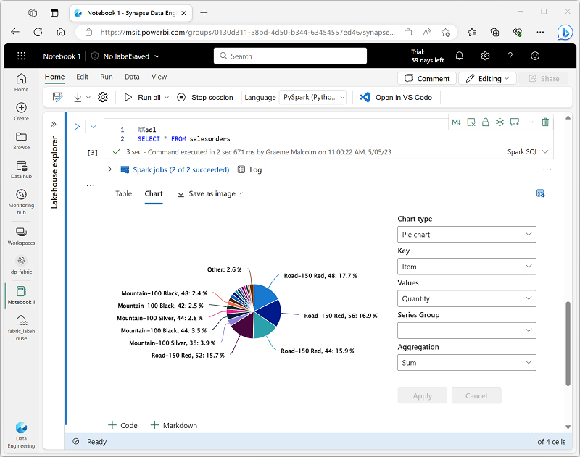

**The built-in charting functionality in notebooks is useful when you want to quickly summarize the data visually. When you want to have more control over how the data is formatted, you should consider using a graphics package to create your own visualizations.**

**Using graphics packages in code**

**There are many graphics packages that you can use to create data visualizations in code. In particular, Python supports a large selection of packages; most of them built on the base Matplotlib library. The output from a graphics library can be rendered in a notebook, making it easy to combine code to ingest and manipulate data with inline data visualizations and markdown cells to provide commentary.**

**For example, you could use the following PySpark code to aggregate data from the hypothetical products data explored previously in this module, and use Matplotlib to create a chart from the aggregated data.**

**PythonCopy**

**from matplotlib import pyplot as plt**

**# Get the data as a Pandas dataframe**

**data = spark.sql("SELECT Category, COUNT(ProductID) AS ProductCount \**

**FROM products \**

**GROUP BY Category \**

**ORDER BY Category").toPandas()**

**# Clear the plot area**

**plt.clf()**

**# Create a Figure**

**fig = plt.figure(figsize=(12,8))**

**# Create a bar plot of product counts by category**

**plt.bar(x=data['Category'], height=data['ProductCount'], color='orange')**

**# Customize the chart**

**plt.title('Product Counts by Category')**

**plt.xlabel('Category')**

**plt.ylabel('Products')**

**plt.grid(color='#95a5a6', linestyle='--', linewidth=2, axis='y', alpha=0.7)**

**plt.xticks(rotation=70)**

**# Show the plot area**

**plt.show()**

**The Matplotlib library requires data to be in a Pandas dataframe rather than a Spark dataframe, so the toPandas method is used to convert it. The code then creates a figure with a specified size and plots a bar chart with some custom property configuration before showing the resulting plot.**

**The chart produced by the code would look similar to the following image:**

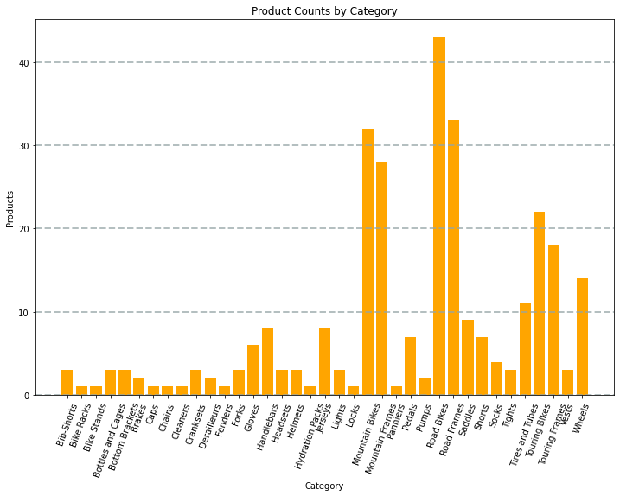

**You can use the Matplotlib library to create many kinds of chart; or if preferred, you can use other libraries such as Seaborn to create highly customized charts.**

**Next unit: Exercise - Analyze data with Apache Spark**

**Exercise - Analyze data with Apache Spark**

**Completed100 XP**

* **45 minutes**

**Now it's your opportunity to work with Apache Spark in Microsoft Fabric. In this exercise, you'll use a Spark notebook to analyze and visualize data from files in lakehouse.**

**Note**

**To complete this exercise, you need a Microsoft Fabric tenant. See**[**Getting started with Fabric**](https://learn.microsoft.com/en-us/fabric/get-started/fabric-trial)**to find out how to enable a Fabric trial license.**

**Launch the exercise and follow the instructions.**

**[](https://go.microsoft.com/fwlink/?linkid=2259707)**

**https://microsoftlearning.github.io/mslearn-fabric/Instructions/Labs/02-analyze-spark.html**

**Next unit: Knowledge check**

**Knowledge check**

**Completed200 XP**

* **Module assessment**
* **3 minutes**

**Great job! You passed the module assessment.**

**Dismiss alert**

**Check your knowledge**

**Top of Form**

**1.**

**You want to use Apache Spark to explore data interactively in Microsoft Fabric. What should you create?**

**A Spark job definition.**

**A pipeline.**

**A notebook.**

**Correct. Notebooks enable you to run Spark code interactively.**

**2.**

**You need to use Spark to analyze data in a CSV file. What's the simplest way to accomplish this goal?**

**Load the file into a dataframe.**

**Correct. You can load data from files in many formats, including CSV, into a Spark dataframe.**

**Import the data into a table in a warehouse.**

**Convert the data to Parquet format.**

**3.**

**Which format is used to store data as lakehouse tables in Microsoft Fabric?**

**Comma-separated-values (CSV)**

**Avro**

**Delta**

**Correct. Tables in a Fabric lakehouse are based on Delta Lake technology, which uses an extended format of Parquet files known as Delta.**

**Bottom of Form**

**Summary**

**Completed100 XP**

* **1 minute**

**Apache Spark is a key technology used in big data analytics. Spark support in Microsoft Fabric enables you to integrate big data processing in Spark with the other data analytics and visualization capabilities of the platform.**

**Tip**

**For more information about working with data in Spark, see the**[**Spark SQL, DataFrames and Datasets Guide**](https://spark.apache.org/docs/latest/sql-programming-guide.html)**in the Apache Spark documentation.**

**All units complete:**

**Orchestrate processes and data movement with Microsoft Fabric**

**Introduction**

**Completed**

**100 XP**

**1 minute**

**Data pipelines define a sequence of activities that orchestrate an overall process, usually by extracting data from one or more sources and loading it into a destination; often transforming it along the way. Pipelines are commonly used to automate extract, transform, and load (ETL) processes that ingest transactional data from operational data stores into an analytical data store, such as a lakehouse, data warehouse, or SQL database.**

**If you're already familiar with Azure Data Factory, then data pipelines in Microsoft Fabric will be immediately familiar. They use the same architecture of connected activities to define a process that can include multiple kinds of data processing tasks and control flow logic. You can run pipelines interactively in the Microsoft Fabric user interface, or schedule them to run automatically.**

**Understand pipelines**

**Completed100 XP**

* **6 minutes**

**Pipelines in Microsoft Fabric encapsulate a sequence of *activities* that perform data movement and processing tasks. You can use a pipeline to define data transfer and transformation activities, and orchestrate these activities through control flow activities that manage branching, looping, and other typical processing logic. The graphical pipeline *canvas* in the Fabric user interface enables you to build complex pipelines with minimal or no coding required.**

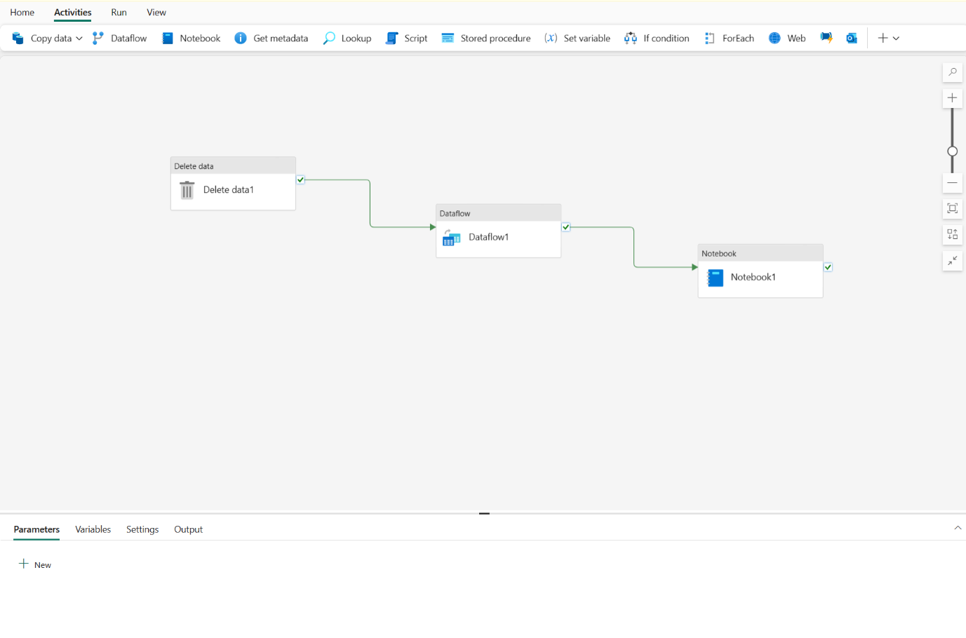

**Core pipeline concepts**

**Before building pipelines in Microsoft Fabric, you should understand a few core concepts.**

**Activities**

**Activities are the executable tasks in a pipeline. You can define a flow of activities by connecting them in a sequence. The outcome of a particular activity (success, failure, or completion) can be used to direct the flow to the next activity in the sequence.**

**There are two broad categories of activity in a pipeline.**

* **Data transformation activities - activities that encapsulate data transfer operations, including simple Copy Data activities that extract data from a source and load it to a destination, and more complex Data Flow activities that encapsulate dataflows (Gen2) that apply transformations to the data as it is transferred. Other data transformation activities include Notebook activities to run a Spark notebook, Stored procedure activities to run SQL code, Delete data activities to delete existing data, and others. In OneLake, you can configure the destination to a lakehouse, warehouse, SQL database, or other options.**
* **Control flow activities - activities that you can use to implement loops, conditional branching, or manage variable and parameter values. The wide range of control flow activities enables you to implement complex pipeline logic to orchestrate data ingestion and transformation flow.**

**Tip**

**For details about the complete set of pipeline activities available in Microsoft Fabric, see**[**Activity overview**](https://learn.microsoft.com/en-us/fabric/data-factory/activity-overview)**in the Microsoft Fabric documentation.**

**Parameters**

**Pipelines can be parameterized, enabling you to provide specific values to be used each time a pipeline is run. For example, you might want to use a pipeline to save ingested data in a folder, but have the flexibility to specify a folder name each time the pipeline is run.**

**Using parameters increases the reusability of your pipelines, enabling you to create flexible data ingestion and transformation processes.**

**Pipeline runs**

**Each time a pipeline is executed, a *data pipeline run* is initiated. Runs can be initiated on-demand in the Fabric user interface or scheduled to start at a specific frequency. Use the unique run ID to review run details to confirm they completed successfully and investigate the specific settings used for each execution.**

**Next unit: Use the Copy Data activity**

**Use the Copy Data activity**

**Completed100 XP**

* **3 minutes**

**The Copy Data activity is one of the most common uses of a data pipeline. Many pipelines consist of a single Copy Data activity that is used to ingest data from an external source into a lakehouse file or table.**

**You can also combine the Copy Data activity with other activities to create a repeatable data ingestion process - for example by using a Delete data activity to remove existing data, a Copy Data activity to replace the deleted data with a file containing data from an external source, and a Notebook activity to run Spark code that transforms the data in the file and loads it into a table.**

**The Copy Data tool**

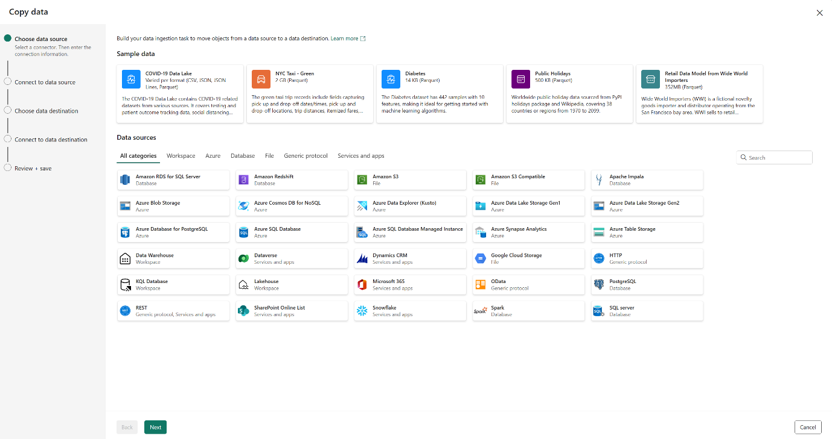

**When you add a Copy Data activity to a pipeline, a graphical tool takes you through the steps required to configure the data source and destination for the copy operation. A wide range of source connections is supported, making it possible to ingest data from most common sources. In OneLake, this includes support for lakehouse, warehouse, SQL Database, and others.**

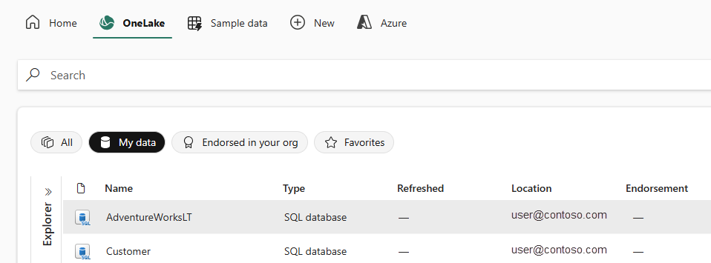

**Copy Data activity settings**

**After you've added a Copy Data activity to a pipeline, you can select it in the pipeline canvas and edit its settings in the pane underneath.**

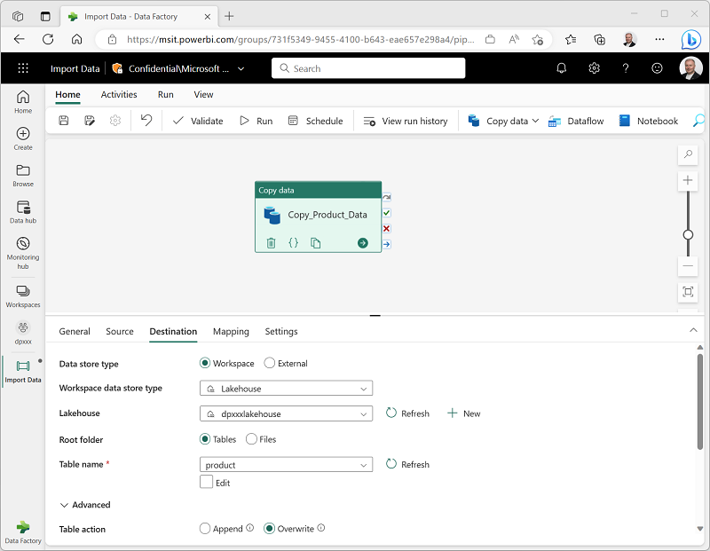

**When to use the Copy Data activity**

**Use the Copy Data activity when you need to copy data directly between a supported source and destination without applying any transformations, or when you want to import the raw data and apply transformations in later pipeline activities.**

**If you need to apply transformations to the data as it is ingested, or merge data from multiple sources, consider using a Data Flow activity to run a dataflow (Gen2). You can use the Power Query user interface to define a dataflow (Gen2) that includes multiple transformation steps, and include it in a pipeline.**

**Tip**

**To learn more about Dataflow (Gen2) in Microsoft Fabric to ingest data, consider completing the**[**Ingest Data with Dataflows Gen2 in Microsoft Fabric**](https://learn.microsoft.com/en-us/training/modules/use-dataflow-gen-2-fabric)**module.**

**Next unit: Use pipeline templates**

**Use pipeline templates**

**Completed100 XP**

* **3 minutes**

**You can define pipelines from any combination of activities you choose, enabling to create custom data ingestion and transformation processes to meet your specific needs. However, there are many common pipeline scenarios for which Microsoft Fabric includes predefined pipeline templates that you can use and customize as required.**

**To create a pipeline based on a template, select the Choose a task to start tile in a new pipeline as shown here.**

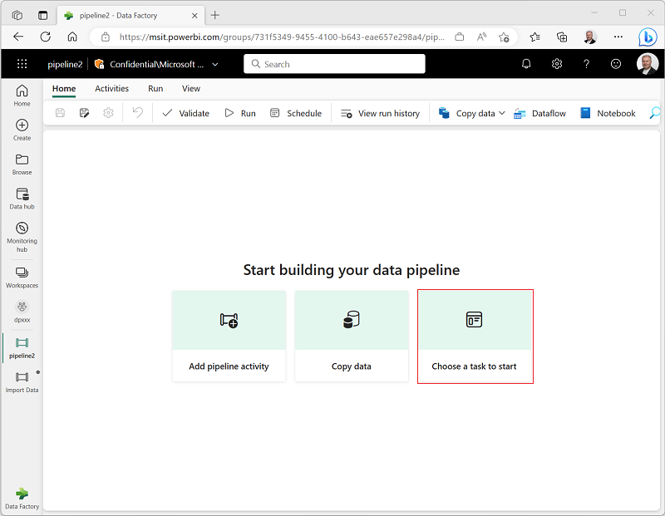

**Selecting this option displays a selection of pipeline templates, as shown here.**

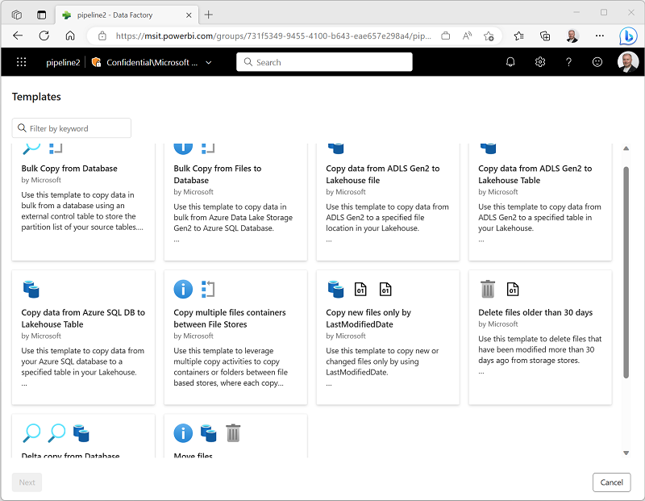

**You can select the most appropriate template for your needs, and then edit the pipeline in the pipeline canvas to customize it to your needs.**

**Next unit: Run and monitor pipelines**

[**Previous**](https://learn.microsoft.com/en-us/training/modules/use-data-factory-pipelines-fabric/3-copy-data/)

**Run and monitor pipelines**

**Completed100 XP**

* **5 minutes**

**When you have completed a pipeline, you can use the Validate option to check that the configuration is valid, and then either run it interactively or specify a schedule.**

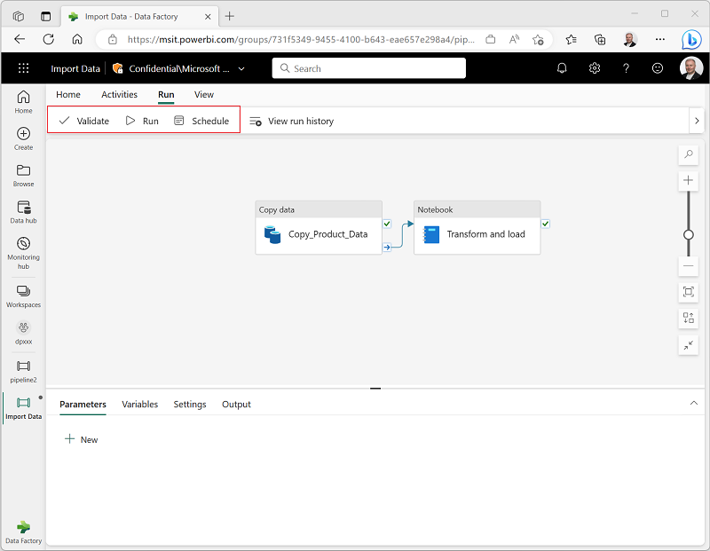

**View run history**

**You can view the run history for a pipeline to see details of each run, either from the pipeline canvas or from the pipeline item listed in the page for the workspace.**

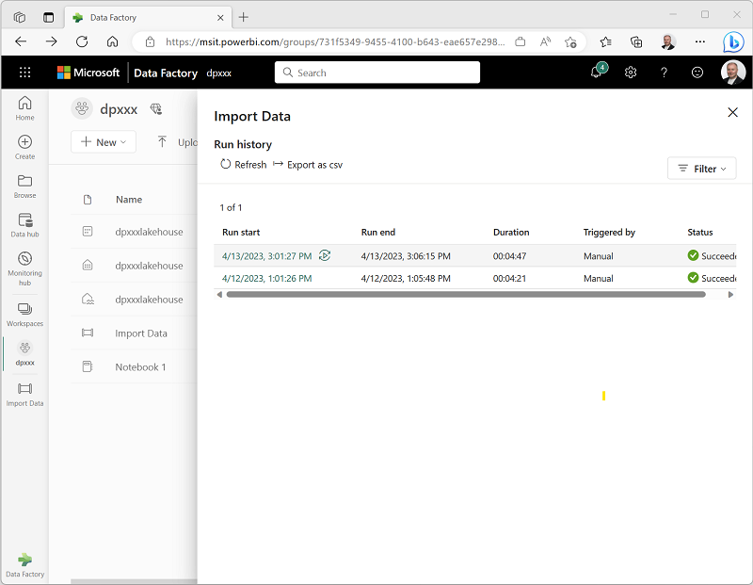

**When you view a pipeline run history from the workspace page, you can select the Run start value to see the details of an individual run; including the option to view the individual execution time for each activity as a Gantt chart.**

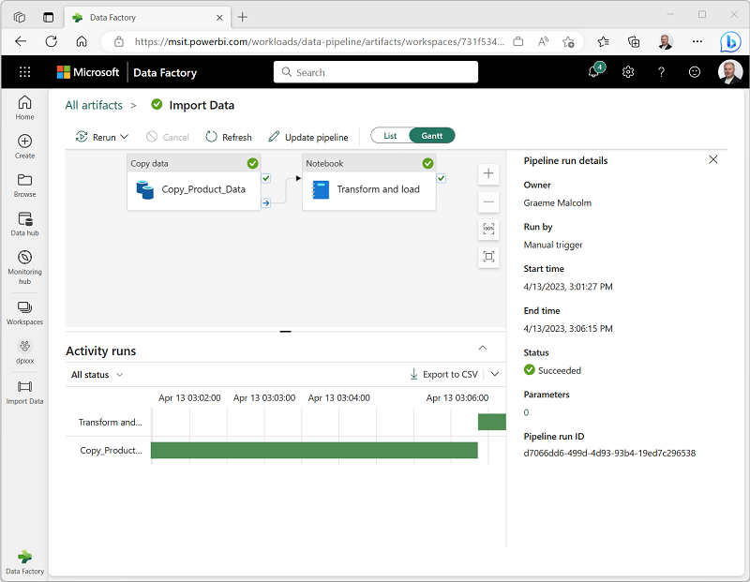

**Next unit: Exercise - Ingest data with a pipeline**

[**Previous**](https://learn.microsoft.com/en-us/training/modules/use-data-factory-pipelines-fabric/4-pipeline-templates/)

**Exercise - Ingest data with a pipeline**

**Completed100 XP**

* **60 minutes**

**Now it's your chance to implement a pipeline in Microsoft Fabric. In this exercise, you create a pipeline that copies data from an external source into a lakehouse. Then enhance the pipeline by adding activities to transform the ingested data.**

**Note**

**You need a Microsoft Fabric trial license with the Fabric preview enabled in your tenant. See**[**Getting started with Fabric**](https://learn.microsoft.com/en-us/fabric/get-started/fabric-trial)**to enable your Fabric trial license.**

**Launch the exercise and follow the instructions.**

**[](https://aka.ms/mslearn-fabric-pipeline&azure-portal=true)**

**Next unit: Knowledge check**

[**Previous**](https://learn.microsoft.com/en-us/training/modules/use-data-factory-pipelines-fabric/5-run-monitor-pipelines/)

**Knowledge check**

**Completed200 XP**

* **Module assessment**
* **3 minutes**

**Answer 100% of questions correctly in order to pass.**[**Retake**](https://learn.microsoft.com/en-us/training/modules/use-data-factory-pipelines-fabric/7-knowledge-check)

**Dismiss alert**

**Check your knowledge**

**Top of Form**

**1.**

**What is a data pipeline?**

**A special folder in OneLake storage where data can be exported from a lakehouse**

**A sequence of activities to orchestrate a data ingestion or transformation process**

**Correct. A pipeline consists of activities to ingest and transform data.**

**A saved Power Query**

**2.**

**You want to use a pipeline to copy data to a folder with a specified name for each run. What should you do?**

**Create multiple pipelines - one for each folder name**

**Use a Dataflow (Gen2)**

**Incorrect. Using a dataflow doesn't inherently enable dynamic folder naming.**

**Add a parameter to the pipeline and use it to specify the folder name for each run**

**Correct. Using a parameter enables greater flexibility for your pipeline.**

**3.**

**You have previously run a pipeline containing multiple activities. What's the best way to check how long each individual activity took to complete?**

**Rerun the pipeline and observe the output, timing each activity.**

**View the run details in the run history.**

**Correct. The run history details show the time taken for each activity - optionally as a Gantt chart.**

**View the Refreshed value for your lakehouse's default dataset**

**Bottom of Form**

**Summary**

**Completed100 XP**

* **1 minute**

**With Microsoft Fabric, you can create pipelines that encapsulate complex data ingestion and transformation processes. Pipelines provide an effective way to orchestrate data processing tasks that can be run on-demand or at scheduled intervals.**

**Tip**

**For more information about pipelines in Microsoft Fabric, see**[**Data pipelines**](https://learn.microsoft.com/en-us/fabric/data-factory/data-factory-overview)**in the Microsoft Fabric documentation.**

[**https://learn.microsoft.com/en-us/training/modules/use-data-factory-pipelines-fabric/8-summary#completion**](https://learn.microsoft.com/en-us/training/modules/use-data-factory-pipelines-fabric/8-summary#completion)

**Ingest Data with Dataflows Gen2 in Microsoft Fabric**

**Introduction**

**Completed100 XP**

* **2 minutes**

**Microsoft Fabric offers a unified solution for data engineering, integration, and analytics. A crucial step in end-to-end analytics is data ingestion. Dataflows Gen2 are used to ingest and transform data from multiple sources, and then land the cleansed data to another destination. They can be incorporated into data pipelines for more complex activity orchestration, and also used as a data source in Power BI.**

**Imagine you work for a retail company with stores across the globe. As a data engineer, you need to prepare and transform data from various sources into a format that is suitable for data analysis and reporting. The business requests a semantic model that consolidates disparate data sources from the different stores. Dataflows Gen2 allow you to prepare the data to ensure consistency, and then stage the data in the preferred destination. They also enable reuse and make it easy to update the data. Without a dataflow, you'd have to manually extract and transform the data from every source, which is time-consuming and prone to errors.**

**In this module, we explain how to use Dataflows Gen2 in Microsoft Fabric to meet your data ingestion needs.**

**Understand Dataflows Gen2 in Microsoft Fabric**

**Completed100 XP**

* **7 minutes**

**In our scenario, you need to develop a semantic model that can standardize the data and provide access to the business. By using Dataflows Gen2, you can connect to the various data sources, and then prep and transform the data. You can land the data directly into your lakehouse or use a data pipeline for other destinations.**

**What is a dataflow?**

***Dataflows* are a type of cloud-based ETL (*Extract, Transform, Load*) tool for building and executing scalable data transformation processes.**

**Dataflows Gen2 allow you to extract data from various sources, transform it using a wide range of transformation operations, and load it into a destination. Using Power Query Online also allows for a visual interface to perform these tasks.**

**Fundamentally, a dataflow includes all of the transformations to reduce data prep time and then can be loaded into a new table, included in a data pipeline, or used as a data source by data analysts.**

**How to use Dataflows Gen2**

**Traditionally, data engineers spend significant time extracting, transforming, and loading data into a consumable format for downstream analytics. The goal of Dataflows Gen2 is to provide an easy, reusable way to perform ETL tasks using Power Query Online.**

**If you only choose to use a data pipeline, you copy data, then use your preferred coding language to extract, transform, and load the data. Alternatively, you can create a Dataflow Gen2 first to extract and transform the data. You can also load the data into a lakehouse, and other destinations. Now the business can easily consume the curated semantic model.**

**Adding a data destination to your dataflow is optional, and the dataflow preserves all transformation steps. To perform other tasks or load data to a different destination after transformation, create a data pipeline and add the Dataflow Gen2 activity to your orchestration.**

**Another option might be to use a data pipeline and Dataflow Gen2 for ELT *(Extract, Load, Transform)* process. For this order, you'd use a Pipeline to extract and load the data into your preferred destination, such as the lakehouse. Then you'd create a Dataflow Gen2 to connect to Lakehouse data to cleanse and transform data. In this case, you'd offer the Dataflow as a curated semantic model for data analysts to develop reports.**

**Dataflows can be horizontally partitioned as well. Once you create a global dataflow, data analysts can use dataflows to create specialized semantic models for specific needs.**

**Dataflows allow you to promote reusable ETL logic that prevents the need to create more connections to your data source. Dataflows offer a wide variety of transformations, and can be run manually, on a refresh schedule, or as part of a data pipeline orchestration.**

**Tip**

**Make your dataflow discoverable so data analysts can also connect to the dataflow through Power BI Desktop. This reduces the data preparation for report development.**

**Benefits and limitations**

**There's more than one way to ETL or ELT data in Microsoft Fabric. Consider the benefits and limitations for using Dataflows Gen2.**

**Benefits:**

* **Extend data with consistent data, such as a standard date dimension table.**
* **Allow self-service users access to a subset of data warehouse separately.**
* **Optimize performance with dataflows, which enable extracting data once for reuse, reducing data refresh time for slower sources.**
* **Simplify data source complexity by only exposing dataflows to larger analyst groups.**
* **Ensure consistency and quality of data by enabling users to clean and transform data before loading it to a destination.**
* **Simplify data integration by providing a low-code interface that ingests data from various sources.**

**Limitations:**

* **Dataflows aren't a replacement for a data warehouse.**
* **Row-level security isn't supported.**
* **Fabric capacity workspace is required.**

**Next unit: Explore Dataflows Gen2 in Microsoft Fabric**

**Explore Dataflows Gen2 in Microsoft Fabric**

**Completed100 XP**

* **7 minutes**

**In Microsoft Fabric, you can create a Dataflow Gen2 in the Data Factory workload or Power BI workspace, or directly in the lakehouse. Since our scenario is focused on data ingestion, let's look at the Data Factory workload experience. Dataflows Gen2 use Power Query Online to visualize transformations. See an overview of the interface:**

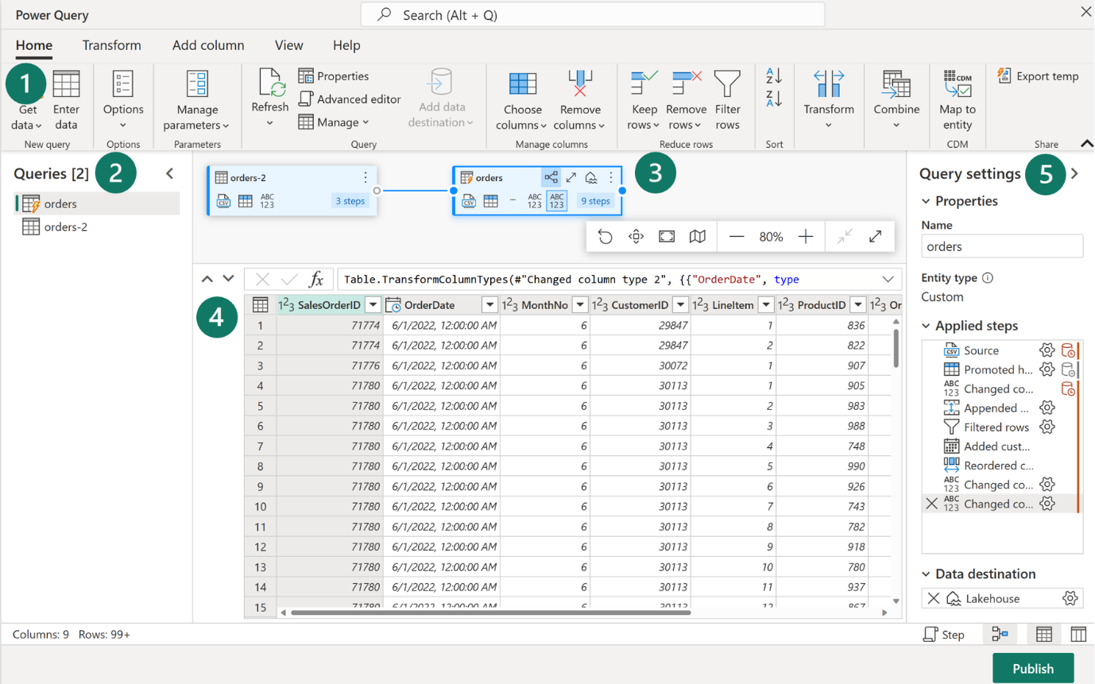

**1. Power Query ribbon**

**Dataflows Gen2 support a wide variety of data source connectors. Common sources include cloud and on-premises relational databases, Excel or flat files, SharePoint, SalesForce, Spark, and Fabric lakehouses. Then there are numerous data transformations possible, such as:**

* **Filter and Sort rows**
* **Pivot and Unpivot**
* **Merge and Append queries**
* **Split and Conditional split**
* **Replace values and Remove duplicates**
* **Add, Rename, Reorder, or Delete columns**
* **Rank and Percentage calculator**
* **Choose Top N and Bottom N**

**You can also create and manage data source connections, manage parameters, and configure the default data destination in this ribbon.**

**2. Queries pane**

**The Queries pane shows you the different data sources - now called *queries*. These queries are called tables when loaded to your data store. You can duplicate or reference a query if you need multiple copies of the same data, such as creating a star schema and splitting data into separate, smaller tables. You can also disable the load of a query, in case you only need the one-time import.**

**3. Diagram view**

**The Diagram View allows you to visually see how the data sources are connected and the different applied transformations. For example, your dataflow connects to a data source, duplicates the query, removes columns from the source query, then unpivots the duplicate query. Each query is represented as a shape with all of the applied transformations and connected by a line for the duplicate query. You can turn this view on or off.**

**4. Data Preview pane**

**The Data Preview pane only shows a subset of data to allow you to see which transformations you should make and how they affect the data. You can also interact with the preview pane by dragging and dropping columns to change order or right-clicking on columns to filter or make changes. The data preview shows all of your transformations for the selected query.**

**5. Query Settings pane**

**The Query Settings pane includes the Applied Steps. Each transformation you do is tied to a step, some of which are automatically applied when you connect the data source. Depending on the complexity of the transformations, you might have several applied steps for each query. Most steps have a gear icon that allows you to modify the step, otherwise you must delete and repeat the transformation.**

**Each step also has a contextual menu when you right-click so you can rename, reorder, or delete the steps. You can also view the data source query when connecting to a**

**While this visual interface is helpful, you can also view the M code through Advanced editor.**

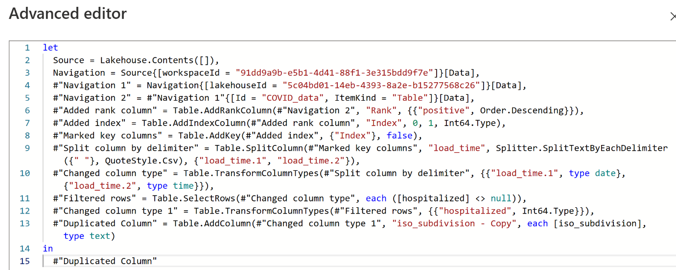

**In the Query settings pane, you can see a Data Destination option to land your data in one of the following locations in your Fabric environment:**

* **Lakehouse**
* **Warehouse**
* **SQL database**

**You can also load your dataflow to Azure SQL database, Azure Data Explorer, or Azure Synapse Analytics.**

**Dataflows Gen2 provide a low-to-no-code solution to ingest, transform, and load data into your Fabric data stores. Power BI developers are familiar and can quickly begin to perform transformations upstream to improve performance for their reports.**

**Note**

**For more information, see the**[**Power Query**](https://learn.microsoft.com/en-us/power-query/)**documentation to optimize your dataflows.**

**Next unit: Integrate Dataflows Gen2 and Pipelines in Microsoft Fabric**

[**Previous**](https://learn.microsoft.com/en-us/training/modules/use-dataflow-gen-2-fabric/2-dataflows-gen-2/)

**Integrate Dataflows Gen2 and Pipelines in Microsoft Fabric**

**Completed100 XP**

* **2 minutes**

**Dataflows Gen2 provide an excellent option for data transformations in Microsoft Fabric. The combination of dataflows and pipelines is useful when you need to perform additional operations on the transformed data.**

**Data pipelines are a common concept in data engineering and offer a wide variety of activities to orchestrate. Some common activities include:**

* **Copy data**
* **Incorporate Dataflow**
* **Add Notebook**
* **Get metadata**
* **Execute a script or stored procedure**

**Pipelines provide a visual way to complete activities in a specific order. You can use a dataflow for data ingestion, transformation, and landing into a Fabric data store. Then incorporate the dataflow into a pipeline to orchestrate extra activities, like execute scripts or stored procedures after the dataflow has completed.**

**Pipelines can also be scheduled or activated by a trigger to run your dataflow. By using a pipeline to run your dataflow, you can have the data refreshed when you need it instead of having to manually run the dataflow. When you're dealing with enterprise or frequently changing data, automation allows you to focus on other responsibilities.**

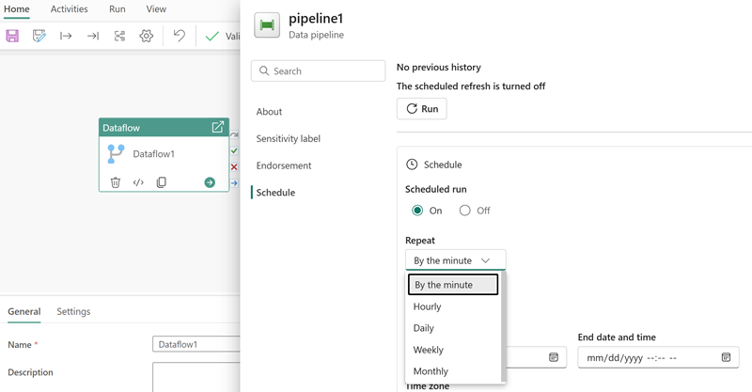

**Next unit: Exercise - Create and use a Dataflow Gen2 in Microsoft Fabric**

[**Previous**](https://learn.microsoft.com/en-us/training/modules/use-dataflow-gen-2-fabric/3-explore-dataflows-gen-2/)

**Exercise - Create and use a Dataflow Gen2 in Microsoft Fabric**

**Completed100 XP**

* **30 minutes**

**In this exercise, you'll use a Dataflow Gen2 to load transformed data into a lakehouse and add a dataflow to a pipeline.**

**Note**

**You need a Microsoft Fabric trial license with the Fabric preview enabled in your tenant. See**[**Getting started with Fabric**](https://learn.microsoft.com/en-us/fabric/get-started/fabric-trial)**to enable your Fabric trial license.**

**Launch the exercise and follow the instructions.**

**[](https://go.microsoft.com/fwlink/?linkid=2259607)**

**Next unit: Knowledge check**

**Knowledge check**

**Completed200 XP**

* **Module assessment**
* **3 minutes**

**Great job! You passed the module assessment.**

**Dismiss alert**

**Top of Form**

**1.**

**What is a Dataflow Gen2?**

**A hybrid database that supports ACID transactions.**

**A way to export data to Power BI Desktop.**

**A way to import and transform data with Power Query Online.**

**Correct. Dataflow Gen2 allows you to get and transform data, then optionally ingest to a lakehouse.**

**2.**

**Which workload experience lets you create a Dataflow Gen2?**

**Real-time intelligence.**

**Data warehouse.**

**Data Factory.**

**Correct. Data Factory and Power BI workloads allow Dataflow Gen2 creation.**

**3.**

**You need to connect to and transform data to be loaded into a Fabric lakehouse. You aren't comfortable using Spark notebooks, so decide to use Dataflows Gen2. How would you complete this task?**

**Connect to Data Factory workload > Create a Dataflow Gen2 to transform data > add your lakehouse as the data destination.**

**Correct. These are the high-level steps to accomplish your task.**

**Connect to Real-time intelligence workload > Create Pipeline to copy data > Transform data with an Eventstream.**

**Connect to Data Factory workload > Create Pipeline to copy data and load to lakehouse > Transform directly in the lakehouse.**

**Bottom of Form**

**Next unit: Summary**

**Summary**

**Completed100 XP**

* **2 minutes**

**In this module, we walked through a scenario where both data engineers need to ingest, transform, and load data into a Fabric data store such as a lakehouse. We also identified data analyst needs to perform transformations closer to the data source to support Power BI report development.**

**With Microsoft Fabric, you can create Dataflows Gen2 to perform data integration for your lakehouse, and optionally include the dataflow in a Data Pipeline as well. You learned about Dataflows Gen2 and how to use them as part of your data integration process. Power Query Online offers a visual interface to perform complex data transformations without writing any code.**

**To learn more about data integration, see the**[**Data Factory in Microsoft Fabric**](https://learn.microsoft.com/en-us/fabric/data-factory/)**documentation**

**Get started with data warehouses in Microsoft Fabric**

**Get started with data warehouses in Microsoft Fabric**

* **1 hr 6 min**
* **Module**
* **9 Units**

**Feedback**

**Beginner**

**Data Analyst**

**Data Engineer**

**Microsoft Fabric**

**Data warehouses are analytical stores built on a relational schema to support SQL queries. Microsoft Fabric enables you to create a relational data warehouse in your workspace and integrate it easily with other elements of your end-to-end analytics solution.**

**Learning objectives**

**In this module, you learn how to:**

* **Describe data warehouses in Fabric.**
* **Understand a data warehouse vs a data Lakehouse.**
* **Work with data warehouses in Fabric.**
* **Create and manage fact tables and dimensions within a data warehouse.**

[**Start**](https://learn.microsoft.com/en-us/training/modules/get-started-data-warehouse/1-introduction/)**Add**

**Prerequisites**

**Before starting this module, you should be familiar with the Microsoft Fabric interface and core concepts.**

**This module is part of these learning paths**

* [**Get started with Microsoft Fabric**](https://learn.microsoft.com/training/paths/get-started-fabric/)
* [**Implement a data warehouse with Microsoft Fabric**](https://learn.microsoft.com/training/paths/work-with-data-warehouses-using-microsoft-fabric/)

**Module assessment**

**Assess your understanding of this module. Sign in and answer all questions correctly to earn a pass designation on your profile.**

[**Take the module assessment**](https://learn.microsoft.com/training/modules/get-started-data-warehouse/8-knowledge-check/)

* [**Introduction**](https://learn.microsoft.com/en-us/training/modules/get-started-data-warehouse/1-introduction)**3 min**
* [**Understand data warehouse fundamentals**](https://learn.microsoft.com/en-us/training/modules/get-started-data-warehouse/2-understand-data-warehouse)**7 min**
* [**Understand data warehouses in Fabric**](https://learn.microsoft.com/en-us/training/modules/get-started-data-warehouse/3-understand-data-warehouse-fabric)**6 min**
* [**Query and transform data**](https://learn.microsoft.com/en-us/training/modules/get-started-data-warehouse/4-query-transform-data)**6 min**
* [**Prepare data for analysis and reporting**](https://learn.microsoft.com/en-us/training/modules/get-started-data-warehouse/5-model-data)**6 min**
* [**Secure and monitor your data warehouse**](https://learn.microsoft.com/en-us/training/modules/get-started-data-warehouse/6-security-monitor)**4 min**
* [**Exercise - Analyze data in a data warehouse**](https://learn.microsoft.com/en-us/training/modules/get-started-data-warehouse/7-exercise)**30 min**
* [**Knowledge check**](https://learn.microsoft.com/en-us/training/modules/get-started-data-warehouse/8-knowledge-check)**3 min**
* [**Summary**](https://learn.microsoft.com/en-us/training/modules/get-started-data-warehouse/9-summary)**1 min**

**Introduction**

**Completed100 XP**

* **3 minutes**

**Relational data warehouses are at the center of most enterprise business intelligence (BI) solutions. While the specific details may vary across data warehouse implementations, a common pattern based on a denormalized, multidimensional schema has emerged as the standard design for a relational data warehouse.**

**Microsoft Fabric's data warehouse is a modern version of the traditional data warehouse. It centralizes and organizes data from different departments, systems, and databases into a single, unified view for analysis and reporting purposes. Fabric's data warehouse provides full SQL semantics, including the ability to insert, update, and delete data in the tables. Fabric's data warehouse is unique because it's built on the Lakehouse, which is stored in Delta format and can be queried using SQL. It's designed for use by the whole data team, not just data engineers.**

**Fabric's data warehouse experience is designed to address these challenges. Fabric enables data engineers, analysts, and data scientists to work together to create and query a data warehouse that is optimized for their specific needs.**

**In this module, you'll learn about data warehouses in Fabric, create a data warehouse, load, query, and visualize data.**

**Next unit: Understand data warehouse fundamentals**

[**Next**](https://learn.microsoft.com/en-us/training/modules/get-started-data-warehouse/2-understand-data-warehouse/)

**Understand data warehouse fundamentals**

**Completed100 XP**

* **7 minutes**

**The process of building a modern data warehouse typically consists of:**

* **Data ingestion - moving data from source systems into a data warehouse.**
* **Data storage - storing the data in a format that is optimized for analytics.**
* **Data processing - transforming the data into a format that is ready for consumption by analytical tools.**
* **Data analysis and delivery - analyzing the data to gain insights and delivering those insights to the business.**

**Microsoft Fabric enables data engineers and analysts to ingest, store, transform, and visualize data all in one tool with both a low-code and traditional experience.**

**Understand Fabric's data warehouse experience**

**Fabric's *data warehouse* is a relational data warehouse that supports the full transactional T-SQL capabilities you'd expect from an enterprise data warehouse. It's a fully managed, scalable, and highly available data warehouse that can be used to store and query data in the Lakehouse. Using the data warehouse, you're fully in control of creating tables, loading, transforming, and querying data using either the Fabric portal or T-SQL commands. You can use SQL to query and analyze the data, or use Spark to process the data and create machine learning models.**

**Data warehouses in Fabric facilitate collaboration between data engineers and data analysts, working together in the same experience. Data engineers build a relational layer on top of data in the Lakehouse, where analysts can use T-SQL and Power BI to explore the data.**

**Design a data warehouse**

**Like all relational databases, Fabric's data warehouse contains tables to store your data for analytics later. Most commonly, these tables are organized in a schema that is optimized for multidimensional modeling. In this approach, numerical data related to events (e.g. sales orders) are grouped by different attributes (e.g. date, customer, store). For instance, you can analyze the total amount paid for sales orders that occurred on a specific date or at a particular store.**

**Tables in a data warehouse**

**Tables in a data warehouse are typically organized in a way that supports efficient and effective analysis of large amounts of data. This organization is often referred to as dimensional modeling, which involves structuring tables into fact tables and dimension tables.**

**Fact tables contain the numerical data that you want to analyze. Fact tables typically have a large number of rows and are the primary source of data for analysis. For example, a fact table might contain the total amount paid for sales orders that occurred on a specific date or at a particular store.**

**Dimension tables contain descriptive information about the data in the fact tables. Dimension tables typically have a small number of rows and are used to provide context for the data in the fact tables. For example, a dimension table might contain information about the customers who placed sales orders.**

**In addition to attribute columns, a dimension table contains a unique key column that uniquely identifies each row in the table. In fact, it's common for a dimension table to include two key columns:**

* **A *surrogate key* is a unique identifier for each row in the dimension table. It's often an integer value that is automatically generated by the database management system when a new row is inserted into the table.**
* **An *alternate key* is often a natural or business key that identifies a specific instance of an entity in the transactional source system - such as a product code or a customer ID.**

**You need both surrogate and alternate keys in a data warehouse, because they serve different purposes. Surrogate keys are specific to the data warehouse and help to maintain consistency and accuracy in the data. Alternate keys on the other hand are specific to the source system and help to maintain traceability between the data warehouse and the source system.**

**Special types of dimension tables**

**Special types of dimensions provide additional context and enable more comprehensive data analysis.**

***Time dimensions* provide information about the time period in which an event occurred. This table enables data analysts to aggregate data over temporal intervals. For example, a time dimension might include columns for the year, quarter, month, and day in which a sales order was placed.**

***Slowly changing dimensions* are dimension tables that track changes to dimension attributes over time, like changes to a customer's address or a product's price. They're significant in a data warehouse because they enable users to analyze and understand changes to data over time. Slowly changing dimensions ensure that data stays up-to-date and accurate, which is imperative to making good business decisions.**

**Data warehouse schema designs**

**In most transactional databases that are used in business applications, the data is *normalized* to reduce duplication. In a data warehouse however, the dimension data is generally *de-normalized* to reduce the number of joins required to query the data.**

**Often, a data warehouse is organized as a *star schema*, in which a fact table is directly related to the dimension tables, as shown in this example:**

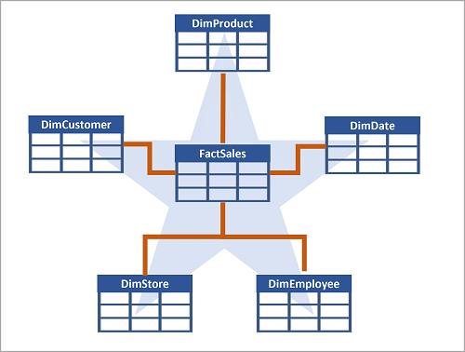

**You can use the attributes of something to group together numbers in the fact table at different levels. For example, you could find the total sales revenue for a whole region or just for one customer. The information for each level can be stored in the same dimension table.**

**Tip**

**See**[**What is a star schema?**](https://learn.microsoft.com/en-us/power-bi/guidance/star-schema)**for more information on designing star schemas for Fabric.**

**If there are lots of levels or some information is shared by different things, it might make sense to use a *snowflake schema* instead. Here's an example:**

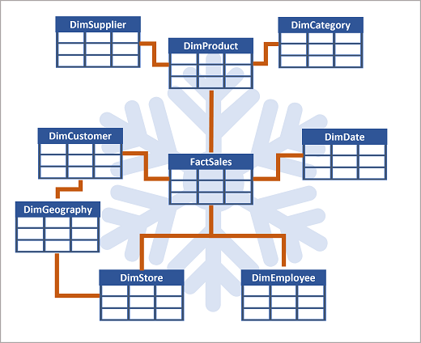

**In this case, the DimProduct table has been split up (normalized) to create separate dimension tables for product categories and suppliers.**

* **Each row in the DimProduct table contains key values for the corresponding rows in the DimCategory and DimSupplier tables.**

**A DimGeography table has been added containing information on where customers and stores are located.**

* **Each row in the DimCustomer and DimStore tables contains a key value for the corresponding row in the DimGeography table.**

**Next unit: Understand data warehouses in Fabric**

[**Previous**](https://learn.microsoft.com/en-us/training/modules/get-started-data-warehouse/1-introduction/)

**Understand data warehouses in Fabric**

**Completed100 XP**

* **6 minutes**

**Fabric's Lakehouse is a collection of files, folders, tables, and shortcuts that act like a database over a data lake. It's used by the Spark engine and SQL engine for big data processing and has features for ACID transactions when using the open-source Delta formatted tables.**

**Fabric's data warehouse experience allows you to transition from the lake view of the Lakehouse (which supports data engineering and Apache Spark) to the SQL experiences that a traditional data warehouse would provide. The Lakehouse gives you the ability to read tables and use the SQL analytics endpoint, whereas the data warehouse enables you to manipulate the data.**

**In the data warehouse experience, you'll model data using tables and views, run T-SQL to query data across the data warehouse and Lakehouse, use T-SQL to perform DML operations on data inside the data warehouse, and serve reporting layers like Power BI.**

**Now that you understand the basic architectural principles for a relational data warehouse schema, let's explore how to create a data warehouse.**

**Describe a data warehouse in Fabric**

**In the data warehouse experience in Fabric, you can build a relational layer on top of physical data in the Lakehouse and expose it to analysis and reporting tools. You can create your data warehouse directly in Fabric from the create hub or within a workspace. After creating an empty warehouse, you can add objects to it.**

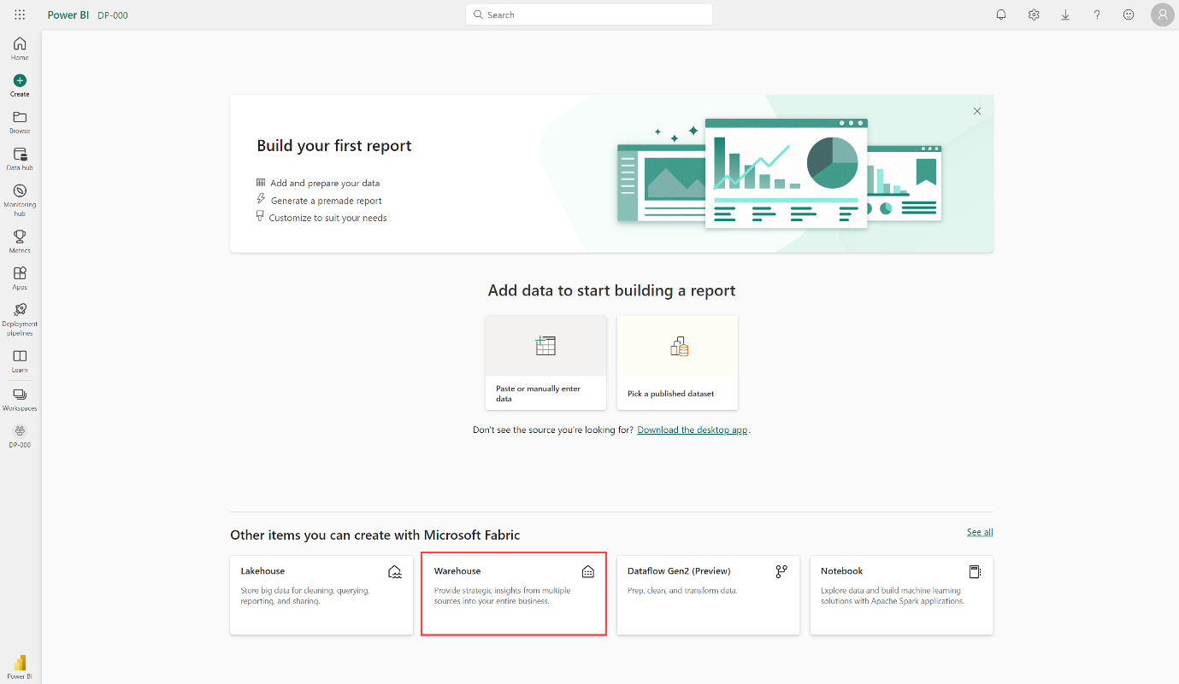

**Once your warehouse is created, you can create tables using T-SQL directly in the Fabric interface.**

**Ingest data into your data warehouse**

**There are a few ways to ingest data into a Fabric data warehouse, including *Pipelines*, *Dataflows*, *cross-database querying*, and the *COPY INTO* command. After ingestion, the data becomes available for analysis by multiple business groups, who can use features such as cross-database querying and sharing to access it.**

**Create tables**

**To create a table in the data warehouse, you can use SQL Server Management Studio (SSMS) or another SQL client to connect to the data warehouse and run a CREATE TABLE statement. You can also create tables directly in the Fabric UI.**

**You can copy data from an external location into a table in the data warehouse using the COPY INTO syntax. For example:**

**SQLCopy**

**COPY INTO dbo.Region**

**FROM 'https://mystorageaccountxxx.blob.core.windows.net/private/Region.csv' WITH (**

**FILE_TYPE = 'CSV'**

**,CREDENTIAL = (**

**IDENTITY = 'Shared Access Signature'**

**, SECRET = 'xxx'**

**)**

**,FIRSTROW = 2**

**)**

**GO**

**This SQL query loads data from a CSV file stored in Azure Blob Storage into a table called "Region" in the Fabric data warehouse.**

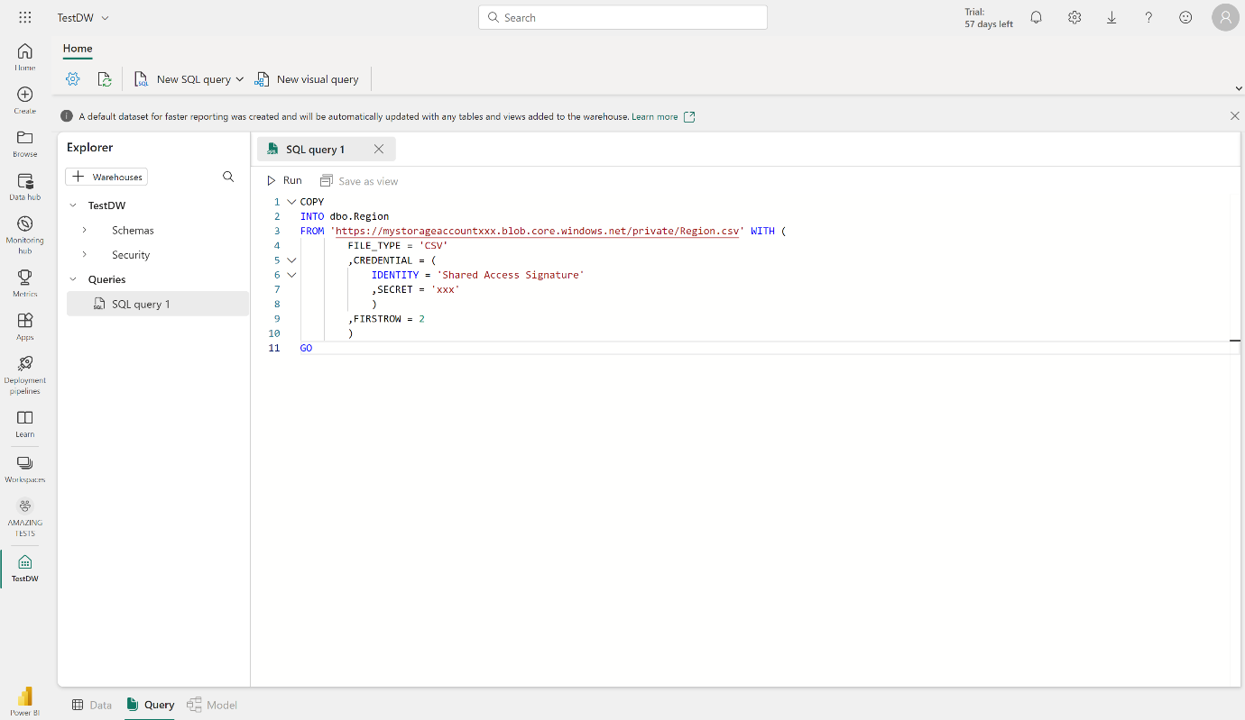

**Clone tables**

**You can create zero-copy table clones with minimal storage costs in a data warehouse. These clones are essentially replicas of tables created by copying the metadata while still referencing the same data files in OneLake. This means that the underlying data stored as parquet files is not duplicated, which helps in saving storage costs.**

[**Table clones**](https://learn.microsoft.com/en-us/fabric/data-warehouse/clone-table)**are particularly useful in several scenarios.**

* **Development and testing: Clones allow developers and testers to create copies of tables in lower environments, facilitating development, debugging, testing, and validation processes.**
* **Data recovery: In the event of a failed release or data corruption, table clones can retain the previous state of data, enabling data recovery.**
* **Historical reporting: They help create historical reports that reflect the state of data at specific points in time and preserve data at specific business milestones.**

**You can create a table clone using the**[**CREATE TABLE AS CLONE OF**](https://learn.microsoft.com/en-us/sql/t-sql/statements/create-table-as-clone-of-transact-sql)**T-SQL command.**

**To learn more about table clones, see**[**Tutorial: Clone a table using T-SQL in Microsoft Fabric**](https://learn.microsoft.com/en-us/fabric/data-warehouse/tutorial-clone-table)**.**

**Table considerations**

**After creating tables in a data warehouse, it's important to consider the process of loading data into those tables. A common approach is to use *staging tables*. In Fabric, you can use T-SQL commands to load data from files into staging tables in the data warehouse.**

**Staging tables are temporary tables that can be used to perform data cleansing, data transformations, and data validation. You can also use staging tables to load data from multiple sources into a single destination table.**

**Usually, data loading is performed as a periodic batch process in which inserts and updates to the data warehouse are coordinated to occur at a regular interval (for example, daily, weekly, or monthly).**

**Generally, you should implement a data warehouse load process that performs tasks in the following order:**

1. **Ingest the new data to be loaded into a data lake, applying pre-load cleansing or transformations as required.**
2. **Load the data from files into staging tables in the relational data warehouse.**
3. **Load the dimension tables from the dimension data in the staging tables, updating existing rows or inserting new rows and generating surrogate key values as necessary.**
4. **Load the fact tables from the fact data in the staging tables, looking up the appropriate surrogate keys for related dimensions.**
5. **Perform post-load optimization by updating indexes and table distribution statistics.**

**If you have tables in the lakehouse, and you want to be able to query it in your warehouse - but not make changes - with a Fabric data warehouse, you don't have to copy data from the lakehouse to the data warehouse. You can query data in the lakehouse directly from the data warehouse using cross-database querying.**

**Important**

**Working with tables in the Fabric data warehouse currently has some limitations. See**[**Tables in data warehousing in Microsoft Fabric**](https://learn.microsoft.com/en-us/fabric/data-warehouse/tables)**for more information.**

**Next unit: Query and transform data**

**Query and transform data**

**Completed100 XP**

* **6 minutes**

**Now that you know how to implement a data warehouse in Fabric, let's prepare the data for analytics.**

**There are two ways to query data from your data warehouse. The *Visual query editor* provides a no-code, drag-and-drop experience to create your queries. If you're comfortable with T-SQL, you may prefer to use the *SQL query editor* to write your queries. In both cases, you can create tables, views, and stored procedures to query data in the data warehouse and Lakehouse.**

**There's also a SQL analytics endpoint, where you can connect from any tool.**

**Query data using the SQL query editor**

**The SQL query editor provides a query experience that includes intellisense, code completion, syntax highlighting, client-side parsing, and validation. If you've written T-SQL in SQL Server Management Studio (SSMS) or Azure Data Studio (ADS), you'll find it familiar.**

**To create a new query, use the New SQL query button in the menu. You can author and run your T-SQL queries here. In the example below we're creating a new view for analysts to use for reporting in Power BI.**

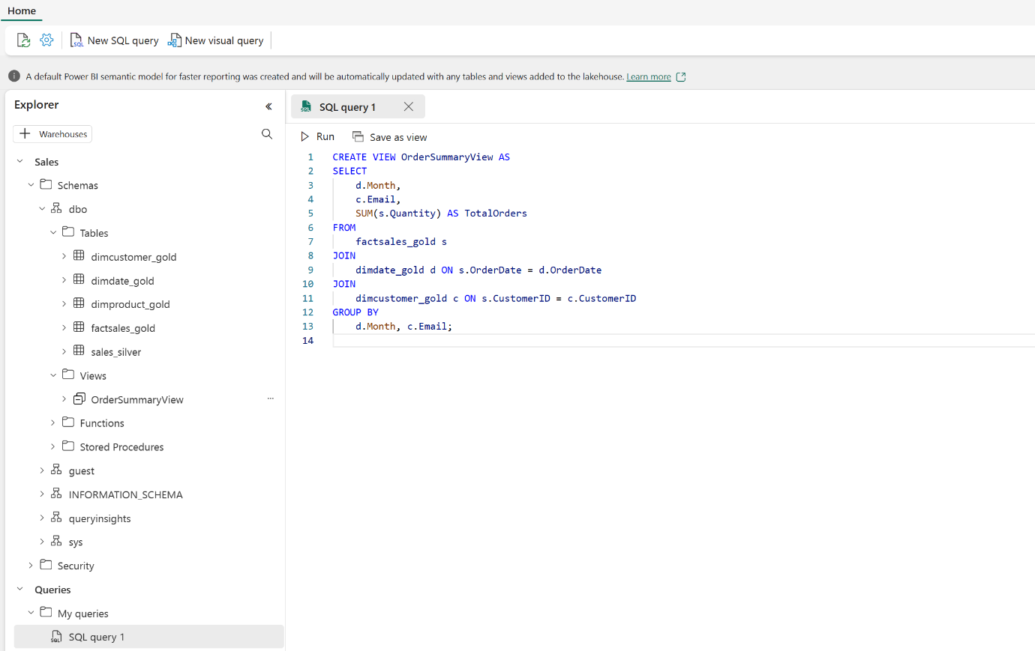

**Query data using the Visual query editor**

**The *Visual query editor* provides an experience similar to the**[**Power Query online diagram view**](https://learn.microsoft.com/en-us/power-query/diagram-view)**. Use the New visual query button to create a new query.**

**Drag a table from your data warehouse onto the canvas to get started. You can then use the Transform menu at the top of the screen to add columns, filters, and other transformations to your query. You can use the (+) button on the visual itself to perform similar transformations.**

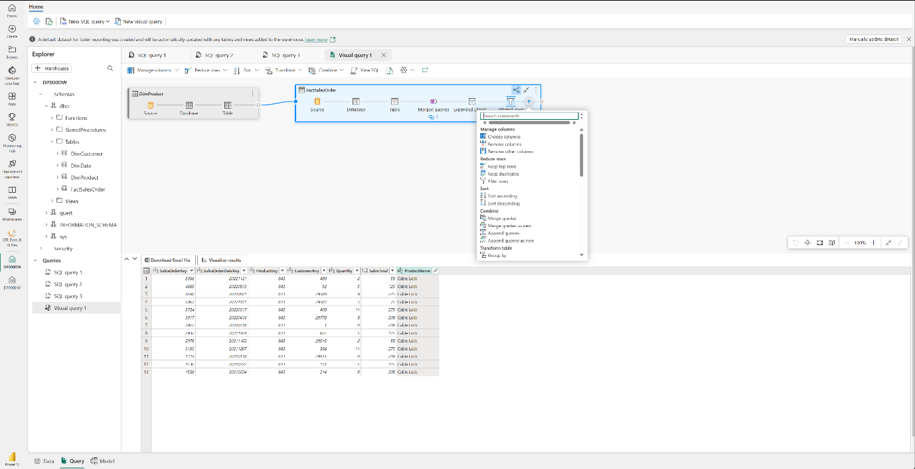

**Next unit: Prepare data for analysis and reporting**

**Prepare data for analysis and reporting**

**Completed100 XP**

* **6 minutes**

**A *semantic model* defines the *relationships* between the different tables in the semantic model, the rules for how data is aggregated and summarized, and the calculations or *measures* that are used to derive insights from the data. These relationships and measures are included in the semantic model, which is then used to create reports in Power BI.**

**You can easily switch between the Data, Query, and Model view Fabric using the menu in the bottom left corner of the screen. The Data view shows the tables in the semantic model, the Query view shows the SQL queries that are used to create the semantic model, and the Model view shows the semantic model.**

**Tip**

**See [Analyze data in a relational data warehouse](https://learn.microsoft.com/en-us/training/modules/design-multidimensional-schema-to-optimize-analytical-workloads/) to learn more about data models and data warehouse schema.**

**Build relationships**

***Relationships* allow you to connect tables in the semantic model. Create relationships between tables in your data warehouse using a click-and-drag interface in Fabric in the Model view.**

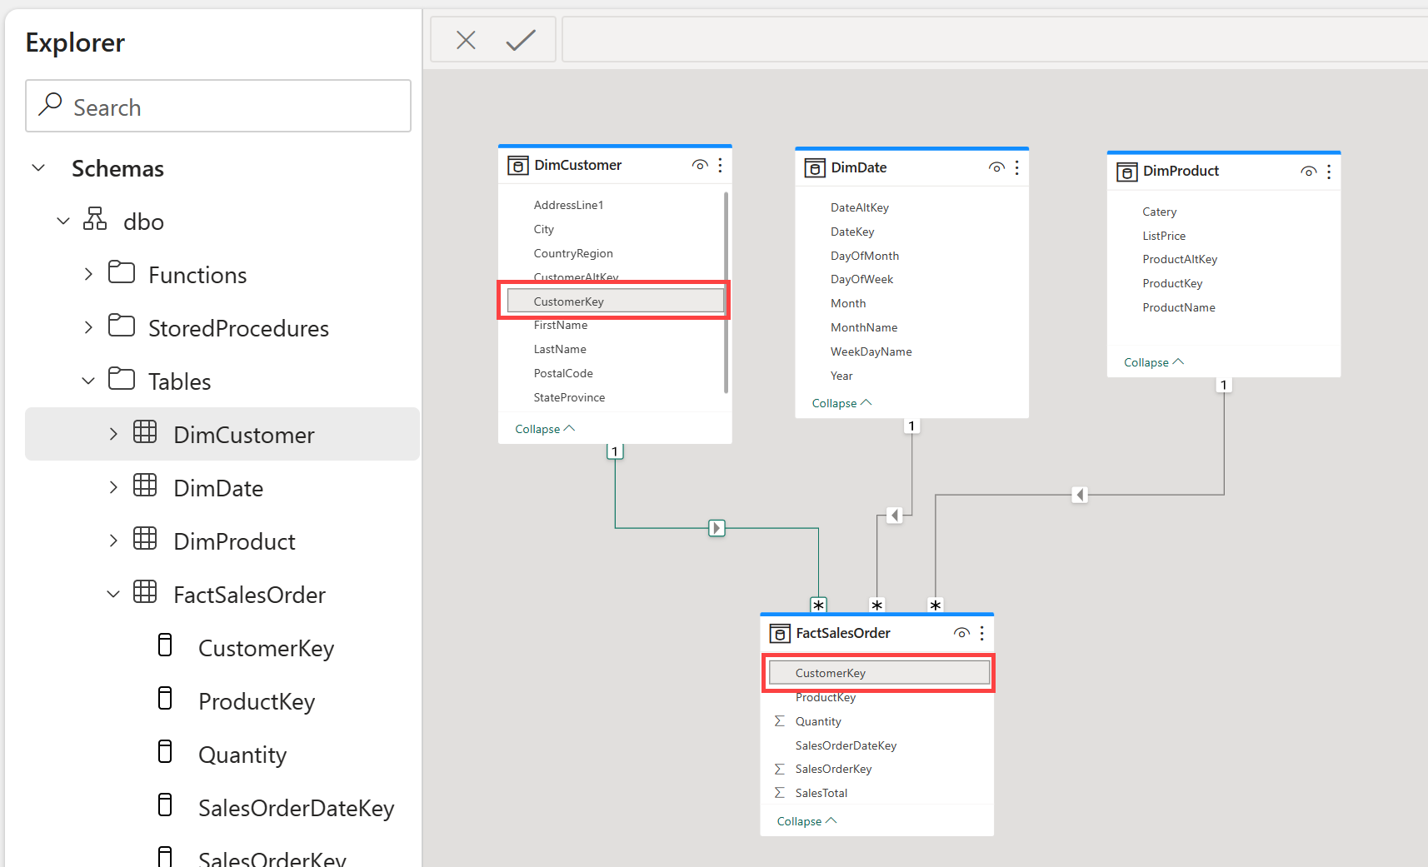

**Tip**

**See**[**Create and manage relationships**](https://learn.microsoft.com/en-us/power-bi/transform-model/desktop-create-and-manage-relationships)**for detailed information on creating relationships.**

**Create measures**

***Measures* are the metrics that you want to analyze in your data warehouse. You can create measures in Fabric by using the New measure button in the Model view.**

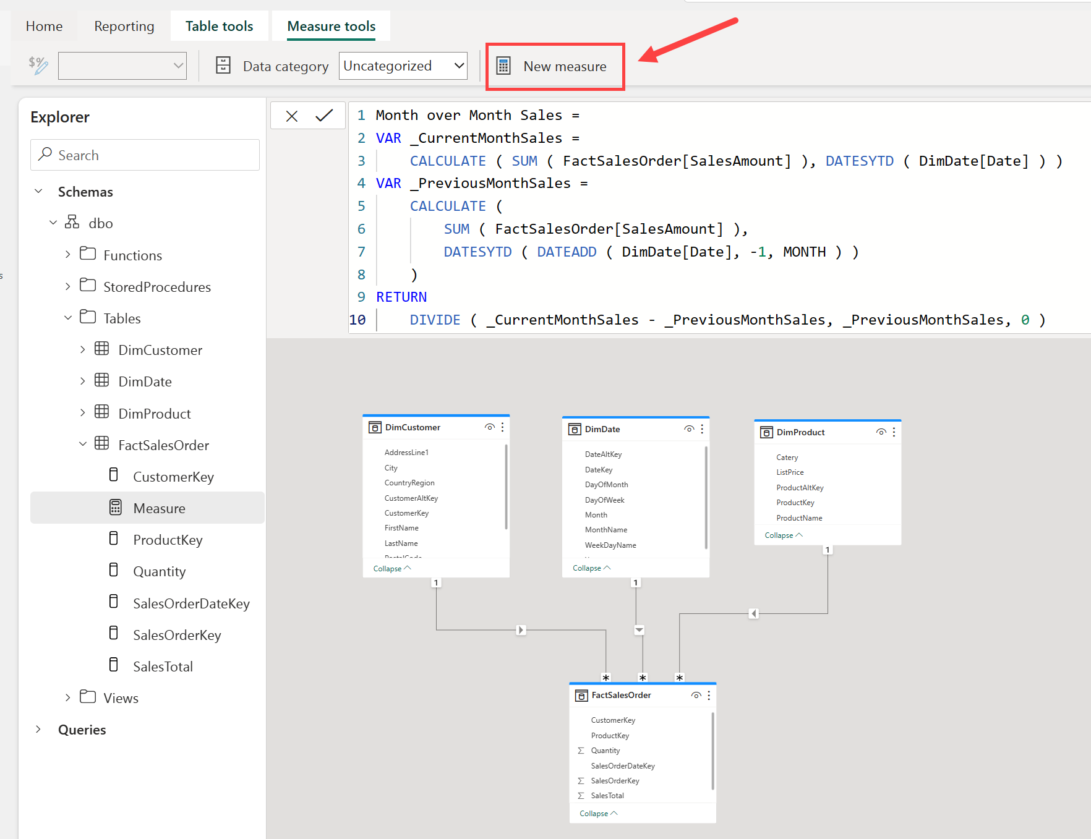

**Measures are calculated fields that are based on the data in the tables in your data warehouse using the Data Analysis Expressions (DAX) formula language.**

**Note**

**Fabric offers many tools to create data transformations. The creation of measures using DAX is one of many ways to create data transformations. To learn more about DAX, see**[**Use DAX in Power BI**](https://learn.microsoft.com/en-us/training/paths/dax-power-bi/)**.**

**Hide fields**

**Building out the semantic model is a critical component to preparing your data for use in downstream reporting. To simplify things for your report builders, you can hide elements from view, either a table or a column. Right-click on the table or column and select Hide. Hiding fields removes the table or column from the model view, but it will still be available for use in the semantic model.**

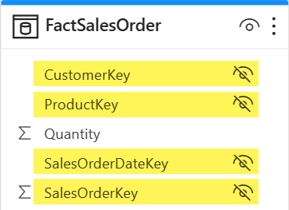

**Understand semantic models**

**Every time a data warehouse is created, Fabric creates a *semantic model* for analysts and/or business users to connect to for reporting.**

**Semantic model has metrics that are used to create reports. Simply put, analysts use the semantic model you created in your warehouse, which is stored in a semantic model. If you're familiar with Power BI, working with semantic models created by the data warehouse experience will be straightforward.**

**Semantic models are automatically kept in sync with the data warehouse, so you don't have to worry about maintaining them. You can also create custom semantic models to meet your specific needs.**

**Understand the default semantic model**

**There's also a *default semantic model* automatically created for you in Fabric. It inherits business logic from the parent lakehouse or warehouse, which initiates the downstream analytics experience for business intelligence and analysis. This semantic model is managed, optimized, and kept in sync for you.**

**New tables in the Lakehouse are automatically added to the default semantic model. Users can also manually select tables or views from the warehouse they want included in the model for more flexibility. Objects that are in the default semantic model are created as a layout in the model view.**

**Note**

**Default semantic models follow the current limitations for semantic models in Power BI. See**[**Default Power BI semantic models**](https://learn.microsoft.com/en-us/fabric/data-warehouse/limitations)**for more information.**

**Visualize data**

**Fabric enables you to *visualize* the results of a single query or your entire data warehouse, without leaving the data warehouse experience. Exploring data while you work to ensure you have all the necessary data and transformations for your analysis is particularly useful.**

**Use the New report button to create a new Power BI report from the contents of your entire data warehouse. Using the New report button opens the Power BI service experience where you can build and save your report for use by the business.**

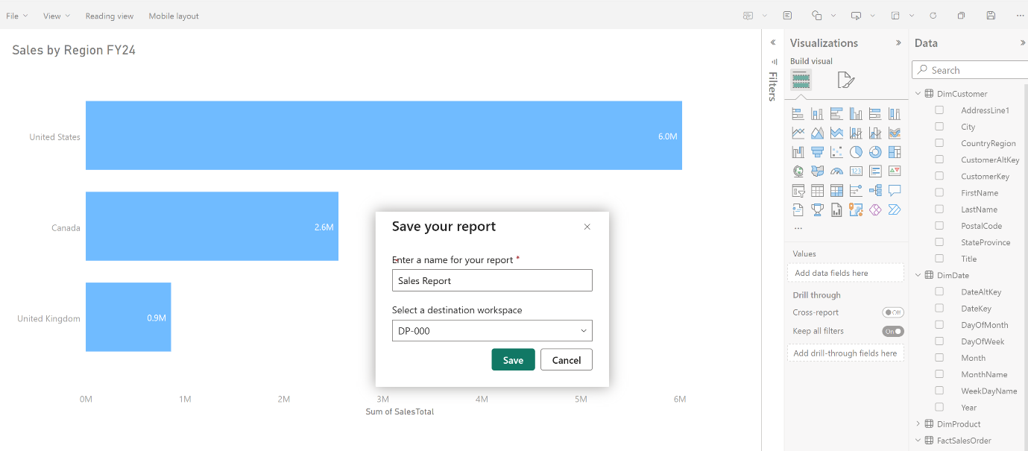

**Next unit: Secure and monitor your data warehouse**

**Secure and monitor your data warehouse**

**Completed100 XP**

* **4 minutes**

**Security and monitoring are critical aspects of managing your data warehouse.**

**Security**

**Data warehouse security is important to protect your data from unauthorized access. Fabric provides a number of security features to help you secure your data warehouse. These include:**

* **Role-based access control (RBAC) to control access to the warehouse and its data.**
* **SSL encryption to secure the communication between the warehouse and the client applications.**
* **Azure Storage Service Encryption to protect the data in transit and at rest.**
* **Azure Monitor and Azure Log Analytics to monitor the warehouse activity and audit the access to the data.**
* **Multifactor authentication (MFA) to add an extra layer of security to user accounts.**
* **Microsoft Entra ID integration to manage the user identities and access to the warehouse.**

**Workspace permissions**

**Data in Fabric is organized into workspaces, which are used to control access and manage the lifecycle of data and services. Appropriate workspace roles are the first line of defense in securing your data warehouse.**

**In addition to workspace roles, you can grant *item permissions* and access through SQL.**

**Tip**

**See**[**Workspaces in Power BI**](https://learn.microsoft.com/en-us/power-bi/collaborate-share/service-new-workspaces#roles-and-licenses)**for more information on workspace roles.**

**Item permissions**

**In contrast to workspace roles, which apply to all items within a workspace, you can use *item permissions* to grant access to individual warehouses. This enables you to share a single data warehouse for downstream consumption.**

**You can grant permissions to users via T-SQL or in the Fabric portal. Grant the following permissions to users who need to access your data warehouse:**

* **Read: Allows the user to CONNECT using the SQL connection string.**
* **ReadData: Allows the user to read data from any table/view within the warehouse.**
* **ReadAll: Allows user to read data the raw parquet files in OneLake that can be consumed by Spark.**

**A user connection to the SQL analytics endpoint will fail without Read permission at a minimum.**

**Monitoring**

**Monitoring activities in your data warehouse is crucial to ensure optimal performance, efficient resource utilization, and security. It helps you identify issues, detect anomalies, and take action to keep the data warehouse running smoothly and securely.**

**You can use *dynamic management views* (DMVs) to monitor connection, session, and request status to see live SQL query lifecycle insights. With DMVs, you can get details like the number of active queries and identify which queries are running for an extended period and require termination.**

**There are currently three DMVs available to use in Fabric:**

* **sys.dm_exec_connections: Returns information about each connection established between the warehouse and the engine.**
* **sys.dm_exec_sessions: Returns information about each session authenticated between the item and engine.**
* **sys.dm_exec_requests: Returns information about each active request in a session.**

**Query monitoring**

**Use 'sys.dm_exec_requests' to identify long-running queries that may be impacting the overall performance of the database, and take appropriate action to optimize or terminate those queries.**

**Start by identifying the queries that have been running for a long time. Use the following query to identify which queries have been running the longest, in descending order:**

**SQLCopy**

**SELECT request_id, session_id, start_time, total_elapsed_time**

**FROM sys.dm_exec_requests**

**WHERE status = 'running'**

**ORDER BY total_elapsed_time DESC;**

**You can continue investigating to understand which user ran the session with the long-running query, by running:**

**SQLCopy**

**SELECT login_name**

**FROM sys.dm_exec_sessions**

**WHERE 'session_id' = 'SESSION_ID WITH LONG-RUNNING QUERY';**

**Finally, you can use the KILL command to terminate the session with the long-running query:**

**SQLCopy**

**KILL 'SESSION_ID WITH LONG-RUNNING QUERY';**

**Important**

**You must be a workspace Admin to run the KILL command. Workspace Admins can execute all three DMVs. Member, Contributor, and Viewer roles can see their own results within the warehouse, but cannot see other users' results.**

**Next unit: Exercise - Analyze data in a data warehouse**

[**Previous**](https://learn.microsoft.com/en-us/training/modules/get-started-data-warehouse/5-model-data/)

**Exercise - Analyze data in a data warehouse**

**Completed100 XP**

* **30 minutes**

**Now it's your turn to create a data warehouse in Fabric and analyze your data.**

**Note**

**You need a Microsoft Fabric trial license with the Fabric preview enabled in your tenant. See**[**Getting started with Fabric**](https://learn.microsoft.com/en-us/fabric/get-started/fabric-trial)**to enable your Fabric trial license.**

**Launch the exercise and follow the instructions.**

**[](https://go.microsoft.com/fwlink/?linkid=2259608)**

**Next unit: Knowledge check**

[**Previous**](https://learn.microsoft.com/en-us/training/modules/get-started-data-warehouse/6-security-monitor/)

**Knowledge check**

**Completed200 XP**

* **Module assessment**
* **3 minutes**

**Great job! You passed the module assessment.**

**Dismiss alert**

**Check your knowledge**

**Top of Form**

**1.**

**Which type of table should an insurance company use to store supplier attribute details for aggregating claims?**

**Fact table.**

**Dimension table.**

**Correct. A dimension table stores attributes used to group numeric measures.**

**Staging table.**

**2.**

**What is a semantic model in the data warehouse experience?**

**A semantic model is a business-oriented data model that provides a consistent and reusable representation of data across the organization.**

**Correct. A semantic model in the data warehouse experience provides a way to organize and structure data in a way that is meaningful to business users, enabling them to easily access and analyze data.**

**A semantic model is a physical data model that describes the structure of the data stored in the data warehouse.**

**A semantic model is a machine learning model that is used to make predictions based on data in the data warehouse.**

**3.**

**What is the purpose of item permissions in a workspace?**

**To grant access to all items within a workspace.**

**To grant access to specific columns within a table.**

**To grant access to individual warehouses for downstream consumption.**

**Correct. By granting access to a single data warehouse using item permissions, you can enable downstream consumption of data.**

**Bottom of Form**

**Next unit: Summary**

[**Previous**](https://learn.microsoft.com/en-us/training/modules/get-started-data-warehouse/7-exercise/)

**Summary**

**Completed100 XP**

* **1 minute**

**In this module, you learned about data warehouses and dimensional modeling, created a data warehouse, loaded, queried, and visualized data, and described semantic models and how they're used for downstream reporting.**

[**https://microsoftlearning.github.io/mslearn-fabric/Instructions/Labs/02-analyze-spark.html**](https://microsoftlearning.github.io/mslearn-fabric/Instructions/Labs/02-analyze-spark.html)

**Load data into a Microsoft Fabric data warehouse**

**Load data into a Microsoft Fabric data warehouse**

* **1 hr 10 min**
* **Module**
* **8 Units**

**Feedback**

**Beginner**

**Data Analyst**

**Data Engineer**

**Microsoft Fabric**

**Data warehouse in Microsoft Fabric is a comprehensive platform for data and analytics, featuring advanced query processing and full transactional T-SQL capabilities for easy data management and analysis.**

**Learning objectives**

**In this module, you'll:**

* **Learn different strategies to load data into a data warehouse in Microsoft Fabric.**
* **Learn how to build a data pipeline to load a warehouse in Microsoft Fabric.**
* **Learn how to load data in a warehouse using T-SQL.**
* **Learn how to load and transform data with dataflow (Gen 2).**

[**Start**](https://learn.microsoft.com/en-us/training/modules/load-data-into-microsoft-fabric-data-warehouse/1-introduction/)**Add**

**Prerequisites**

**Before starting this module, you should be familiar with the basic principles of a data warehouse.**

**This module is part of these learning paths**

* [**Implement a data warehouse with Microsoft Fabric**](https://learn.microsoft.com/training/paths/work-with-data-warehouses-using-microsoft-fabric/)

**Module assessment**

**Assess your understanding of this module. Sign in and answer all questions correctly to earn a pass designation on your profile.**

[**Take the module assessment**](https://learn.microsoft.com/training/modules/load-data-into-microsoft-fabric-data-warehouse/7-knowledge-check/)

* [**Introduction**](https://learn.microsoft.com/en-us/training/modules/load-data-into-microsoft-fabric-data-warehouse/1-introduction)**4 min**
* [**Explore data load strategies**](https://learn.microsoft.com/en-us/training/modules/load-data-into-microsoft-fabric-data-warehouse/2-explore-data-load-strategies)**6 min**
* [**Use data pipelines to load a warehouse**](https://learn.microsoft.com/en-us/training/modules/load-data-into-microsoft-fabric-data-warehouse/3-load-data-using-data-pipeline)**5 min**
* [**Load data using T-SQL**](https://learn.microsoft.com/en-us/training/modules/load-data-into-microsoft-fabric-data-warehouse/4-load-data-using-tsql)**8 min**
* [**Load and transform data with Dataflow Gen2**](https://learn.microsoft.com/en-us/training/modules/load-data-into-microsoft-fabric-data-warehouse/5-load-data-using-dataflow)**7 min**
* [**Exercise: Load data into a warehouse in Microsoft Fabric**](https://learn.microsoft.com/en-us/training/modules/load-data-into-microsoft-fabric-data-warehouse/6-exercise-load-data-into-warehouse)**30 min**
* [**Knowledge check**](https://learn.microsoft.com/en-us/training/modules/load-data-into-microsoft-fabric-data-warehouse/7-knowledge-check)**8 min**
* [**Summary**](https://learn.microsoft.com/en-us/training/modules/load-data-into-microsoft-fabric-data-warehouse/8-summary)**2 min**

**Introduction**

**Completed100 XP**

* **4 minutes**

[**Microsoft Fabric Data Warehouse**](https://learn.microsoft.com/en-us/fabric/data-warehouse/)**is a complete platform for data, analytics, and AI (Artificial Intelligence). It refers to the process of storing, organizing, and managing large volumes of structured and semi-structured data.**

**Data warehouse in Microsoft Fabric is powered up with Synapse Analytics by offering a rich set of features that make it easier to manage and analyze data. It includes advanced query processing capabilities, and supports the full transactional T-SQL capabilities like an enterprise data warehouse.**

**Unlike a dedicated SQL pool in Synapse Analytics, a warehouse in Microsoft Fabric is centered around a single data lake. The data in the Microsoft Fabric warehouse is stored in the Parquet file format. This setup allows users to focus on tasks such as data preparation, analysis, and reporting. It takes advantage of the SQL engine’s extensive capabilities, where a unique copy of their data is stored in**[**Microsoft OneLake**](https://learn.microsoft.com/en-us/fabric/onelake/onelake-overview)**.**

**[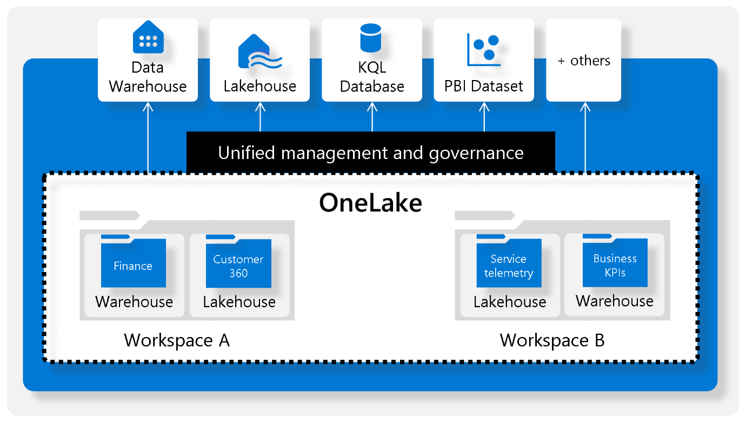](https://learn.microsoft.com/en-us/training/wwl-data-ai/load-data-into-microsoft-fabric-data-warehouse/media/1-access-onelake-data-other-tools.png#lightbox)**

**Understand the ETL (Extract, Transform, and Load) process**

**ETL provides the foundation for data analytics and data warehouse workstreams. Let's review some aspects of data manipulation in an ETL process.**

**Expand table**

|  | **Description** |
| --- | --- |
| **Data extraction** | **It involves connecting to the source system and collecting necessary data for analytical processing.** |
| **Data transformation** | **It involves a series of steps performed on the extracted data to convert it into a standard format. Combining data from different tables, cleaning data, deduplicating data, and performing data validations.** |
| **Data loading** | **The extracted and transformed data are loaded into the fact and dimension tables. For an incremental load, this involves periodically applying ongoing changes as per requirement. This process often involves reformatting the data to ensure its quality and compatibility with the data warehouse schema.** |
| **Post-load optimizations** | **Once the data is loaded, certain optimizations can be performed to enhance the performance of the data warehouse.** |

**All these steps in the ETL process can run in parallel depending on the scenario. As soon as some data is ready, it's loaded without waiting for the previous steps to be completed.**

**In the next units, we'll explore various ways of loading data in a warehouse, and how they can facilitate the tasks of building a data warehouse workload.**

**Next unit: Explore data load strategies**

**Explore data load strategies**

**Completed100 XP**

* **6 minutes**

**In Microsoft Fabric, there are many ways you can choose to load data in a warehouse. This step is fundamental as it ensures that high-quality, transformed, or processed data is integrated into a single repository.**

**Also, the efficiency of data loading directly impacts the timeliness and accuracy of analytics, making it vital for real-time decision-making processes. Investing time and resources in designing and implementing a robust data loading strategy is essential for the success of the data warehouse project.**

**Understand data ingestion and data load operations**

**While both processes are part of the ETL (Extract, Transform, Load) pipeline in a data warehouse scenario, they usually serve different purposes. Data ingestion/extract is about moving raw data from various sources into a central repository. On the other hand, data loading involves taking the transformed or processed data and loading it into the final storage destination for analysis and reporting.**

**Fabric data warehouses and lakehouses automatically store their data in OneLake using the Delta Parquet format.**

**Stage your data**

**You might have to build and work with auxiliary objects involved in a load operation, such as tables, stored procedures, and functions. These auxiliary objects are commonly known as staging. Staging objects act as temporary storage and transformation areas. They can either share resources with a data warehouse or reside in their own storage area.**

**Staging serves as an abstraction layer, simplifying and facilitating the load operation to the final tables in the data warehouse.**

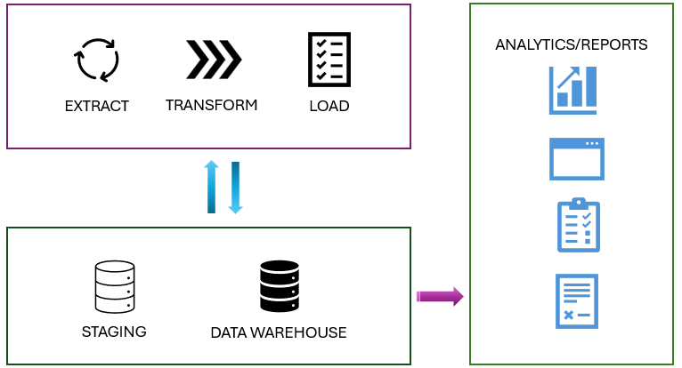

**Also, staging area provides a buffer that can help to minimize the impact of the load operation on the performance of the data warehouse. This is important in environments where the data warehouse needs to remain operational and responsive during the data loading process.**

**Review type of data loads**

**There are two types of data loads to consider when loading a data warehouse.**

**Expand table**

| **Load Type** | **Description** | **Operation** | **Duration** | **Complexity** | **Best used** |
| --- | --- | --- | --- | --- | --- |
| **Full (initial) load** | **The process of populating the data warehouse for the first time.** | **All the tables are truncated and reloaded, and the old data is lost** | **It may take longer to complete due to the amount of data being handled** | **Easier to implement as there's no history preserved** | **This method is typically used when setting up a new data warehouse, or when a complete refresh of the data is required** |
| **Incremental load** | **The process of updating the data warehouse with the changes since the last update** | **The history is preserved, and tables are updated with new information** | **Takes less time than the initial load** | **Implementation is more complex than the initial load** | **This method is commonly used for regular updates to the data warehouse, such as daily or hourly updates. It requires mechanisms to track changes in the source data since the last load.** |

**An ETL (Extract, Transform, Load) process for a data warehouse doesn't always need both the full load and the incremental load. In some cases, a combination of both methods might be used. The choice between a full load and an incremental load depends on many factors such as the amount of data, the characteristics of the data, and the requirements of the data warehouse.**

**To learn more about how to perform an incremental load, see**[**Incremental load**](https://learn.microsoft.com/en-us/fabric/data-factory/tutorial-incremental-copy-data-warehouse-lakehouse)**.**

**Understand business key and surrogate key**

**In a data warehouse, both surrogate keys and business keys are essential for effective data warehousing and data integration, but they serve different purposes.**

* **Surrogate key: A surrogate key is a system-generated identifier that is used to uniquely identify a record in a table within the data warehouse. It has no business meaning and is typically an integer or a unique identifier. Surrogate keys are used to maintain consistency and accuracy in the data warehouse, especially when integrating data from multiple sources. They help to avoid issues that can arise from changes in the source systems, such as reusing or changing business keys.**
* **Business Key: A business key, also known as a natural key, is an identifier that comes from the source system and has business meaning. It's used to uniquely identify a record in the source system. Examples of business keys include product codes, customer IDs, and employee numbers. Business keys are important for maintaining traceability between the data warehouse and the source systems. They help to ensure that data in the warehouse can be accurately matched to the corresponding records in the source systems.**

**Load a dimension table**

**Think of a dimension table as the *"who, what, where, when, why”* of your data warehouse. It’s like the descriptive backdrop that gives context to the raw numbers found in the fact tables.**

**For example, if you’re running an online store, your fact table might contain the raw sales data - how many units of each product were sold. But without a dimension table, you wouldn’t know who bought those products, when they were bought, or where the buyer is located.**

**Slowly changing dimensions (SCD)**

**Slowly Changing Dimensions evolve over time, but at a slow pace and unpredictably. Take, for instance, a customer's address in a retail business. When a customer relocates, their address changes. If you overwrite the old address with the new one, you lose the historical data. However, if you need to analyze historical sales data, it's crucial to know where the customer lived at the time of each sale. This is where SCDs become essential.**

**There are several types of slowly changing dimensions in a data warehouse, with type 1 and type 2 being the most frequently used.**

* **Type 0 SCD: The dimension attributes never change.**
* **Type 1 SCD: Overwrites existing data, doesn't keep history.**
* **Type 2 SCD: Adds new records for changes, keeps full history for a given natural key.**
* **Type 3 SCD: History is added as a new column.**
* **Type 4 SCD: A new dimension is added.**
* **Type 5 SCD: When certain attributes of a large dimension change over time, but using type 2 isn't feasible due to the dimension’s large size.**
* **Type 6 SCD: Combination of type 2 and type 3.**

**In type 2 SCD, when a new version of the same element is brought to the data warehouse, the old version is considered expired and the new one becomes active.**

**[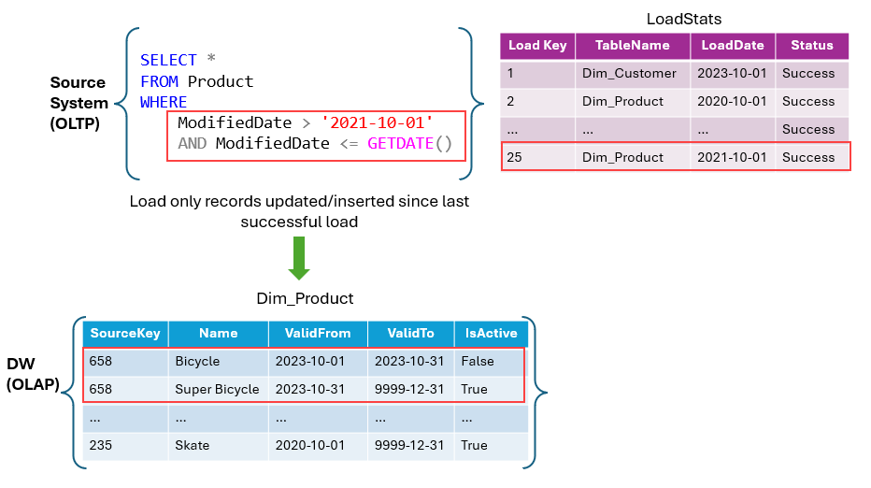](https://learn.microsoft.com/en-us/training/wwl-data-ai/load-data-into-microsoft-fabric-data-warehouse/media/2-slowly-changing-dimension.png#lightbox)**

**The following example shows how to handle the business key in a type 2 SCD for the *Dim_Products* table using T-SQL.**

**SQLCopy**

**IF EXISTS (SELECT 1 FROM Dim_Products WHERE SourceKey = @ProductID AND IsActive = 'True')**

**BEGIN**

**-- Existing product record**

**UPDATE Dim_Products**

**SET ValidTo = GETDATE(), IsActive = 'False'**

**WHERE SourceKey = @ProductID**

**AND IsActive = 'True';**

**END**

**ELSE**

**BEGIN**

**-- New product record**

**INSERT INTO Dim_Products (SourceKey, ProductName, StartDate, EndDate, IsActive)**

**VALUES (@ProductID, @ProductName, GETDATE(), '9999-12-31', 'True');**

**END**

**The mechanism for detecting changes in source systems is crucial for determining when records are inserted, updated, or deleted.**[**Change Data Capture (CDC)**](https://learn.microsoft.com/en-us/sql/relational-databases/track-changes/about-change-data-capture-sql-server)**,**[**change tracking**](https://learn.microsoft.com/en-us/sql/relational-databases/track-changes/about-change-tracking-sql-server)**, and**[**triggers**](https://learn.microsoft.com/en-us/sql/relational-databases/triggers/dml-triggers)**are all features available for managing data tracking in source systems such as SQL Server.**

**Load a fact table**

**Typically, a standard data warehouse load operation involves loading fact tables after dimension tables. This ensures that the dimensions, which the facts reference, are already present in the data warehouse.**

**The staged fact data usually includes business keys for the related dimensions, so your loading logic must look up the corresponding surrogate keys. When dealing with slowly changing dimensions in the data warehouse, it's crucial to identify the appropriate version of the dimension record to ensure the correct surrogate key is used. This matches the event recorded in the fact table with the state of the dimension at the time the fact occurred.**

**In many cases, you can retrieve the latest "current" version of the dimension. However, sometimes you might need to find the correct dimension record based on DateTime columns that indicate the period of validity for each version of the dimension.**

**The following example assumes that dimension records have incrementing surrogate keys and that the most recently added version of a specific dimension instance, which will have the highest key value, might be used.**

**SQLCopy**

**-- Lookup keys in dimension tables**

**INSERT INTO dbo.FactSales**

**SELECT (SELECT MAX(DateKey)**

**FROM dbo.DimDate**

**WHERE FullDateAlternateKey = stg.OrderDate) AS OrderDateKey,**

**(SELECT MAX(CustomerKey)**

**FROM dbo.DimCustomer**

**WHERE CustomerAlternateKey = stg.CustNo) AS CustomerKey,**

**(SELECT MAX(ProductKey)**

**FROM dbo.DimProduct**

**WHERE ProductAlternateKey = stg.ProductID) AS ProductKey,**

**(SELECT MAX(StoreKey)**

**FROM dbo.DimStore**

**WHERE StoreAlternateKey = stg.StoreID) AS StoreKey,**

**OrderNumber,**

**OrderLineItem,**

**OrderQuantity,**

**UnitPrice,**

**Discount,**

**Tax,**

**SalesAmount**

**FROM dbo.StageSales AS stg**

**Next unit: Use data pipelines to load a warehouse**

**Use data pipelines to load a warehouse**

**Completed100 XP**

* **5 minutes**

**Microsoft Fabric’s Warehouse provides integrated data ingestion tools, enabling users to load and ingest data into warehouses on a large scale through either coding or noncoding experiences.**

**Data pipeline is the cloud-based service for data integration, which enables the creation of workflows for data movement and data transformation at scale. You can create and schedule data pipelines that can ingest and load data from disparate data stores. You can build complex ETL, or ELT processes that transform data visually with data flows.**

**Most of the functionality of data pipelines in Microsoft Fabric comes from Azure Data Factory, allowing for seamless integration and utilization of its features within the Microsoft Fabric ecosystem.**

**Note**

**All data in a Warehouse is automatically stored in the Delta Parquet format in OneLake.**

**Create a data pipeline**

**There are a few ways to launch the data pipeline editor.**

* **From the workspace: Select + New, then select Data pipeline. If it's not visible in the list, select More options, then find Data pipeline under the Get data section.**
* **From the warehouse asset - Select Get Data, and then New data pipeline.**

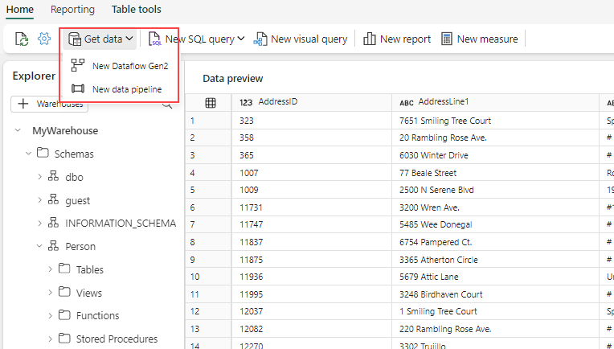

**There are three options available when creating a pipeline.**

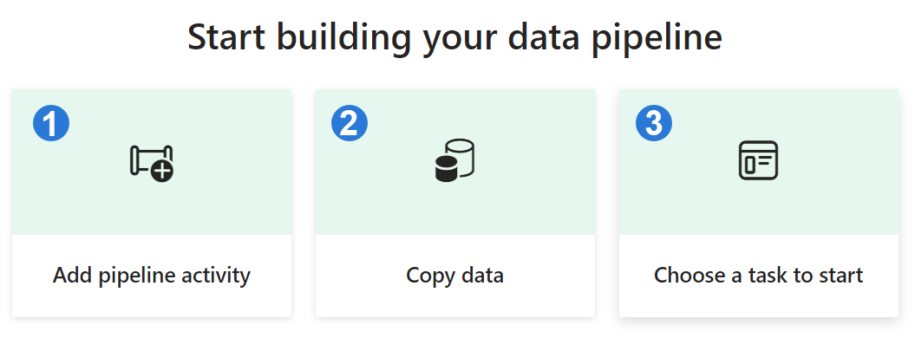

**Expand table**

| **Option** | **Description** |
| --- | --- |
| **1. Add pipeline activity** | **Launches the pipeline editor where you can create your own pipeline.** |
| **2. Copy data** | **Launches an assistant to copy data from various data sources to a data destination. A new pipeline activity is generated at the end with a preconfigured Copy Data task.** |
| **3. Choose a task to start** | **You can choose from a collection of predefined templates to assist you in initiating pipelines based on many scenarios.** |

**Configure the copy data assistant**

**The copy data assistant provides a step-by-step interface that facilitates the configuration of a Copy Data task.**

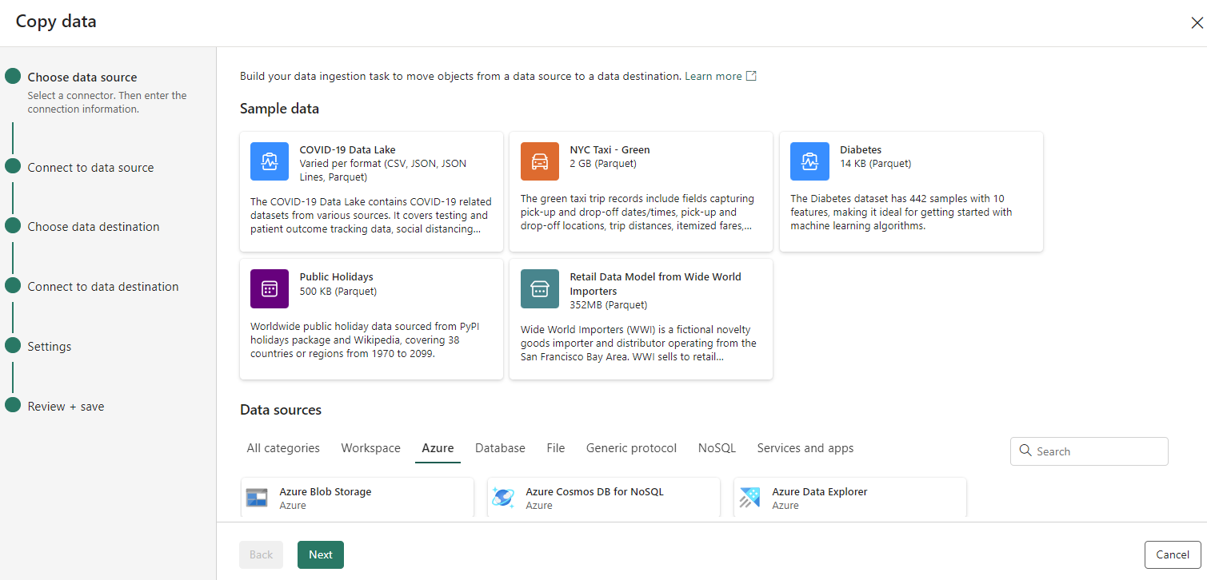

* **Choose data source: Select a connector, and provide the connection information.**
* **Connect to a data source: Select, preview, and choose the data. This can be done from tables or views, or you can customize your selection by providing your own query.**
* **Choose data destination: Select the data store as the destination.**
* **Connect to data destination: Select and map columns from source to destination. You can load to a new or existing table.**
* **Settings: Configure other settings like staging, and default values.**

**After you copy the data, you can use other tasks to further transform and analyze it. You can also use the Copy Data task to publish transformation and analysis results for business intelligence (BI) and application consumption.**

**Schedule a data pipeline**

**You can schedule your data pipeline by selecting Schedule from the data pipeline editor.**

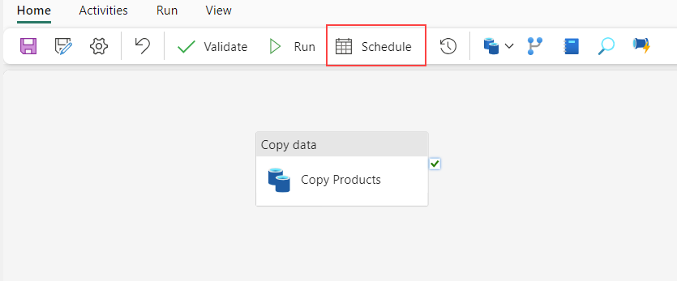

**You can also configure the schedule by selecting Settings in the Home menu in the data pipeline editor.**

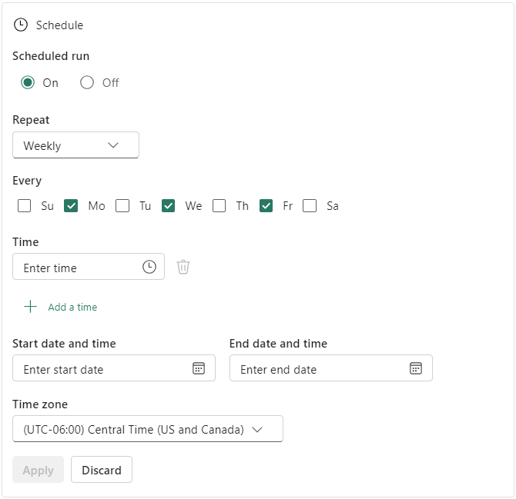

**We recommend data pipelines for a code-free or low-code experience due to the graphical user interface. They're ideal for data workflows that run at a schedule, or that connects to different data sources.**

**To learn more about data pipelines, see**[**Ingest data into your Warehouse using data pipelines**](https://learn.microsoft.com/en-us/fabric/data-warehouse/ingest-data-pipelines)**.**

**Next unit: Load data using T-SQL**

**Load data using T-SQL**

**Completed100 XP**

* **8 minutes**

**SQL developers or citizen developers, who are often well-versed in the SQL engine and adept at using T-SQL, will find the Warehouse in Microsoft Fabric favorable.**

**This is because the Warehouse is powered by the same SQL engine they're familiar with, enabling them to perform complex queries and data manipulations. These operations include filtering, sorting, aggregating, and joining data from different tables. The SQL engine’s wide range of functions and operators further allows for sophisticated data analysis and transformations at the database level.**

**Use COPY statement**

**The**[**COPY statement**](https://learn.microsoft.com/en-us/sql/t-sql/statements/copy-into-transact-sql)**serves as the main method for importing data into the Warehouse. It facilitates efficient data ingestion from an external Azure storage account.**

**It offers flexibility, allowing you to specify the format of the source file, designate a location for storing rows that are rejected during the import process, skip header rows, among other configurable options.**

**The option to store rejected rows separately is useful for data cleaning and quality control. It allows you to easily identify and investigate any issues with the data that weren't successfully imported.**

**To connect to an Azure storage account, you need to use either Shared Access Signature (SAS) or Storage Account Key (SAK).**

**Note**

**The COPY statement currently supports the PARQUET and CSV file formats.**

**Handle error**

**The option to use a different storage account for the *ERRORFILE* location (REJECTED_ROW_LOCATION) allows for better error handling and debugging. It makes it easier to isolate and investigate any issues that occur during the data loading process. *ERRORFILE* only applies to CSV.**

**Load multiple files**

**The ability to specify wildcards and multiple files in the storage location path allows the COPY statement to handle bulk data loading efficiently. This is useful when dealing with large datasets distributed across multiple files.**

**Multiple file locations can only be specified from the same storage account and container via a comma-separated list.**

**SQLCopy**

**COPY my_table**

**FROM 'https://myaccount.blob.core.windows.net/myblobcontainer/folder0/*.csv,**

**https://myaccount.blob.core.windows.net/myblobcontainer/folder1/'**

**WITH (**

**FILE_TYPE = 'CSV',**

**CREDENTIAL=(IDENTITY= 'Shared Access Signature', SECRET='<Your_SAS_Token>')**

**FIELDTERMINATOR = '|'**

**)**

**The following example shows how to load a PARQUET file.**

**SQLCopy**

**COPY INTO test_parquet**

**FROM 'https://myaccount.blob.core.windows.net/myblobcontainer/folder1/*.parquet'**

**WITH (**

**CREDENTIAL=(IDENTITY= 'Shared Access Signature', SECRET='<Your_SAS_Token>')**

**)**

**Ensure that all the files have the same structure (that is, same columns in the same order) and that this structure matches the structure of the target table.**

**Load table from other warehouses and lakehouses**

**You can load data from various data assets in a workspace, such as other warehouses and lakehouses.**

**To reference the data asset, ensure that you use**[**three-part naming**](https://learn.microsoft.com/en-us/sql/t-sql/language-elements/transact-sql-syntax-conventions-transact-sql)**to combine data from tables on these workspace assets. You can then use CREATE TABLE AS SELECT (CTAS) and INSERT...SELECT to load the data into the warehouse.**

**Expand table**

| **SQL Statement** | **Description** |
| --- | --- |
| [**CREATE TABLE AS SELECT**](https://learn.microsoft.com/en-us/sql/t-sql/statements/create-table-as-select-azure-sql-data-warehouse) | **Allows you to create a new table based on the output of a SELECT statement. This operation is often used for creating a copy of a table or for transforming and loading the results of complex queries.** |
| [**INSERT...SELECT**](https://learn.microsoft.com/en-us/sql/t-sql/statements/insert-transact-sql) | **Allows you to insert data from one table into another. It’s useful when you want to copy data from one table to another without creating a new table.** |

**In a scenario where an analyst needs data from both a warehouse and a lakehouse, they can use this feature to combine the data. They can then load this combined data into the warehouse for analysis. This feature is useful when data is distributed across many assets in a workspace.**

**The following query creates a new table in the analysis_warehouse that combines data from the sales_warehouse and the social_lakehouse using the *product_id* as the common key. The new table can then be used for further analysis.**

**SQLCopy**

**CREATE TABLE [analysis_warehouse].[dbo].[combined_data]**

**AS**

**SELECT**

**FROM [sales_warehouse].[dbo].[sales_data] sales**

**INNER JOIN [social_lakehouse].[dbo].[social_data] social**

**ON sales.[product_id] = social.[product_id];**

**All the Warehouses that share the same workspace are integrated into the same logical SQL server. If you use SQL client tools such as**[**SQL Server Management Studio**](https://learn.microsoft.com/en-us/sql/ssms/download-sql-server-management-studio-ssms)**, you can easily perform a cross-database query like in any SQL Server instance.**



***MyWarehouse* and *Sales* are both warehouse assets that share the same workspace.**

**If you’re using the object Explorer from the workspace to query your Warehouses, you need to add them explicitly. The warehouses added will also be visible from the Visual query editor.**



**Data can be efficiently loaded into a warehouse in Microsoft Fabric through the COPY statement, or from other warehouses and lakehouses within the same workspace, allowing for seamless data management and analysis.**

**Next unit: Load and transform data with Dataflow Gen2**

**Load and transform data with Dataflow Gen2**

**Completed100 XP**

* **7 minutes**

[**Dataflow Gen2**](https://learn.microsoft.com/en-us/fabric/data-factory/dataflows-gen2-overview)**is the new generation of dataflows. It provides a comprehensive Power Query experience, guiding you through each step of importing data into your dataflow. The process of creating dataflows has been simplified, reducing the number of steps involved.**

**You can use dataflows in data pipelines to ingest data into a lakehouse or warehouse, or to define a dataset for a Power BI report.**

**Create a dataflow**

**To create a new dataflow, navigate to your workspace, then select + New. If Dataflow Gen2 isn't visible in the list, select More options, then find Dataflow Gen2 under the Data Factory section.**



**Import data**

**Once the Dataflow Gen2 launches, there are many options to load your data available.**

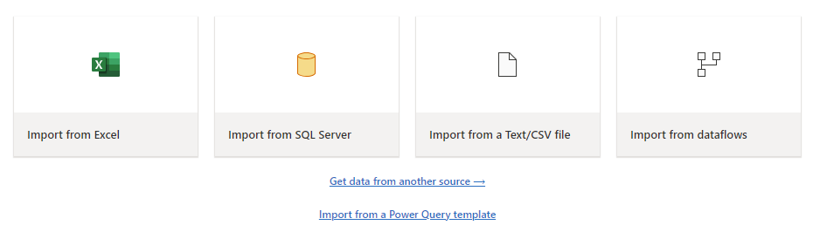

**You can load different file types with just a few steps. For example, to load a text or CSV file from your local computer.**

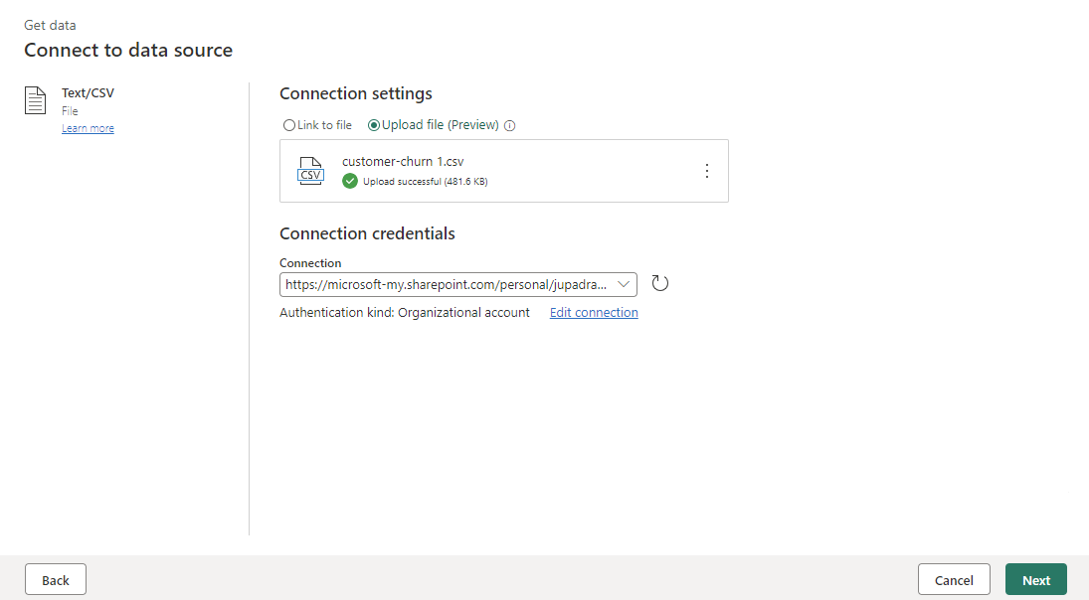

**Once the data is imported you can start authoring your dataflow, you might decide to clean your data, reshape, remove columns, and create new ones. All the steps you perform are saved.**

**Transform data with Copilot**

**Copilot can be a valuable tool for assisting with dataflow transformations. Let's say we have a *Gender* column that contains *'Male'* and *'Female'* and we want to transform it.**

**The first step is to activate Copilot within your dataflow. Once that's done, you can then provide specific instructions on the transformation you want to perform.**

**For instance, you might input the following command: *"Transform the Gender column. If Male 0, if Female 1. Then convert it to integer."***

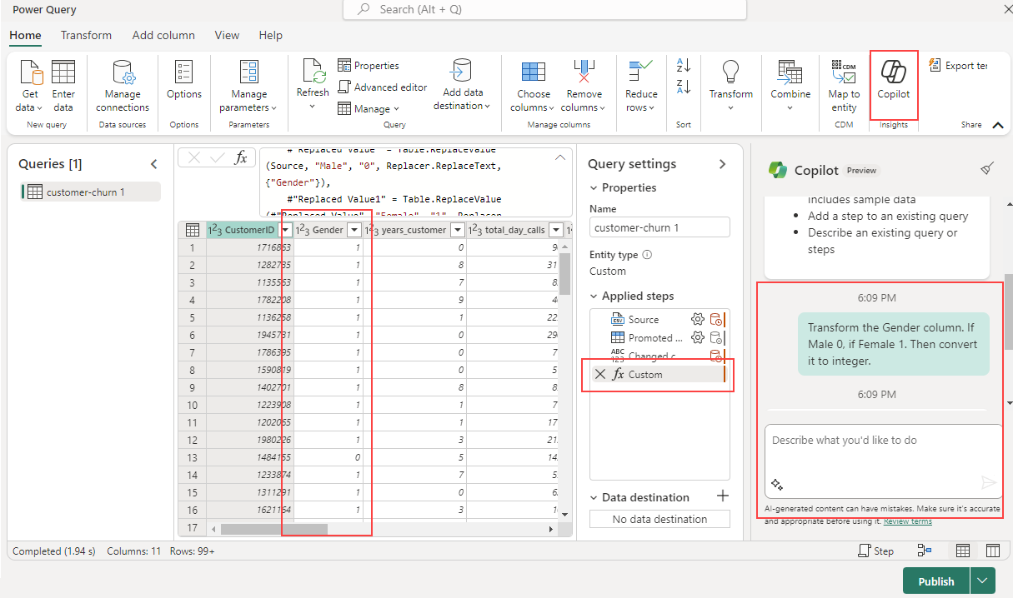

**Copilot adds a new step automatically, and you can always revert it if you want, or continue to build on it for further transformations.**

**Add a data destination**

**With the Add data destination feature, you can separate your ETL logic and destination storage. This separation can lead to cleaner, more maintainable code and can make it easier to modify either the ETL process or the storage configuration without affecting the other.**

**Once the data is transformed, the next step is to add a destination step. On the Query settings tab, select + to add a destination step in your dataflow.**

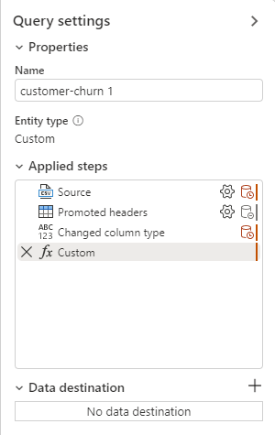

**The following destination options are available.**

* **Azure SQL Database**
* **Lakehouse**
* **Azure Data Explorer (Kusto)**
* **Azure Synapse Analytics (SQL DW)**
* **Warehouse**

**Data that’s loaded into a destination like a warehouse can be easily accessed and analyzed using various tools. This improves the accessibility of your data and allows for more flexible and comprehensive data analysis.**

**When you select a warehouse as a destination, you can choose the following update methods.**

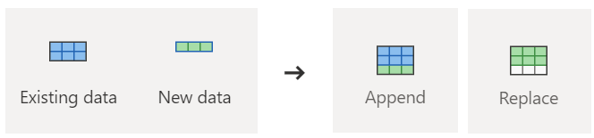

* **Append: Add new rows to an existing table.**
* **Replace: Replace the entire content of a table with a new set of data.**

**Publish a dataflow**

**After you choose your update method, the final step is to publish your dataflow.**

**Publishing makes your transformations and data loading operations live, allowing the dataflow to be executed either manually or on a schedule. This process encapsulates your ETL operations into a single and reusable unit, streamlining your data management workflow.**

**Any changes made in the dataflow take effect when it’s published. So, always ensure to publish your dataflow after making any relevant modifications.**

**Next unit: Exercise: Load data into a warehouse in Microsoft Fabric**

[**Previous**](https://learn.microsoft.com/en-us/training/modules/load-data-into-microsoft-fabric-data-warehouse/4-load-data-using-tsql/)

**Exercise: Load data into a warehouse in Microsoft Fabric**

Completed100 XP

* 30 minutes

Now it's your chance to load data into a warehouse in Microsoft Fabric.

In this exercise, you’ll learn how to load data into a warehouse using T-SQL.

**Note**

You need a Microsoft Fabric trial license with the Fabric preview enabled in your tenant. See [**Getting started with Fabric**](https://learn.microsoft.com/en-us/fabric/get-started/fabric-trial) to enable your Fabric trial license.

Launch the exercise and follow the instructions.

[](https://microsoftlearning.github.io/mslearn-fabric/Instructions/Labs/06a-data-warehouse-load.html)

**Next unit: Knowledge check**

**Knowledge check**

Completed200 XP

* **Module assessment**
* 8 minutes

 Answer 100% of questions correctly in order to pass. [**Retake**](https://learn.microsoft.com/en-us/training/modules/load-data-into-microsoft-fabric-data-warehouse/7-knowledge-check)

Dismiss alert

Top of Form

**1.**

**What are the four data ingestion options available in Microsoft Fabric for loading data into a data warehouse?**

COPY (Transact-SQL) statement, data pipelines, dataflows, and cross-warehouse.

**Correct. COPY (Transact-SQL) statement, data pipelines, dataflows, and cross-warehouse are the four data ingestion options available in Microsoft Fabric for loading data into a data warehouse.**

COPY (Transact-SQL) statement, data pipelines, dataflows, and Data Wrangler.

**Incorrect. Data Wrangler is a tool used to preprocess data.**

COPY (Transact-SQL) statement, data pipelines, dataflows, and cross-platform ingestion.

**2.**

**What are the supported data sources and file formats for the COPY (Transact-SQL) statement in Warehouse?**

Azure Data Lake Storage (ADLS) Gen2 and Azure Blob Storage, with PARQUET and CSV file formats.

**Correct. The COPY (Transact-SQL) statement currently supports the PARQUET and CSV file formats, and Azure Data Lake Storage (ADLS) Gen2 and Azure Blob Storage as data sources.**

Azure Data Lake Storage (ADLS) Gen1 and Azure Blob Storage, with PARQUET and CSV file formats.

**Incorrect. The supported data source is Azure Data Lake Storage (ADLS) Gen2, not Gen1.**

Azure Data Lake Storage (ADLS) Gen2 and Azure Blob Storage, with ORC and CSV file formats.

**3.**

**What is the recommended minimum file size when working with external data on files in Microsoft Fabric?**

At least 4 MB.

**Correct. When working with external data on files, we recommend that files are at least 4 MB in size.**

At least 1 MB.

**Incorrect. The recommended minimum file size is 4 MB, not 1 MB.**

At least 10 MB.

Bottom of Form

**Next unit: Summary**

**Summary**

Completed100 XP

* 2 minutes

There’s no one-size-fits-all solution for loading your data. The best approach depends on the specifics of your business requirement and the question you’re trying to answer.

When it comes to loading data in a data warehouse, there are several considerations to keep in mind.

Expand table

|  | **Description** |
| --- | --- |
| **Load volume & frequency** | Assess data volume and load frequency to optimize performance. |
| **Governance** | Any data that lands in OneLake is governed by default. |
| **Data mapping** | Manage mapping from source to staging to warehouse. |
| **Dependencies** | Understand dependencies in the data model for loading dimensions. |
| **Script design** | Design efficient import scripts considering column names, filtering rules, value mapping, and database indexing. |

For additional reading, you can refer to the following URLs:

* [Create a Warehouse in Microsoft Fabric](https://learn.microsoft.com/en-us/fabric/data-warehouse/create-warehouse)
* [Ingest data into the Warehouse](https://learn.microsoft.com/en-us/fabric/data-warehouse/ingest-data)
* [Compare the Warehouse and the SQL analytics endpoint of the Lakehouse](https://learn.microsoft.com/en-us/fabric/data-warehouse/data-warehousing#compare-the-warehouse-and-the-sql-endpoint-of-the-lakehouse?azure-portal=true)

“”” <https://learn.microsoft.com/en-us/training/modules/load-data-into-microsoft-fabric-data-warehouse/8-summary#completion> “”

**Secure a Microsoft Fabric data warehouse**

**Secure a Microsoft Fabric data warehouse**

* **1 hr 11 min**
* **Module**
* **8 Units**

**Feedback**

**Beginner**

**Data Analyst**

**Data Engineer**

**Microsoft Fabric**

**Data warehouse in Microsoft Fabric is a comprehensive platform for data and analytics, featuring advanced query processing and full transactional T-SQL capabilities for easy data management and analysis.**

**Learning objectives**

**In this module, you'll:**

* **Learn the concepts of securing a data warehouse in Microsoft Fabric.**
* **Learn how to implement dynamic data masking to obscure sensitive information.**
* **Learn how to configure row-level security to provide granular control.**
* **Learn how to implement column-level security to protect sensitive data.**
* **Learn how to configure granular permissions using T-SQL.**

[**Start**](https://learn.microsoft.com/en-us/training/modules/secure-data-warehouse-in-microsoft-fabric/1-introduction/)**Add**

**Prerequisites**

**Before starting this module, you should be familiar with the Microsoft Fabric interface and core concepts.**

**This module is part of these learning paths**

* [**Administer and govern Microsoft Fabric**](https://learn.microsoft.com/training/paths/microsoft-fabric-admin-governance/)
* [**Implement a data warehouse with Microsoft Fabric**](https://learn.microsoft.com/training/paths/work-with-data-warehouses-using-microsoft-fabric/)

**Module assessment**

**Assess your understanding of this module. Sign in and answer all questions correctly to earn a pass designation on your profile.**

[**Take the module assessment**](https://learn.microsoft.com/training/modules/secure-data-warehouse-in-microsoft-fabric/7-knowledge-check/)

* [**Introduction**](https://learn.microsoft.com/en-us/training/modules/secure-data-warehouse-in-microsoft-fabric/1-introduction)**4 min**
* [**Explore dynamic data masking**](https://learn.microsoft.com/en-us/training/modules/secure-data-warehouse-in-microsoft-fabric/2-explore-dynamic-data-masking)**6 min**
* [**Implement row-level security**](https://learn.microsoft.com/en-us/training/modules/secure-data-warehouse-in-microsoft-fabric/3-implement-row-level-security)**8 min**
* [**Implement column-level security**](https://learn.microsoft.com/en-us/training/modules/secure-data-warehouse-in-microsoft-fabric/4-implement-column-level-security)**8 min**
* [**Configure SQL granular permissions using T-SQL**](https://learn.microsoft.com/en-us/training/modules/secure-data-warehouse-in-microsoft-fabric/5-configure-sql-granular-permissions)**5 min**
* [**Exercise: Secure a warehouse in Microsoft Fabric**](https://learn.microsoft.com/en-us/training/modules/secure-data-warehouse-in-microsoft-fabric/6-exercise-secure-data-warehouse)**30 min**
* [**Knowledge check**](https://learn.microsoft.com/en-us/training/modules/secure-data-warehouse-in-microsoft-fabric/7-knowledge-check)**8 min**
* [**Summary**](https://learn.microsoft.com/en-us/training/modules/secure-data-warehouse-in-microsoft-fabric/8-summary)**2 min**

**Introduction**

Completed100 XP

* 4 minutes

[Microsoft Fabric Data Warehouse](https://learn.microsoft.com/en-us/fabric/data-warehouse/) is a complete platform for data, analytics, and AI (Artificial Intelligence). It refers to the process of storing, organizing, and managing large volumes of structured and semi-structured data.

In a warehouse, administrators have access to a suite of technologies aimed at safeguarding sensitive information. These security measures are capable of securing or masking data from users or roles without proper authorization, ensuring data protection across both Warehouse and SQL analytics endpoints. This ensures a smooth and secure user experience, with no need for alterations to the existing applications.

**Understand security features**

Data engineers who are often well-versed in the SQL engine and adept at using T-SQL, will find warehouses in Microsoft Fabric easy to use.

This is because warehouses are powered by the same SQL engine they're familiar with, enabling them to perform complex queries and data manipulations. The SQL engine’s wide range of security features further allows for sophisticated security mechanism at the warehouse level.

* [**Workspaces roles**](https://learn.microsoft.com/en-us/fabric/data-warehouse/workspace-roles/) – Designed to provide different levels of access and control within the workspace. You can assign users to the various workspace roles such as **Admin**, **Member**, **Contributor**, and **Viewer**. These roles are crucial for maintaining the security and efficiency of data warehousing operations within an organization.
* [**Item permissions**](https://learn.microsoft.com/en-us/fabric/data-warehouse/share-warehouse-manage-permissions/) – Individual warehouses can have item permissions assigned directly to them. The main intent behind assigning such permissions is to facilitate the sharing of the Warehouse for downstream use.
* [**Data protection security**](https://learn.microsoft.com/en-us/fabric/data-warehouse/security#granular-security?azure-portal=true) – For more precise control, you can use T-SQL to grant specific permissions to users. Warehouse supports a range of data protection features that enable administrators to shield sensitive data from unauthorized access. This includes object-level security for database objects, column-level security for table columns, row-level security for table rows using WHERE clause filters, and dynamic data masking to obscure sensitive data like email addresses. These features ensure data protection across Warehouses and SQL analytics endpoints without necessitating changes to applications.

In the next units, we'll explore various ways of enabling security in a warehouse, and how they can facilitate the tasks of keeping your data warehouse workload protected.

**Next unit: Explore dynamic data masking**

[**Next**](https://learn.microsoft.com/en-us/training/modules/secure-data-warehouse-in-microsoft-fabric/2-explore-dynamic-data-masking/)

**Explore dynamic data masking**

Completed100 XP

* 6 minutes

[Dynamic Data Masking (DDM)](https://learn.microsoft.com/en-us/fabric/data-warehouse/dynamic-data-masking) is a security feature that limits data exposure to nonprivileged users by obscuring sensitive information.

Dynamic data masking offers several key benefits that enhance the security and manageability of your data. One of the primary advantages is its real-time masking feature. When querying sensitive data, DDM applies dynamic masking to it in real time. This process means that the actual data is never exposed to unauthorized users, thus enhancing the security of your data. Furthermore, DDM is straightforward to implement. It doesn’t require complex coding, making it accessible for users of all skill levels.

Another benefit of DDM is that the data in the database isn’t changed when DDM is applied. Instead, the masking rules are applied to the query results. This benefit means that the actual data remains intact and secure, while nonprivileged users only see a masked version of the data.

**Define masking rule**

Dynamic data masking, which is set up at the column level, offers a suite of features including comprehensive and partial masking capabilities, along with a random masking function designed for numeric data.

Expand table

| **Masking Type** | **Description** | **Use Case** | **Limitations** | **Masking Rule** |
| --- | --- | --- | --- | --- |
| **Default** | Full masking according to the data types of the designated fields. | Useful when you want to completely hide the actual data. | Completely mask the data. No information is visible. | default() |
| **Email** | Exposes the first letter of an email address and the constant suffix ".com" | Useful when you want to show that the data field contains an email without revealing the actual email. | Only applicable to email fields. | email() |
| **Custom Text** | Exposes the first and last 'n' characters and adds a custom padding string in the middle. | Useful when you want to partially hide the actual data. | Not suitable for numeric, date, and time data types. | partial(prefix_padding, padding_string, suffix_padding) |
| **Random** | Replaces any numeric or binary value with a random number within a specified range. | Useful when you want to hide the actual numeric or binary data. | Only applicable to numeric and binary data types. | random(low, high) |

The prefix_padding and suffix_padding parameters in the partial() function specify the number of characters to expose at the beginning and end of the string, and the padding_string parameter specifies the string to use for masking the remaining characters.

The low and high parameters in the random() function specify the range of random numbers to generate.

These masking types help prevent unauthorized viewing of sensitive data by enabling administrators to specify how much sensitive data to reveal, with minimal effect on the application layer. They're applied to query results, so the data in the database isn't changed. This approach allows many applications to mask sensitive data without modifying existing queries.

**Configure data masking**

Let's consider an example of a warehouse that stores customer information. The warehouse contains a Customer table with fields such as CustomerName, Email, PhoneNumber, and CreditCardNumber.

To apply data masking on the CustomerName, Email, PhoneNumber, and CreditCardNumber columns, run the following command:

Transact-SQLCopy

-- For Email

ALTER TABLE Customers

ALTER COLUMN Email ADD MASKED WITH (FUNCTION = 'email()');

-- For PhoneNumber

ALTER TABLE Customers

ALTER COLUMN PhoneNumber ADD MASKED WITH (FUNCTION = 'partial(3,"XXX-XXX-",4)');

-- For CreditCardNumber

ALTER TABLE Customers

ALTER COLUMN CreditCardNumber ADD MASKED WITH (FUNCTION = 'partial(4,"XXXX-XXXX-XXXX-",4)');

**View masked results**

Without Dynamic Data Masking, if a nonprivileged user runs a query to fetch customer details, they might see something like this:

Copy

CustomerName: John Doe

Email: johndoe@contoso.com

PhoneNumber: 123-456-7890

CreditCardNumber: 1234-5678-9012-3456

However, with DDM applied to the Email, PhoneNumber, and CreditCardNumber fields, the same query would return:

Copy

CustomerName: John Doe

Email: j*****@contoso.com

PhoneNumber: XXX-XXX-7890

CreditCardNumber: XXXX-XXXX-XXXX-3456

As you can see, the sensitive data is hidden from the nonprivileged user, enhancing the security of your data. This scenario is a basic example of how Dynamic Data Masking works. It helps to ensure that sensitive data isn't exposed to users who don't have the necessary privileges to view it.

**Note**

Unprivileged users with query permissions can infer the actual data since the data isn’t physically obfuscated.

DDM should be used as part of a comprehensive data security strategy that includes proper management of object-level security with SQL granular permissions and adherence to the principle of minimal required permissions.

**Next unit: Implement row-level security**

**Implement row-level security**

Completed100 XP

* 8 minutes

[Row-Level Security (RLS)](https://learn.microsoft.com/en-us/fabric/data-warehouse/row-level-security) is a feature that provides granular control over access to rows in a table based on group membership or execution context.

For example, in an e-commerce platform, you can ensure that sellers only have access to order rows that are related to their own products. This way, each seller can manage their orders independently, while maintaining the privacy of other sellers’ order information.

If you have experience with SQL Server, you find that row-level security shares similar characteristics and features.

**Protect your data**

Row-Level Security (RLS) works by associating a function, known as a security predicate, with a table. This function is defined to return *true* or *false* based on certain conditions, typically involving the values of one or more columns in the table. When a user attempts to access data in the table, the security predicate function is invoked. If the function returns *true*, the row is accessible to the user; if it returns *false*, the row doesn't show up in the query results.

Depending on the business requirements, an RLS predicate can be as simple as WHERE CustomerId = 29 or as complex as required.

This process is transparent to the user and is enforced automatically by SQL Server, ensuring consistent application of security rules.

Row-level security is implemented in two main steps:

* **Filter predicates** - It's an inline table-valued function that filters the results based on the predicate defined.

Expand table

| **Access** | **Definition** |
| --- | --- |
| **SELECT** | Can't view rows that are filtered. |
| **UPDATE** | Can't update rows that are filtered. |
| **DELETE** | Can't delete rows that are filtered. |
| **INSERT** | Not applicable. |

* **Security policy** - It's a security policy that invokes an inline table-valued function to protect access to the rows in a table.

Because access control is configured and applied at the warehouse level, application changes are minimal - if any. Also, users can directly have access to the tables and can query their own data.

**Configure row-level security**

The T-SQL commands below demonstrate how to use RLS in a scenario where user access is segregated by tenant:

SQLCopy

-- Create supporting objects for this example

CREATE TABLE [Sales] (SalesID INT,

ProductID INT,

TenantName NVARCHAR(10),

OrderQty INT,

UnitPrice MONEY)

GO

INSERT INTO [Sales] VALUES (1, 3, 'tenant1@contoso.com', 5, 10.00);

INSERT INTO [Sales] VALUES (2, 4, 'tenant2@contoso.com', 2, 57.00);

INSERT INTO [Sales] VALUES (3, 7, 'tenant3@contoso.com', 4, 23.00);

INSERT INTO [Sales] VALUES (4, 2, 'tenant4@contoso.com', 2, 91.00);

INSERT INTO [Sales] VALUES (5, 9, 'tenant5@contoso.com', 5, 80.00);

-- View all the rows in the table

SELECT * FROM Sales;

Next, we create a new schema, an inline table-valued function, and grant user access to the new function. The WHERE @TenantName = USER_NAME() OR USER_NAME() = 'TenantAdmin' predicate evaluates if the user name executing the query matches the *TenantName* column values.

SQLCopy

--Create a schema

CREATE SCHEMA [Sec];

GO

--Create the filter predicate

CREATE FUNCTION sec.tvf_SecurityPredicatebyTenant(@TenantName AS NVARCHAR(10))

RETURNS TABLE

WITH SCHEMABINDING

AS

RETURN SELECT 1 AS result

WHERE @TenantName = USER_NAME() OR USER_NAME() = 'tenantAdmin@contoso.com';

GO

--Create security policy and add the filter predicate

CREATE SECURITY POLICY sec.SalesPolicy

ADD FILTER PREDICATE sec.tvf_SecurityPredicatebyTenant(TenantName) ON [dbo].[Sales]

WITH (STATE = ON);

GO

The *tenantAdmin@contoso.com* user should see all the rows. The *tenant1@contoso.com* to *tenant5@contoso.com* users should only see their own rows.

If you alter the security policy with WITH (STATE = OFF);, you notice that users see all the rows.

**Note**

There is a risk of information leakage if an attacker writes a query with a specially crafted WHERE clause and, for example, a divide-by-zero error, to force an exception if the WHERE condition is true. This is known as a *side-channel attack*.

**Explore use cases**

Row-level security is ideal for many scenarios, including:

* When you need to isolate departmental access at the row level.
* When you need to restrict customers' data access to only the data relevant to their company.
* When you need to restrict access for compliance purposes.

**Apply best practices**

Here are a few best practices to consider when implementing RLS:

* It's recommended to create a separate schema for predicate functions, and security policies.
* Whenever possible, avoid type conversions in predicate functions.
* To maximize performance, avoid using excessive table joins and recursion in predicate functions.

**Next unit: Implement column-level security**

[**Previous**](https://learn.microsoft.com/en-us/training/modules/secure-data-warehouse-in-microsoft-fabric/2-explore-dynamic-data-masking/)

**Implement column-level security**

Completed100 XP

* 8 minutes

[Column-level security (CLS)](https://learn.microsoft.com/en-us/fabric/data-warehouse/column-level-security) allows you to restrict column access in order to protect sensitive data. It provides granular control over who can access specific pieces of data, enhancing the overall security of your data warehouse.

**Secure sensitive data**

Let's consider a practical example of column-level security (CLS) in the healthcare industry. Suppose we have a table named Patients with the following columns: PatientID, Name, Address, DateOfBirth, and MedicalHistory.

The MedicalHistory column contains sensitive health information about the patients. As per the healthcare regulations and privacy laws, this information should only be accessible to authorized medical personnel such as doctors or nurses.

Here's how you might implement column-level security in this scenario:

1. **Identify the sensitive columns**: In this case, the MedicalHistory column is identified as containing sensitive data.
2. **Define access roles**: Define roles such as Doctor and Nurse who are allowed to access the MedicalHistory column. Other roles such as Receptionist or Patient might be restricted from accessing this column.
3. **Assign roles to users**: Assign the appropriate roles to each user in the warehouse. For example, user DrSmith might be assigned the Doctor role, while user JohnDoe might be assigned the Patient role.
4. **Implement access control**: Restrict access to the MedicalHistory column based on the user's role.

Column-level security can help ensure that sensitive health information is only accessible to those who are authorized to see it, though protecting patient privacy and complying with healthcare regulations.

**Configure column-level security**

In the scenario we've recently explored, the syntax to use for implementing column-level security might look as follows:

SQLCopy

-- Create roles

CREATE ROLE Doctor AUTHORIZATION dbo;

CREATE ROLE Nurse AUTHORIZATION dbo;

CREATE ROLE Receptionist AUTHORIZATION dbo;

CREATE ROLE Patient AUTHORIZATION dbo;

GO

-- Grant SELECT on all columns to all roles

GRANT SELECT ON dbo.Patients TO Doctor;

GRANT SELECT ON dbo.Patients TO Nurse;

GRANT SELECT ON dbo.Patients TO Receptionist;

GRANT SELECT ON dbo.Patients TO Patient;

GO

-- Deny SELECT on the MedicalHistory column to the Receptionist and Patient roles

DENY SELECT ON dbo.Patients (MedicalHistory) TO Receptionist;

DENY SELECT ON dbo.Patients (MedicalHistory) TO Patient;

GO

In this example, we first create the roles Doctor, Nurse, Receptionist, and Patient. We then grant SELECT permissions on all columns in the Patients table to all roles. Finally, we deny SELECT permissions on the MedicalHistory column to the Receptionist and Patient roles. This ensures that only users with the Doctor or Nurse role can access the MedicalHistory column.

**Understand the benefits**

In the realm of warehouse security, two commonly used techniques are column-level security and views. Both methods serve to restrict access to sensitive data, but they do so in different ways and offer different advantages. The following table provides a comparative analysis of these two techniques across various aspects such as granularity of access control, maintenance, performance, transparency, and flexibility.

This comparison can help you understand the strengths and weaknesses of each method and guide you in choosing the most suitable approach for your specific application requirements.

Expand table

| **Aspect** | **Column-Level Security** | **Views** |
| --- | --- | --- |
| **Granularity of Access Control** | Allows control at a more granular level. Can specify different access rights for different users or roles on different columns within the same table. | Would need to create different views for different sets of permissions. |
| **Maintenance** | Permissions are tied to the columns themselves, so they automatically adapt to changes in table structure. | If the underlying table structure changes, views may need to be updated to reflect these changes. |
| **Performance** | Generally more efficient because it operates directly on the table data. | Can introduce performance overhead, especially if they are complex or if the underlying tables are large. |
| **Transparency** | The restrictions are transparent to the user. The user queries the table as usual, and the database engine takes care of applying the security rules. | The user needs to query a different object (the view instead of the table). |
| **Flexibility** | Less flexible than views. | Very flexible and can provide row-level security (by including a WHERE clause in the view definition) in addition to column-level security. They can also transform the data (for example, by calculating derived columns) which is not possible with column-level security. |

The choice between using column-level security or views will depend on the specific requirements of your application. Always make sure to test any security changes in a safe environment before applying them to a production warehouse.

**Next unit: Configure SQL granular permissions using T-SQL**

**Configure SQL granular permissions using T-SQL**

Completed100 XP

* 5 minutes

If you're familiar with relational databases and enterprise warehouses, it's common knowledge that there are four fundamental permissions governing [Data Manipulation Language (DML)](https://learn.microsoft.com/en-us/sql/t-sql/queries/queries) operations. These permissions, namely SELECT, INSERT, UPDATE, and DELETE, are universally applicable across all database platforms.

All of these permissions can be granted, revoked or denied on tables and views. If a permission is granted using the GRANT statement, then the permission is given to the user or role referenced in the GRANT statement. Users can also be denied permissions using the DENY command. If a user is granted a permission and denied the same permission, the DENY will always supersede the grant, and the user will be denied access to the specific object.

**Table and view permissions**

Tables and views represent the objects on which permissions can be granted within a warehouse. Within those tables and views, you can additionally restrict the columns that are accessible to a given security principal.

Expand table

| **Permission** | **Definition** |
| --- | --- |
| SELECT | Allows the user to view the data within the object (table or view). When denied, the user will be prevented from viewing the data within the object. |
| INSERT | Allows the user to insert data into the object. When denied, the user will be prevented from inserting data into the object. |
| UPDATE | Allows the user the update data within the object. When denied, the user will be prevented from updating data in the object. |
| DELETE | Allows the user to delete data within the object. When denied, the user will be prevented from deleting data from the object. |

**Function and stored procedure permissions**

Like tables and views, functions and stored procedures have several permissions, which can be granted or denied.

Expand table

| **Permission** | **Definition** |
| --- | --- |
| ALTER | Grants the user the ability to change the definition of the object. |
| CONTROL | Grants the user all rights to the object. |

**Principle of least privilege**

The basic idea of the principle of least privilege is that users and applications should only be given the permissions needed in order for them to complete the task. Applications should only have permissions that they need to do in order to complete the task at hand.

As an example, if an application accesses all data through stored procedures, then the application should only have the permission to execute the stored procedures, with no access to the tables.

**Dynamic SQL**

Dynamic SQL is a concept where a query is built programmatically. Dynamic SQL allows T-SQL statements to be generated within a stored procedure or a query itself. A simple example is shown below.

SQLCopy

CREATE PROCEDURE sp_TopTenRows @tableName NVARCHAR(128)

AS

BEGIN

DECLARE @query NVARCHAR(MAX);

SET @query = N'SELECT TOP 10 * FROM ' + QUOTENAME(@tableName);

EXEC sp_executesql @query;

END;

This example demonstrates a stored procedure that accepts a table name as a parameter and returns the top 10 rows from that table. This could be useful for quickly inspecting tables in a data warehouse.

SQLCopy

CREATE PROCEDURE sp_TopTenRows @tableName NVARCHAR(128)

AS

BEGIN

DECLARE @query NVARCHAR(MAX);

SET @query = N'SELECT TOP 10 * FROM ' + QUOTENAME(@tableName);

EXEC sp_executesql @query;

END;

In this example, @tableName is the parameter that you can replace with the name of the table you want to inspect. The QUOTENAME function is used to safely quote the table name, preventing SQL injection attacks. The sp_executesql stored procedure is then used to execute the dynamically built query.

Please note that this is a simple example and real-world data warehouse tasks might require more complex dynamic SQL queries. Always be cautious when using dynamic SQL due to the risk of SQL injection attacks. Always use parameterization methods like sp_executesql or QUOTENAME to sanitize inputs.

**Next unit: Exercise: Secure a warehouse in Microsoft Fabric**

**Exercise: Secure a warehouse in Microsoft Fabric**

Completed100 XP

* 30 minutes

Now it's your chance to secure a warehouse in Microsoft Fabric.

In this exercise, you’ll learn how to secure a warehouse using the concepts explored in this module.

**Note**

You need a Microsoft Fabric trial license with the Fabric preview enabled in your tenant. See [**Getting started with Fabric**](https://learn.microsoft.com/en-us/fabric/get-started/fabric-trial) to enable your Fabric trial license.

Launch the exercise and follow the instructions.

[](https://go.microsoft.com/fwlink/?linkid=2277744)

**Next unit: Knowledge check**

[**Previous**](https://learn.microsoft.com/en-us/training/modules/secure-data-warehouse-in-microsoft-fabric/5-configure-sql-granular-permissions/)

**Knowledge check**

Completed200 XP

* **Module assessment**
* 8 minutes

 Answer 100% of questions correctly in order to pass. [**Retake**](https://learn.microsoft.com/en-us/training/modules/secure-data-warehouse-in-microsoft-fabric/7-knowledge-check)

Dismiss alert

Top of Form

**1.**

**What is the primary advantage of Dynamic Data Masking (DDM)?**

It limits data exposure by obscuring sensitive information in real time.

**Correct. DDM enhances security by applying dynamic masking to sensitive data in real time, thus preventing exposure to unauthorized users.**

It changes the actual data in the database.

**Incorrect. DDM doesn't change the actual data in the database. It only masks it in query results.**

It requires complex coding to implement.

**2.**

**What is the purpose of a security predicate function in Row-Level Security (RLS)?**

It determines whether a row is accessible to a user based on certain conditions.

**Correct. The security predicate function in RLS is defined to return true or false based on certain conditions, typically involving the values of one or more columns in the table.**

It enables type conversions in predicate functions.

**Incorrect. The security predicate function doesn't enable type conversions. It returns true or false based on certain conditions, typically involving the values of one or more columns in the table.**

It allows users to run ad hoc queries.

**3.**

**What happens when a user is granted a permission and then denied the same permission in a warehouse?**

The GRANT statement supersedes the DENY, and the user will have access to the specific object.

**Incorrect. If a user is granted a permission and then denied the same permission, the DENY always supersedes the GRANT.**

The DENY always supersedes the GRANT, and the user is denied access to the specific object.

**Correct. If a user is granted a permission and then denied the same permission, the DENY always supersedes the GRANT.**

The user has both permissions, and it causes a conflict.

Bottom of Form

“”” <https://learn.microsoft.com/en-us/training/modules/secure-data-warehouse-in-microsoft-fabric/8-summary#completion> “

**Get started with Real-Time Intelligence in Microsoft Fabric**

**Get started with Real-Time Intelligence in Microsoft Fabric**

* 1 hr 32 min
* Module
* 8 Units

Feedback

Beginner

Data Analyst

Data Engineer

Microsoft Fabric

Analysis of real-time data streams is a critical capability for any modern data analytics solution. You can use the Real-Time Intelligence capabilities of Microsoft Fabric to ingest, query, and process streams of data.

**Learning objectives**

In this module, you'll learn how to:

* Describe Real-Time Intelligence in Microsoft Fabric.
* Create eventhouse databases and tables using KQL database.
* Describe Real-Time hub in Microsoft Fabric.
* Use KQL to query tables and create querysets.

[**Start**](https://learn.microsoft.com/en-us/training/modules/get-started-kusto-fabric/1-introduction/)Add

**Prerequisites**

Before starting this module, you should be familiar with Microsoft Fabric.

**This module is part of these learning paths**

* [Get started with Microsoft Fabric](https://learn.microsoft.com/training/paths/get-started-fabric/)
* [Implement Real-Time Intelligence with Microsoft Fabric](https://learn.microsoft.com/training/paths/explore-real-time-analytics-microsoft-fabric/)
* [Ingest data with Microsoft Fabric](https://learn.microsoft.com/training/paths/ingest-data-with-microsoft-fabric/)

**Module assessment**

Assess your understanding of this module. Sign in and answer all questions correctly to earn a pass designation on your profile.

[**Take the module assessment**](https://learn.microsoft.com/training/modules/get-started-kusto-fabric/6-knowledge-check/)

* [Introduction](https://learn.microsoft.com/en-us/training/modules/get-started-kusto-fabric/1-introduction)3 min
* [Describe Microsoft Fabric Real-Time Intelligence?](https://learn.microsoft.com/en-us/training/modules/get-started-kusto-fabric/2-define-real-time-analytics)10 min
* [Understand KQL database and tables](https://learn.microsoft.com/en-us/training/modules/get-started-kusto-fabric/3-describe-kusto-databases-tables)15 min
* [Describe Microsoft Fabric Real-Time hub](https://learn.microsoft.com/en-us/training/modules/get-started-kusto-fabric/3a-define-real-time-hub)15 min
* [Write queries with KQL](https://learn.microsoft.com/en-us/training/modules/get-started-kusto-fabric/4-write-queries-kusto-query-language)15 min
* [Exercise: Explore Real-Time Intelligence in Fabric](https://learn.microsoft.com/en-us/training/modules/get-started-kusto-fabric/5-exercise-use-kusto-query-data-onelake)30 min
* [Knowledge check](https://learn.microsoft.com/en-us/training/modules/get-started-kusto-fabric/6-knowledge-check)3 min
* [Summary](https://learn.microsoft.com/en-us/training/modules/get-started-kusto-fabric/7-summary)1 min

**Introduction**

Completed100 XP

* 3 minutes

This module covers the broad topic of Microsoft Fabric's Real-Time Intelligence, an end-to-end streaming solution optimized for high-speed time-series data analysis. It's designed to handle data of various sizes from different sources and supports automatic partitioning and indexing of any data format.

Imagine you're a data analyst in a large corporation that deals with massive amounts of data daily. You need a solution that can ingest data from any source, run analytical queries directly on raw data, and scale to an unlimited amount of data. You also need to visualize data insights through dashboards and reports, and set alerts for specific thresholds. This is where Microsoft Fabric's Real-Time Intelligence comes into play, providing a streamlined workflow from data loading to visualization.

The topics covered in this module include:

* Understanding and Utilizing Microsoft Fabric's Real-Time Intelligence.
* Exploring Core Components and Objects of Real-Time Intelligence in Microsoft Fabric.
* Understanding and Utilizing Microsoft Fabric Real-Time Hub.
* Using Kusto Query Language (KQL) to Create, Load, and Query Tables.
* Building and Querying a KQL database in Microsoft Fabric.

By the end of this module, you'll be able to understand how Microsoft Fabric's Real-Time Intelligence works, its core components, and how to use the Kusto Query Language (KQL) to analyze and extract insights from data. You'll also get hands-on experience through a practical exercise.

**Next unit: Describe Microsoft Fabric Real-Time Intelligence?**

**Describe Microsoft Fabric Real-Time Intelligence?**

Completed100 XP

* 10 minutes

Fabric's Real-Time Intelligence solution provides an end-to-end streaming solution for high-speed data analysis across the Fabric service. It’s optimized for time-series data and supports automatic partitioning and indexing of any data format.

Real-Time Intelligence delivers high performance for data of various sizes, ranging from a few gigabytes to several petabytes. It can handle data from different sources and in various formats. Fabric's Real-Time Intelligence workload can be used for solutions like IoT and log analytics in many scenarios including manufacturing, oil and gas, and automotive.

**Understand Real-Time Intelligence in Microsoft Fabric**

Real-Time Intelligence is a fully managed service that is optimized for streaming time-series data. With Real-Time Intelligence, you're able to get consistent performance searching all types of data at scale, including structured, unstructured, and semi-structured data. Additionally, it's integrated with the entire suite of Fabric capabilities, which allows a streamlined workflow from data loading to data visualization.

By Using Real-Time Intelligence in Fabric, you can:

* Ingest data from any source, in any data format.
* Run analytical queries directly on raw data without the need to build complex data models or create scripting to transform the data.
* Import data with by-default streaming that provides high performance, low latency, high freshness data analysis.
* Imported data undergoes default partitioning - both time and hash-based partitioning, and by-default indexing.
* Work with versatile data structures and query structured, semi-structured, or free text.
* Query raw data without transformation, with high performance, incredibly low response time, and using a wide variety of available operators.
* Scale to an unlimited amount of data, from gigabytes to petabytes, with unlimited scale on concurrent queries and concurrent users.
* Integrate seamlessly with other workloads and items in Microsoft Fabric.

**Explore the world of real-time data with Real-Time hub**

The Real-Time Hub serves as your gateway to uncover and control the flow of your streaming data. It's a dynamic catalog that includes:

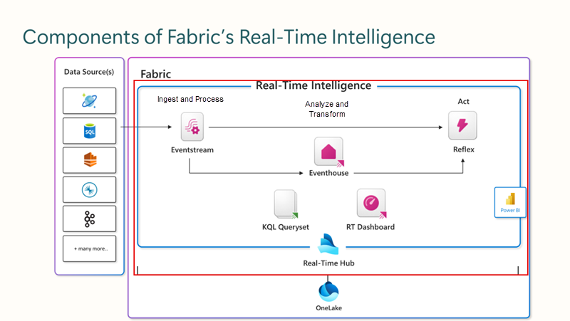

**Visualize data insights with Real-Time Dashboards**

Data insights can be visualized through KQL querysets, Real-Time dashboards, and Power BI reports, with a rapid transition from data ingestion to visualization. These visualizations cater to both beginners and experts, allowing them to represent their data as charts and tables with minimal coding. Users can employ visual cues for filtering and aggregating query results, utilizing a comprehensive suite of built-in visualizations. Insights are accessible in Power BI Reports and Real-Time Dashboards, both of which can incorporate alerts based on the data insights.

Alerts can also be set within the non-table visualizations on the Real-Time Dashboards while in editing mode to provide notifications when an established threshold that you set has been met.

[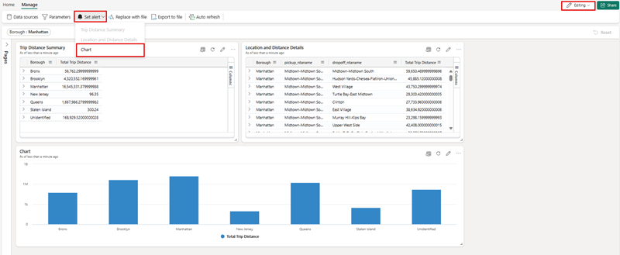](https://learn.microsoft.com/en-us/training/wwl/get-started-kusto-fabric/media/set-alert-dashboard-large.png#lightbox)

The alerts can notify you within Microsoft Teams or by sending an email.

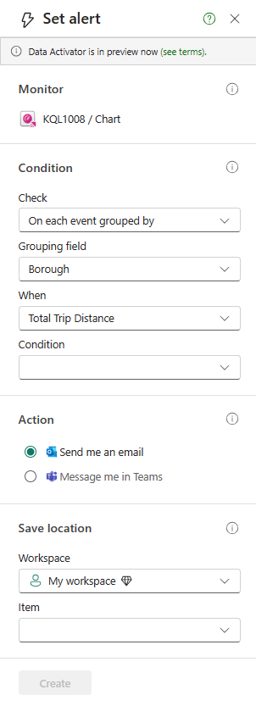

**Kusto Query Language (KQL)**

Kusto Query Language (KQL) is a declarative query language used to analyze and extract insights from structured, semi-structured, and unstructured data. KQL was designed specifically for searching large-scale log data efficiently and quickly, making it perfectly suited for cloud-based data analytics. We'll explore some basic KQL syntax later in this module, but for now, consider the following benefits of the KQL capabilities in Microsoft Fabric:

* It enables **efficiency in data exploration and data analysis** by allowing users to work with heterogeneous data sources and visualize the results in various ways.
* It supports **reproducible analyses** by allowing users to create notebooks with Kusto kernel that can capture code, results, and context on the analysis.
* It improves **DevOps troubleshooting experience** by allowing users to create runbooks or playbooks in notebooks with Kusto kernel that can detail how to troubleshoot and mitigate issues using telemetry data.
* It enriches **DevOps flow** by allowing users to add KQL files and KQL notebook files to their Git repositories and CI/CD pipelines.
* It provides **guidance and helps you build search queries from scratch** by using the KQL editor that quickly identifies potential errors and displays hints about how to resolve issues.
* It lets you **quickly paste long, complex queries directly into the editor** if you receive them from other sources.
* It allows you to **filter, present, and aggregate your data** using various operators and functions that are easy to read and author.

**Next unit: Understand KQL database and tables**

**Understand KQL database and tables**

Completed100 XP

* 15 minutes

Let's explore the core elements of Real-Time Intelligence in Microsoft Fabric.

**Real-Time Intelligence core components**

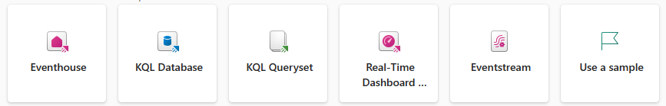

* **Event house**: Event houses are like a large, efficient library for data. They help organizations handle and analyze lots of data quickly, especially when it's important to get insights fast. Think of it as a supercharged database that can deal with data coming in nonstop, from different places, and in various forms. It's designed to grow with the data needs of a project, making sure everything will run smoothly without wasting resources.

[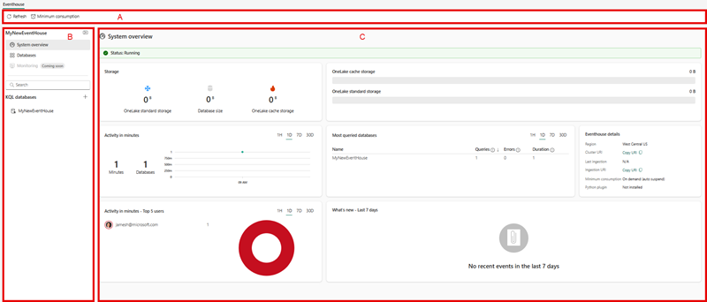](https://learn.microsoft.com/en-us/training/wwl/get-started-kusto-fabric/media/eventhouse-landing-page-large.png#lightbox)

* **KQL database**: is a Kusto database and an upper-level entity that hosts a collection of tables, stored functions, materialized views, shortcuts, and datastreams.

**Note**

**You can continue to create and use stand-alone KQL databases while event house is still in preview**. After this period, they will be managed with the event house as the management layer hosting **many** KQL databases.

* **KQL Queryset**: Use this tool to run queries, and view and manipulate query results on data from your KQL database. The KQL Queryset allows you to save queries for future use, or export and share queries with others. In addition, the KQL Queryset uses the Kusto Query language for query creation, and also supports T-SQL and some T-SQL functions. For more information about the query language, see [Kusto Query Language overview](https://learn.microsoft.com/en-us/azure/data-explorer/kusto/query/?branch=release-public-preview).
* **Real-Time Dashboards**: to understand these, imagine a dashboard as a customizable control panel on your computer or game console. Each section, or "tile," shows you different information, like your score, health level, or map in a game. These tiles are set up to show specific data and can be arranged in different pages to keep things organized. Just like you can change settings in a game. You can tweak these tiles to show different data or look different visually. It's like having a bunch of mini-screens, each showing you something useful, and you can export complex data queries from Kusto Query Language (KQL) directly into these tiles as visuals. This dashboard isn't just about looking cool; it makes exploring data easier and faster. It's like having a high-performance gaming rig that lets you switch between screens and data without lag, giving you a smooth and integrated experience.
* **Eventstream**: Think of event streams in Microsoft Fabric as a super handy tool that lets you handle live data without any coding. It's like a high-tech funnel that collects, changes, and sends data to different places automatically. When you set up an eventstream in the system, you're basically creating a mini-factory that processes real-time data. You tell it where to get data from, where to send it, and how to change it along the way if needed. It's part of a bigger feature called Real-Time Intelligence, which is all about making sense of data as it happens.

**KQL Database objects**

As with many databases, the KQL Database has many objects to handle your data storage, streaming, and querying needs to support your decision making systems downstream. From the event house landing page, you can select on any of the databases and navigate to the individual database for exploring data, adding elements, and more.

[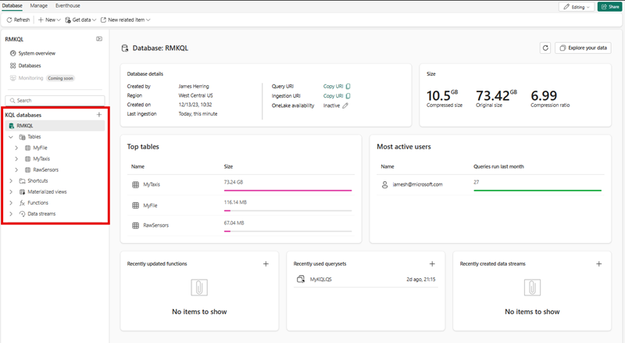](https://learn.microsoft.com/en-us/training/wwl/get-started-kusto-fabric/media/kql-database-landing-large.png#lightbox)

* A **table** is a schema entity that contains a set of columns and rows of data. A table has a well-defined schema (an ordered list of column name and data type pairs). You can use the .create table command to create a new table, the .show table command to show the table schema, and the .ingest command to ingest data into a table.
* A **function** is a schema entity that encapsulates a subquery expression that can be invoked from within other KQL queries. A stored function has a name, an optional list of parameters, and a body that contains the subquery expression. You can use the .create function command to create a new stored function, and the .show functions command to show the stored functions in a database.
* A **materialized view** is a schema entity that stores precomputed results of a query for faster retrieval. A materialized view has a name, an optional list of parameters, and a body that contains the query expression. You can use the .create materialized-view command to create a new materialized view, and the .show materialized-views command to show the materialized views in a database.
* A **datastream** is a representation of all of the attached KQL eventstream connected to the KQL database

**Next unit: Describe Microsoft Fabric Real-Time hub**

**Describe Microsoft Fabric Real-Time hub**

Completed100 XP

* 15 minutes

**Getting data into the Real-Time hub**

The Real-Time Hub serves as your gateway to uncover and control the flow of your streaming data. It's a dynamic catalog that includes:



* **Event streams**: Gain access to all the active event streams within Fabric that you're permitted to view.
* **Microsoft Sources**: Quickly find and configure streaming sources available to you, such as Azure Event Hubs, Azure IoT Hub, and various Change Data Capture (CDC) options from Azure SQL DB, Azure Cosmos DB, and PostgreSQL DB.
* **Fabric Events**: Use event-driven features for instant notifications and data handling. Keep tabs on events from Fabric Workspace Items to Azure Blob Storage, which can initiate further processes or workflows. This action could involve starting a data pipeline or dispatching an email alert. Plus, you have the flexibility to route these events to different destinations through Event streams. Alerts allow you to interact both within your workspace and outside of it from the Real-Time hub by selecting the  ***Set alert*** button.

All this information is presented in an easy-to-digest format, ensuring seamless integration with your Fabric workloads.

**Source the event stream**

The Microsoft Fabric Real-Time Intelligence experience's event streams feature allows for seamless integration of real-time events into Fabric. You can create an eventstream, which is an instance within Fabric, add sources of event data, apply optional transformations to the data, and route it to various destinations, all without the need for coding. This no-code approach simplifies the process of managing event data within Fabric.

[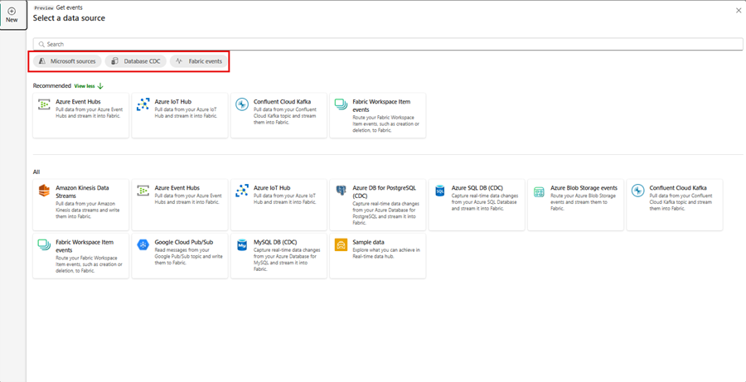](https://learn.microsoft.com/en-us/training/wwl/get-started-kusto-fabric/media/event-stream-sources-large.png#lightbox)

**Processing events within event streams**

The drag and drop interface offers a straightforward and user-friendly method for constructing your event data workflows. This includes processing, transformation, and routing, all without the need for coding. An eventstream's data flow diagram provides a clear visual representation of the data's journey and structure. Additionally, the event processor editor's no-code environment enables you to design your event data processing logic simply by dragging and dropping elements into place.

* **Transformation Description**

When you create an eventstream with Enhanced capabilities enabled, all destinations support transformation operations. Without Enhanced capabilities, transformations are only available for Lakehouse and KQL Database destinations, which handle event processing before ingestion.

* **Filter**: Use the Filter transformation to filter events based on the value of a field in the input. Depending on the data type (number or text), the transformation keeps the values that match the selected condition, such as is null or is not null.
* **Manage fields**: This transformation allows you to add, remove, change data type, or rename fields coming in from an input or another transformation.
* **Aggregate**: Use the Aggregate transformation to calculate an aggregation (Sum, Minimum, Maximum, or Average) every time a new event occurs over a period of time. This operation also allows for the renaming of these calculated columns, and filtering or slicing the aggregation based on other dimensions in your data. You can have one or more aggregations in the same transformation.
* **Group by**: Use the Group by transformation to calculate aggregations across all events within a certain time window. You can group by the values in one or more fields. It's like the Aggregate transformation allows for the renaming of columns, but provides more options for aggregation and includes more complex options for time windows. Like Aggregate, you can add more than one aggregation per transformation.
* **Union**: Use the Union transformation to connect two or more nodes and add events with shared fields (with the same name and data type) into one table. Fields that don't match are dropped and not included in the output.
* **Expand**: Use this array transformation to create a new row for each value within an array.
* **Join**: this is a transformation to combine data from two streams based on a matching condition between them.

**Standard destination locations**

We can see that by not choosing the enhanced capabilities, our destinations are limited.

Expand table

| **Destination** | **Description** |
| --- | --- |
| **Custom app** | With this feature, you can seamlessly direct your real-time event traffic to a bespoke application. It enables the integration of your proprietary applications with the event stream, allowing for the immediate consumption of event data. This feature is advantageous when you aim to transfer real-time data to an independent system not hosted on the Microsoft Fabric. |
| **Lakehouse** | This destination empowers you to preprocess your real-time events prior to their ingestion into your lakehouse. The events are transformed into Delta Lake format and later stored in specific lakehouse tables, facilitating your data warehousing needs. For detailed guidance on utilizing the event processor for real-time data handling, refer to the 'Process event data with event processor editor' section. |
| **KQL database** | This destination offers the capability to funnel your real-time event data into a KQL database, granting you the power to employ the robust Kusto Query Language (KQL) for data interrogation and analysis. Housing your data within the KQL database unlocks the potential for enhanced comprehension of your event data and the creation of comprehensive reports and dashboards. You have the flexibility to opt for one of two data ingestion approaches: either direct ingestion or preprocessing of events prior to ingestion. |
| **Reflex** | This destination facilitates a direct linkage of your real-time event data with a Reflex. A Reflex is an intelligent entity equipped with all necessary details to establish data connections, monitor specific conditions, and execute actions. Upon the event data meeting certain predefined criteria or identifying particular patterns, the Reflex autonomously initiates suitable responses, such as notifying users or triggering Power Automate workflows. |

**Enhanced destination locations**

When you choose the enhanced capabilities, you're able to use the standard destinations along with ***derived stream***.

Expand table

| **Destination** | **Description** |
| --- | --- |
| **Derived stream** | The derived stream is a specialized destination created post-application of stream operations like Filter or Manage Fields to an eventstream. It represents the altered default stream after processing, which can be routed to various destinations within Fabric and monitored in the Real-Time hub. |

You're now able to attach to multiple destinations within an event stream at the same time without impacting or colliding with each other.

[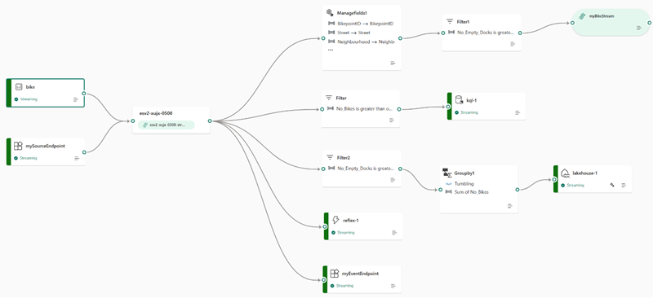](https://learn.microsoft.com/en-us/training/wwl/get-started-kusto-fabric/media/real-time-events-workflow-large.png#lightbox)

**Next unit: Write queries with KQL**

**Write queries with KQL**

Completed100 XP

* 15 minutes

To query data from a table in a KQL database, you can use the **Kusto Query Language (KQL)**, which is used to write queries in Azure Data Explorer, Azure Monitor Log Analytics, Azure Sentinel, and Microsoft Fabric. KQL is a read-only request to process data and return results. KQL queries are made of one or more query statements.

A query statement consists of a table name followed by one or more operators that take, filter, transform, aggregate, or join data. For example:

KustoCopy

sales

| take 10

KQL queries are created using relational operators to filter and transform data using a syntax similar to SQL. However, KQL syntax includes extensions that enable advanced text and pattern matching, statistical analysis, time-series projections, geo-spatial, and machine learning algorithms.

**Create and load tables in KQL**

In most cases, you create tables and define their source using the graphical tools in Microsoft Fabric. However, you can use KQL statements to create and load tables.

To create a table and ingest data into it, you can use the **.create table** command, which creates a new empty table with a specified schema. You need to provide the table name, the column names and their data types, and optionally some properties such as docstring or folder. For example:

KustoCopy

.create table sales (

SalesOrderNumber: string,

SalesOrderLineItem: int,

OrderDate: datetime,

CustomerName: string,

EmailAddress: string,

Item: string,

Quantity: int,

UnitPrice: real,

TaxAmount: real)

This command creates a table called **sales** with 9 columns of different data types.

You can ingest data into a table in multiple ways, including the ingest into command, as shown in this example:

kqlCopy

.ingest into table sales 'https://<StorageAccountName>.blob.core.windows.net/container/<TableName>.csv'

with (ignoreFirstRecord = true)

**Retrieve data from a table**

A basic KQL query consists of selecting data from a table and applying filters and transformations to the data. In the following example, we're going to just query all the data from the sales table.

kqlCopy

sales

The output from this query would look similar to the following example:

Expand table

| **SalesOrderNumber** | **SalesOrderLineItem** | **OrderDate** | **CustomerName** | **EmailAddress** | **Item** | **Quantity** | **UnitPrice** | **TaxAmount** |
| --- | --- | --- | --- | --- | --- | --- | --- | --- |
| SO43701 | 1 | 2019-07-01T00:00:00Z | Christy Zhu | christy12@adventure-works.com | Mountain-100 Silver 44 | 1 | 3399.99 | 271.9992 |
| SO43704 | 1 | 2019-07-01T00:00:00Z | Julio Ruiz | julio1@adventure-works.com | Mountain-100 Black 48 | 1 | 3374.99 | 269.9992 |
| SO43705 | 1 | 2019-07-01T00:00:00Z | Curtis Lu | curtis9@adventure-works.com | Mountain-100 Silver 38 | 1 | 3399.99 | 271.9992 |
| SO43700 | 1 | 2019-07-01T00:00:00Z | Ruben Prasad | ruben10@adventure-works.com | Road-650 Black 62 | 1 | 699.0982 | 55.9279 |
| SO43703 | 1 | 2019-07-01T00:00:00Z | Albert Alvarez | albert7@adventure-works.com | Road-150 Red 62 | 1 | 3578.27 | 286.2616 |
| SO43697 | 1 | 2019-07-01T00:00:00Z | Cole Watson | cole1@adventure-works.com | Road-150 Red 62 | 1 | 3578.27 | 286.2616 |
| SO43699 | 1 | 2019-07-01T00:00:00Z | Sydney Wright | sydney61@adventure-works.com | Mountain-100 Silver 44 | 1 | 3399.99 | 271.9992 |
| ... | ... | ... | ... | ... | ... | ... | ... | ... |

The query output can then be further analyzed using visualization tools or integrated with other programs to create custom dashboards and automated workflows.

The next example returns five rows from the sales table in the KQL database by using the take statement, which is a simple and quick way to view a small sample of records when browsing data.

kqlCopy

sales

| take 5

This time, the results include five rows:

Expand table

| **SalesOrderNumber** | **SalesOrderLineItem** | **OrderDate** | **CustomerName** | **EmailAddress** | **Item** | **Quantity** | **UnitPrice** | **TaxAmount** |
| --- | --- | --- | --- | --- | --- | --- | --- | --- |
| SO43701 | 1 | 2019-07-01T00:00:00Z | Christy Zhu | christy12@adventure-works.com | Mountain-100 Silver 44 | 1 | 3399.99 | 271.9992 |
| SO43704 | 1 | 2019-07-01T00:00:00Z | Julio Ruiz | julio1@adventure-works.com | Mountain-100 Black 48 | 1 | 3374.99 | 269.9992 |
| SO43705 | 1 | 2019-07-01T00:00:00Z | Curtis Lu | curtis9@adventure-works.com | Mountain-100 Silver 38 | 1 | 3399.99 | 271.9992 |
| SO43700 | 1 | 2019-07-01T00:00:00Z | Ruben Prasad | ruben10@adventure-works.com | Road-650 Black 62 | 1 | 699.0982 | 55.9279 |
| SO43703 | 1 | 2019-07-01T00:00:00Z | Albert Alvarez | albert7@adventure-works.com | Road-150 Red 62 | 1 | 3578.27 | 286.2616 |

**Filter with the where clause**

In KQL, where is a clause that is used to filter the rows of a table based on a specified condition. The where clause is followed by a Boolean expression that evaluates to true or false for each row in the table. Rows for which the expression evaluates to true are included in the result, while rows for which the expression evaluates to false are excluded.

The contains operator is used in the where clause of the query to filter the rows of the ***sales*** table based on whether the **Item** column contains the string "Mountain-100".

kqlCopy

sales

| where Item contains 'Mountain-100'

The results include only sales for items containing "Mountain-100":

Expand table

| **SalesOrderNumber** | **SalesOrderLineItem** | **OrderDate** | **CustomerName** | **EmailAddress** | **Item** | **Quantity** | **UnitPrice** | **TaxAmount** |
| --- | --- | --- | --- | --- | --- | --- | --- | --- |
| SO43701 | 1 | 2019-07-01T00:00:00Z | Christy Zhu | christy12@adventure-works.com | Mountain-100 Silver 44 | 1 | 3399.99 | 271.9992 |
| SO43704 | 1 | 2019-07-01T00:00:00Z | Julio Ruiz | julio1@adventure-works.com | Mountain-100 Black 48 | 1 | 3374.99 | 269.9992 |
| SO43705 | 1 | 2019-07-01T00:00:00Z | Curtis Lu | curtis9@adventure-works.com | Mountain-100 Silver 38 | 1 | 3399.99 | 271.9992 |
| SO43699 | 1 | 2019-07-01T00:00:00Z | Sydney Wright | sydney61@adventure-works.com | Mountain-100 Silver 44 | 1 | 3399.99 | 271.9992 |
| ... | ... | ... | ... | ... | ... | ... | ... | ... |

KQL works well when you want to work with time series data. For example, to filter the sales data to show orders that occurred between two datetime values. You can take advantage of many time series functions, including now(), which returns the current time. This example returns all orders that occurred within the last day (24 hours).

kqlCopy

sales

| where OrderDate between (now(-1d) .. now())

The results are filtered to include only orders within the specified time period.

Expand table

| **SalesOrderNumber** | **SalesOrderLineItem** | **OrderDate** | **CustomerName** | **EmailAddress** | **Item** | **Quantity** | **UnitPrice** | **TaxAmount** |
| --- | --- | --- | --- | --- | --- | --- | --- | --- |
| SO49171 | 1 | 2023-05-01T22:01:00Z | Mariah Foster | mariah21@adventure-works.com | Road-250 Black 48 | 1 | 2181.5625 | 174.525 |
| SO49172 | 1 | 2021-05-01T23:55:00Z | Brian Howard | brian23@adventure-works.com | Road-250 Red 44 | 1 | 2443.35 | 195.468 |
| SO49173 | 1 | 2021-05-02T01:10:00Z | Linda Alvarez | linda19@adventure-works.com | Mountain-200 Silver 38 | 1 | 2071.4196 | 165.7136 |
| ... | ... | ... | ... | ... | ... | ... | ... | ... |

**Sort query results**

This query uses the sort operator to retrieve sales of "Mountain-100" items sorted so that the most recent sales are shown first:

kqlCopy

sales

| where Item contains 'Mountain-100'

| sort by OrderDate desc

The results look similar to this example:

Expand table

| **SalesOrderNumber** | **SalesOrderLineItem** | **OrderDate** | **CustomerName** | **EmailAddress** | **Item** | **Quantity** | **UnitPrice** | **TaxAmount** |
| --- | --- | --- | --- | --- | --- | --- | --- | --- |
| SO43699 | 1 | 2023-05-01T00:00:00Z | Sydney Wright | sydney61@adventure-works.com | Mountain-100 Silver 44 | 1 | 3399.99 | 271.9992 |
| SO43705 | 1 | 2023-04-20T00:00:00Z | Curtis Lu | curtis9@adventure-works.com | Mountain-100 Silver 38 | 1 | 3399.99 | 271.9992 |
| SO43704 | 1 | 2023-04-12T00:00:00Z | Julio Ruiz | julio1@adventure-works.com | Mountain-100 Black 48 | 1 | 3374.99 | 269.9992 |
| SO43701 | 1 | 2023-03-27T00:00:00Z | Christy Zhu | christy12@adventure-works.com | Mountain-100 Silver 44 | 1 | 3399.99 | 271.9992 |
| ... | ... | ... | ... | ... | ... | ... | ... | ... |

**Summarize and aggregate**

You can use the summarize operator to group data by a column and create a new column with an aggregation for the group. For example, the following query returns the total quantity of each item that has sold.

kqlCopy

sales

| summarize ItemsSold= sum(Quantity) by Item

The results include a column based on the aggregation function used (in this case sum())

Expand table

| **Item** | **ItemsSold** |
| --- | --- |
| Water Bottle - 30 oz. | 2,097 |
| Patch Kit/8 Patches | 1,621 |
| Mountain Tire Tube | 1,581 |
| Road Tire Tube | 1,212 |
| ... | ... |

**Using Copilot to assist with queryset queries**

One new feature within the Microsoft Real-Time Intelligence tooling is the ability to use [Copilot for Real-Time Intelligence](https://learn.microsoft.com/en-us/fabric/get-started/copilot-real-time-analytics?branch=main). Copilot gives you the ability to write natural language prompts instead of writing or having to quickly learn KQL queries.

When your administrator enables Copilot, you see the option in the top menubar of your querysets. When you ask a question about your data, Copilot will generate the KQL Code to answer your question. You can create several queries within the queryset using this no-code approach to gather useful information for user consumption.

[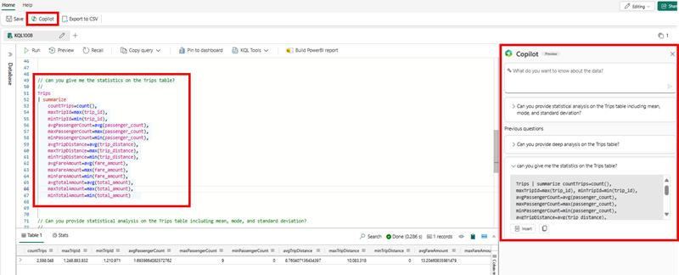](https://learn.microsoft.com/en-us/training/wwl/get-started-kusto-fabric/media/copilot-large.png#lightbox)

Once you have queries within the queryset, you can then Pin them to an existing dashboard or create a new dashboard. To accomplish this, select the queries you want pinned, and then select the **Pin to dashboard**. This gives you a window to perform other actions.

[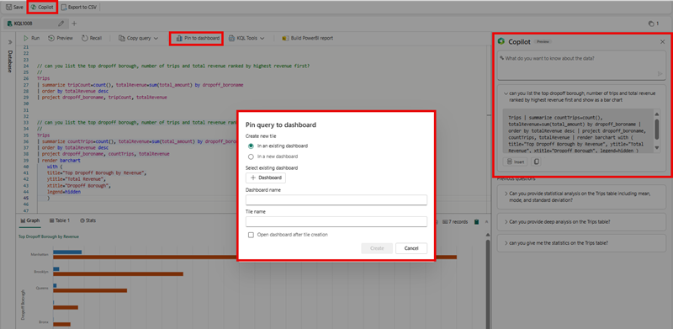](https://learn.microsoft.com/en-us/training/wwl/get-started-kusto-fabric/media/copilot-pin-to-dashboard-large.png#lightbox)

You also have the ability to add a queryset query to a Power BI Report by highlighting your preferred query and then selecting the **Build PowerBI report**.

[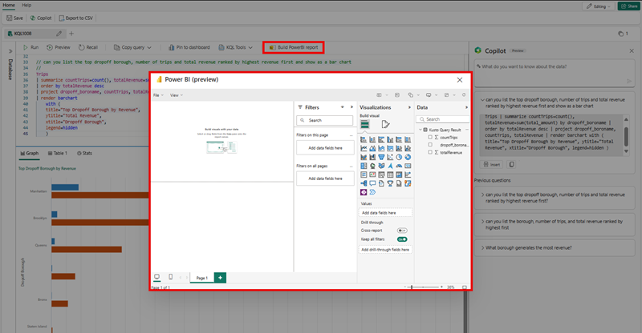](https://learn.microsoft.com/en-us/training/wwl/get-started-kusto-fabric/media/copilot-build-power-bi-report-large.png#lightbox)

**Note**

You can only select one query at a time using the **Pin to Dashboard** or the **Build PowerBI report** but you can append dashboard elements to existing dashboards.

**Next unit: Exercise: Explore Real-Time Intelligence in Fabric**

[**Previous**](https://learn.microsoft.com/en-us/training/modules/get-started-kusto-fabric/3a-define-real-time-hub/)

**Exercise: Explore Real-Time Intelligence in Fabric**

Completed100 XP

* 30 minutes

Now it's your chance to build an event house that contains a KQL database then run some KQL queries.

**Note**

You need a Microsoft Fabric trial license with the Fabric preview enabled in your tenant. See [**Getting started with Fabric**](https://learn.microsoft.com/en-us/fabric/get-started/fabric-trial) to enable your Fabric trial license.

Launch the exercise and follow the instructions.

[](https://go.microsoft.com/fwlink/?linkid=2260722)

**Next unit: Knowledge check**

[**Previous**](https://learn.microsoft.com/en-us/training/modules/get-started-kusto-fabric/4-write-queries-kusto-query-language/)

Top of Form

**Knowledge check**

Completed200 XP

* **Module assessment**
* 3 minutes

 Great job! You passed the module assessment.

Dismiss alert

Top of Form

**1.**

**Which Kusto Query Language (KQL) keyword is used to limit the results of a query to a specified number of rows?**

select

take

**Correct. take limits the results to a specified number of rows.**

project

**2.**

**Which Kusto Query Language (KQL) keyword is used to group and aggregate data?**

group_by

aggregate

summarize

**Correct. Use the summarize keyword to group and aggregate data.**

**3.**

**What is one of the main benefits of using Real-Time Intelligence in Microsoft Fabric?**

It requires complex data models and scripting to transform the data before analysis.

It allows ingestion of data from any source, in any data format.

**Correct. Real-Time Intelligence in Microsoft Fabric allows data ingestion from any source and in any format.**

It only supports structured data formats.

**4.**

**What is the role of a KQL database in Microsoft Fabric's Real-Time Intelligence?**

It's an upper-level entity that hosts a collection of tables, stored functions, materialized views, shortcuts, and datastreams.

**Correct. A KQL database hosts various entities and is used for data storage, streaming, and querying in Microsoft Fabric's Real-Time Intelligence.**

It acts as a high-tech funnel that collects, changes, and sends data to different places automatically.

It's a customizable control panel that shows specific data in different sections or 'tiles.'

Bottom of Form

**Next unit: Summary**

**Summary**

Completed100 XP

* 1 minute

In this module, you have learnt about Microsoft Fabric's Real-Time Intelligence, an end-to-end streaming solution for high-speed data analysis. The service is optimized for time-series data and supports automatic partitioning and indexing of any data format. You have also learnt about the core components of Real-Time Intelligence, including Event House, KQL Database, KQL Queryset, Real-Time Dashboards, and Eventstream. The module also covered the use of the Real-Time Hub as a gateway to control the flow of streaming data and the use of Kusto Query Language (KQL) for data analysis and extraction of insights.

The main takeaways from this module include understanding how Real-Time Intelligence can handle data of various sizes and formats. This understanding comes from different sources, making it suitable for solutions like IoT and log analytics in various industries. The module also provided practical knowledge on how to construct an event house with a KQL database and execute some KQL queries.

More Reading:

1. [Microsoft Fabric's Real-Time Intelligence](https://learn.microsoft.com/en-us/azure/stream-analytics/stream-analytics-introduction)
2. [Kusto Query Language (KQL)](https://learn.microsoft.com/en-us/azure/data-explorer/kusto/query/)
3. [Real-Time Hub in Microsoft Fabric](https://learn.microsoft.com/en-us/azure/event-hubs/event-hubs-about)
4. [Getting started with Microsoft Fabric](https://learn.microsoft.com/en-us/azure/azure-functions/functions-overview)

**All units complete:**

[**Previous**](https://learn.microsoft.com/en-us/training/modules/get-started-kusto-fabric/6-knowledge-check/)

“” <https://learn.microsoft.com/en-us/training/modules/get-started-kusto-fabric/7-summary#completion> “”

**Create Power BI model relationships**

**Create Power BI model relationships**

* 1 hr 30 min
* Module
* 8 Units

Feedback

Intermediate

Data Analyst

Power BI

Power BI model relationships form the basis of a tabular model. Define Power BI model relationships, set up relationships, recognize DAX relationship functions, and describe relationship evaluation.

**Learning objectives**

By the end of this module, you’ll be able to:

* Understand how model relationship work.
* Set up relationships.
* Use DAX relationship functions.
* Understand relationship evaluation.

[**Start**](https://learn.microsoft.com/en-us/training/modules/create-power-bi-model-relationships/1-introduction/)Add

**Prerequisites**

* Experience developing Power BI data models by using Power BI Desktop.

**This module is part of these learning paths**

* [Design and build tabular models](https://learn.microsoft.com/training/paths/design-build-tabular-models/)

**Module assessment**

Assess your understanding of this module. Sign in and answer all questions correctly to earn a pass designation on your profile.

[**Take the module assessment**](https://learn.microsoft.com/training/modules/create-power-bi-model-relationships/6-knowledge-check/)

* [Introduction](https://learn.microsoft.com/en-us/training/modules/create-power-bi-model-relationships/1-introduction)2 min
* [Understand model relationships](https://learn.microsoft.com/en-us/training/modules/create-power-bi-model-relationships/2-understand-model-relationships)6 min
* [Set up relationships](https://learn.microsoft.com/en-us/training/modules/create-power-bi-model-relationships/3-set-up-relationships)14 min
* [Use DAX relationship functions](https://learn.microsoft.com/en-us/training/modules/create-power-bi-model-relationships/4-use-dax-relationship-functions)3 min
* [Understand relationship evaluation](https://learn.microsoft.com/en-us/training/modules/create-power-bi-model-relationships/5-understand-relationship-evaluation)12 min
* [Exercise: Work with model relationships](https://learn.microsoft.com/en-us/training/modules/create-power-bi-model-relationships/5a-exercise-work-model-relationships)45 min
* [Knowledge check](https://learn.microsoft.com/en-us/training/modules/create-power-bi-model-relationships/6-knowledge-check)5 min
* [Summary](https://learn.microsoft.com/en-us/training/modules/create-power-bi-model-relationships/7-summary)3 min

**Introduction**

Completed100 XP

* 2 minutes

Together with model tables, model relationships form the basis of a tabular model. Relationships are responsible for the propagation of filters to other model tables. When correctly set up, they silently work to provide a natural and intuitive querying experience.

There’s a lot to learn about relationships, and it can take new developers time to understand how to set them up correctly, especially for complex data relationships. There are also Data Analysis Expressions (DAX) functions that work with model relationships. These functions allow your model calculation to navigate relationships, modify relationship behavior, and even create virtual relationships.

**Learning objectives**

By the end of this module, you’ll be able to:

* Understand how model relationship work.
* Set up relationships.
* Use DAX relationship functions.
* Understand relationship evaluation.

**Next unit: Understand model relationships**

[**Next**](https://learn.microsoft.com/en-us/training/modules/create-power-bi-model-relationships/2-understand-model-relationships/)

**Understand model relationships**

Completed100 XP

* 6 minutes

A model relationship propagates filters applied on the column of one model table to a different model table. Filters will propagate so long as there's a relationship path to follow, which can involve propagation to multiple tables.

Relationship paths are deterministic, meaning that filters are always propagated in the same way and without random variation. Relationships can, however, be disabled, or have filter context modified by model calculations that use particular DAX functions. Use DAX relationship functions are described in Unit 2.

**Important**

Model relationships don’t enforce data integrity. Unit 4, which describes relationship evaluation, explains how model relationships behave when there are data integrity issues with your data.

Here's how relationships propagate filters with an animated example.



In this example, the model consists of four tables: **Category**, **Product**, **Year**, and **Sales**. The **Category** table relates to the **Product** table, and the **Product** table relates to the **Sales** table. The **Year** table also relates to the **Sales** table. All relationships are one-to-many (the details of which are described in the next unit).

A query, possibly generated by a Power BI card visual, requests the total sales quantity for sales orders made for a single category, **Cat-A**, and for a single year, **CY2018**. It's why you can see filters applied on the **Category** and **Year** tables. The filter on the **Category** table propagates to the **Product** table to isolate two products that are assigned to the category **Cat-A**. Then the **Product** table filters propagate to the **Sales** table to isolate just two sales rows for these products. These two sales rows represent the sales of products assigned to category **Cat-A**. Their combined quantity is 14 units. At the same time, the **Year** table filter propagates to further filter the **Sales** table, resulting in just the one sales row that is for products assigned to category **Cat-A** and that was ordered in year **CY2018**. The quantity value returned by the query is 11 units. Note that when multiple filters are applied to a table (like the **Sales** table in this example), it's always an AND operation, requiring that all conditions must be true.

**Apply star schema design principles**

We recommend you apply [star schema](https://learn.microsoft.com/en-us/power-bi/guidance/star-schema) design principles to produce a model comprising dimension and fact tables. It’s common to set up Power BI to enforce rules that filter dimension tables, allowing model relationships to efficiently propagate those filters to fact tables.

The following image is the model diagram of the Adventure Works sales analysis data model. It shows a star schema design comprising a single fact table named **Sales**. The other four tables are dimension tables that support the analysis of sales measures by date, state, region, and product. Notice the model relationships connecting all tables. These relationships propagate filters (directly or indirectly) to the **Sales** table.

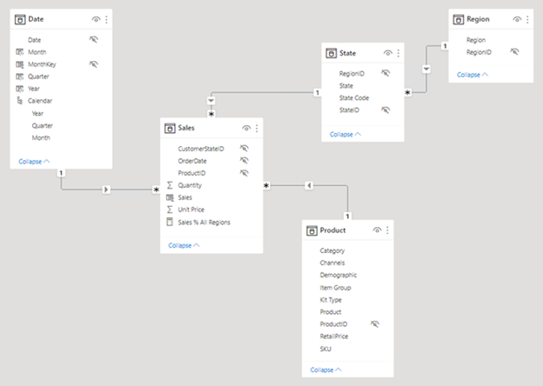

**Use disconnected tables**

It's unusual that a model table isn't related to another model table. Such a table in a valid model design is described as a disconnected table. A disconnected table isn't intended to propagate filters to other model tables. Instead, it accepts "user input" (perhaps with a slicer visual), allowing model calculations to use the input value in a meaningful way. For example, consider a disconnected table that’s loaded with a range of currency exchange rate values. As long as a filter is applied to filter by a single rate value, a measure expression can use that value to convert sales values.

The Power BI Desktop what-if parameter is a feature that creates a disconnected table. For more information, see [Create and use a What if parameter to visualize variables in Power BI Desktop](https://learn.microsoft.com/en-us/power-bi/transform-model/desktop-what-if).

**Next unit: Set up relationships**

[**Previous**](https://learn.microsoft.com/en-us/training/modules/create-power-bi-model-relationships/1-introduction/)

**Set up relationships**

Completed100 XP

* 14 minutes

A model relationship relates one column in a table to one column in a different table. (There's one specialized case where this requirement isn't true, and it applies only to multi-column relationships in DirectQuery models. This topic is described in the next unit.)

**Note**

It's not possible to relate a column to a different column in the same table. This concept is sometimes confused with the ability to define a relational database foreign key constraint that’s table self-referencing. You can use this relational database concept to store parent-child relationships (for example, each employee record is related to a "reports to" employee). However, you can’t use model relationships to generate a model hierarchy based on this type of relationship. To create a parent-child hierarchy, see [**Parent and Child functions**](https://learn.microsoft.com/en-us/dax/parent-and-child-functions-dax).

**Set relationship cardinality**

Each model relationship is defined by a cardinality type. There are four cardinality type options, representing the data characteristics of the "from" and "to" related columns. The "one" side means the column contains unique values; the "many" side means the column can contain duplicate values.

**Note**

If a data refresh operation attempts to load duplicate values into a "one" side column, the entire data refresh will fail.

The four options, together with their shorthand notations, are described in the following bulleted list:

* One-to-many (1:*)
* Many-to-one (*:1)
* One-to-one (1:1)
* Many-to-many (*:*)

When you create a relationship in Power BI Desktop, the designer automatically detects and sets the cardinality type. Power BI Desktop queries the model to know which columns contain unique values. For import models, it uses internal storage statistics; for DirectQuery models, it sends profiling queries to the data source.

Sometimes, however, Power BI Desktop can get it wrong. It can get it wrong when tables are yet to be loaded with data, or because columns that you expect to contain duplicate values currently contain unique values. In either case, you can update the cardinality type as long as any "one" side columns contain unique values (or the table is yet to be loaded with rows of data).

**One-to-many (and many-to-one) cardinality**

The **one-to-many** and **many-to-one** cardinality options are the same, and they're also the most common cardinality types.

When configuring a one-to-many or many-to-one relationship, you'll choose the one that matches the order in which you related the columns. Consider how you would configure the relationship from the **Product** table to the **Sales** table by using the **ProductID** column found in each table. The cardinality type would be one-to-many, as the **ProductID** column in the **Product** table contains unique values. If you related the tables in the reverse direction, **Sales** to **Product**, then the cardinality would be many-to-one.

**One-to-one cardinality**

A **one-to-one** relationship means both columns contain unique values. This cardinality type isn't common, and it likely represents a suboptimal model design because of the storage of redundant data. It’s often a better idea to use Power Query to consolidate the two tables into one.

For more information on using this cardinality type, see [One-to-one relationship guidance](https://learn.microsoft.com/en-us/power-bi/guidance/relationships-one-to-one).

**Many-to-many cardinality**

A **many-to-many** relationship means both columns can contain duplicate values. This cardinality type is infrequently used. It's typically useful when designing complex model requirements. You can use it to relate many-to-many facts or to relate higher grain facts. For example, when sales target facts are stored at product category level and the product dimension table is stored at product level.

For guidance on using this cardinality type, see [Many-to-many relationship guidance](https://learn.microsoft.com/en-us/power-bi/guidance/relationships-many-to-many).

**Tip**

In Power BI Desktop model view, you can interpret a relationship's cardinality type by looking at the indicators (1 or *) on either side of the relationship line. To determine which columns are related, you'll need to select, or hover the cursor over, the relationship line to highlight the related columns.

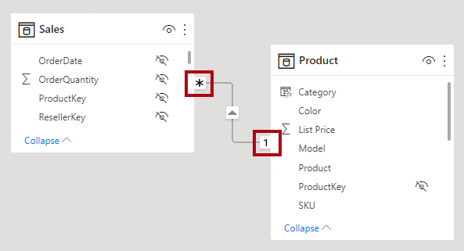

**Set cross filter direction**

Each model relationship is defined with a cross filter direction. Your setting determines the direction(s) that filters will propagate. The possible cross filter options are dependent on the cardinality type.

Expand table

| **Cardinality type** | **Cross filter options** |
| --- | --- |
| One-to-many (or many-to-one) | Single Both |
| One-to-one | Both |
| Many-to-many | Single (Table1 to Table2) Single (Table2 to Table1) Both |

Single cross filter direction means "single direction", and Both means "both directions". A relationship that filters in both directions is commonly described as bi-directional.

For one-to-many relationships, the cross filter direction is always from the "one" side, and optionally from the "many" side (bi-directional). For one-to-one relationships, the cross filter direction is always from both tables. Lastly, for many-to-many relationships, cross filter direction can be from either one of the tables, or from both tables. Notice that when the cardinality type includes a "one" side, that filters will always propagate from that side.

When the cross filter direction is set to **Both**, an additional property becomes available. It can apply bi-directional filtering when Power BI enforces row-level security (RLS) rules. For more information about RLS, see the [Row-level security (RLS) with Power BI Desktop](https://learn.microsoft.com/en-us/power-bi/create-reports/desktop-rls) article.

You can modify the relationship cross filter direction, including the disabling of filter propagation, by using a model calculation. It's achieved by using the [CROSSFILTER](https://learn.microsoft.com/en-us/dax/crossfilter-function) DAX function, which is described in Unit 3.

Bear in mind that bi-directional relationships can impact negatively on performance. Further, attempting to configure a bi-directional relationship could result in ambiguous filter propagation paths. In this case, Power BI Desktop may fail to commit the relationship change and will alert you with an error message. Sometimes, however, Power BI Desktop may allow you to define ambiguous relationship paths between tables. Precedence rules that affect ambiguity detection and path resolution are described in Unit 4.

We recommend using bi-directional filtering only as needed. For more information, see [Bi-directional relationship guidance](https://learn.microsoft.com/en-us/power-bi/guidance/relationships-bidirectional-filtering).

**Tip**

In Power BI Desktop model view, you can interpret a relationship's cross filter direction by noticing the arrowhead(s) along the relationship line. A single arrowhead represents a single-direction filter in the direction of the arrowhead; a double arrowhead represents a bi-directional relationship.

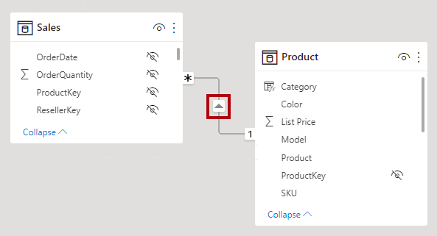

**Set active vs inactive relationships**

There can only be one active filter propagation path between two model tables. However, it's possible to introduce additional relationship paths, though you must set these relationships as inactive. Inactive relationships can only be made active during the evaluation of a model calculation. It’s achieved by using the [USERELATIONSHIP](https://learn.microsoft.com/en-us/dax/userelationship-function-dax) DAX function, which is described in Unit 3.

Generally, we recommend defining active relationships whenever possible. They widen the scope and potential of how report authors can use your model. Using only active relationships means that role-playing dimension tables should be duplicated in your model.

In specific circumstances, however, you can define one or more inactive relationships for a role-playing dimension table. You can consider this design when:

* There's no requirement for report visuals to simultaneously filter by different roles.
* You use the USERELATIONSHIP DAX function to activate a specific relationship for relevant model calculations.

For more information, see [Active vs inactive relationship guidance](https://learn.microsoft.com/en-us/power-bi/guidance/relationships-active-inactive).

**Tip**

In Power BI Desktop model view, you can interpret a relationship's active vs inactive status. An active relationship is represented by a solid line; an inactive relationship is represented as a dashed line.

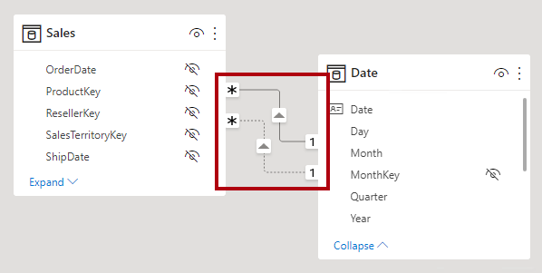

**Set assume referential integrity**

The **Assume referential integrity** property is available only for one-to-many and one-to-one relationships between two DirectQuery storage mode tables that belong to the same source group. You can only enable this property when the “many” side column doesn’t contain NULLs.

When enabled, native queries sent to the data source will join the two tables together by using an INNER JOIN rather than an OUTER JOIN. Generally, enabling this property improves query performance, though it does depend on the specifics of the data source.

Always enable this property when a single-column database foreign key constraint exists between the two tables. Even when a foreign key constraint doesn't exist, consider enabling the property as long as you're certain data integrity exists.

**Important**

If data integrity should become compromised, the inner join will eliminate unmatched rows between the tables. For example, consider a model **Sales** table with a **ProductID** column value that didn’t exist in the related **Product** table. Filter propagation from the **Product** table to the **Sales** table will eliminate sales rows for unknown products. This would result in an understatement of the sales results.

For more information, see [Assume referential integrity settings in Power BI Desktop](https://learn.microsoft.com/en-us/power-bi/connect-data/desktop-assume-referential-integrity).

**Next unit: Use DAX relationship functions**

**Use DAX relationship functions**

Completed100 XP

* 3 minutes

There are several DAX functions that are relevant to model relationships.

**RELATED**

The [RELATED](https://learn.microsoft.com/en-us/dax/related-function-dax) function retrieves the value from "one" side of a relationship. It’s useful when involving calculations from different tables that are evaluated in row context.

**Tip**

To learn more about row context, work through the [**Add calculated tables and columns to Power BI Desktop models**](https://learn.microsoft.com/en-us/training/modules/dax-power-bi-add-calculated-tables/) module. While this module describes adding model calculations, it includes a unit that introduces and describes row context.

**RELATEDTABLE**

The [RELATEDTABLE](https://learn.microsoft.com/en-us/dax/relatedtable-function-dax) function retrieves a table of rows from the "many" side of a relationship.

**USERELATIONSHIP**

The [USERELATIONSHIP](https://learn.microsoft.com/en-us/dax/userelationship-function-dax) function forces the use of a specific inactive model relationship. It’s useful when your model includes a role-playing dimension table, and you choose to create inactive relationships from this table.

For more information, see [Active vs inactive relationship guidance](https://learn.microsoft.com/en-us/power-bi/guidance/relationships-active-inactive).

**CROSSFILTER**

The [CROSSFILTER](https://learn.microsoft.com/en-us/dax/crossfilter-function) function either modifies the relationship cross filter direction (to one or both), or it disables filter propagation (none). It’s useful when you need to change or ignore model relationships during the evaluation of a specific calculation.

**COMBINEVALUES**

The [COMBINEVALUES](https://learn.microsoft.com/en-us/dax/combinevalues-function-dax) function joins two or more text strings into one text string. The purpose of this function is to support multi-column relationships in DirectQuery models when tables belong to the same source group.

**TREATAS**

The [TREATAS](https://learn.microsoft.com/en-us/dax/treatas-function) function applies the result of a table expression as filters to columns from an unrelated table. It’s helpful in advanced scenarios when you want to create a virtual relationship during the evaluation of a specific calculation.

**Parent and child functions**

The [Parent and child functions](https://learn.microsoft.com/en-us/dax/parent-and-child-functions-dax) are a family of related functions that you can use to generate calculated columns to naturalize a parent-child hierarchy. You can then use these columns to create a fixed-level hierarchy.

For more information, see [Understanding functions for parent-child hierarchies in DAX](https://learn.microsoft.com/en-us/dax/understanding-functions-for-parent-child-hierarchies-in-dax).

**Next unit: Understand relationship evaluation**

[**Previous**](https://learn.microsoft.com/en-us/training/modules/create-power-bi-model-relationships/3-set-up-relationships/)

**Understand relationship evaluation**

Completed100 XP

* 12 minutes

Model relationships, from an evaluation perspective, are classified as either regular or limited. It's not a configurable relationship property. It’s inferred from the cardinality type and the data source of the two related tables. It's important to understand the evaluation type because there may be performance implications or consequences should data integrity be compromised. These implications and integrity consequences are described in this unit.

First, some modeling theory is required to fully understand relationship evaluations.

An import or DirectQuery model sources all of its data from either the VertiPaq cache or the source database. In both instances, Power BI is able to determine that a "one" side of a relationship exists.

A composite model, however, can comprise tables using different storage modes (import, DirectQuery, or dual), or multiple DirectQuery sources. Each source, including the VertiPaq cache of imported data, is considered to be a source group. Model relationships can then be classified as intra source group or inter/cross source group. An intra source group relationship is one that relates two tables within a source group, while an inter/cross source group relationship relates tables across two source groups. Relationships in import or DirectQuery models are always intra source group.

Here's an example of a composite model.

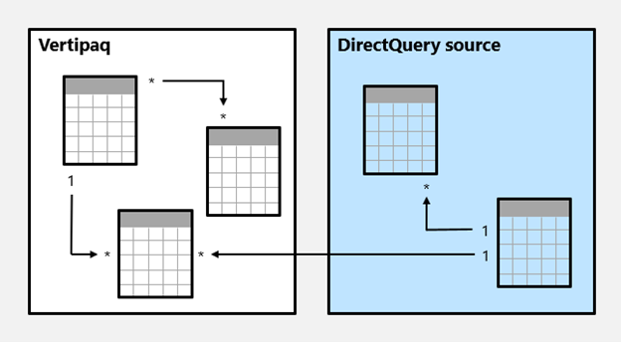

In this example, the composite model consists of two source groups: a VertiPaq source group and a DirectQuery source group. The VertiPaq source group contains three tables, and the DirectQuery source group contains two tables. One cross source group relationship exists to relate a table in the VertiPaq source group to a table in the DirectQuery source group.

**Regular relationships**

A model relationship is regular when the query engine can determine the "one" side of relationship. It has confirmation that the "one" side column contains unique values. All one-to-many intra source group relationships are regular relationships.

In the following example, there are two regular relationships, both marked as **R**. Relationships include the one-to-many relationship contained within the VertiPaq source group, and the one-to-many relationship contained within the DirectQuery source group.

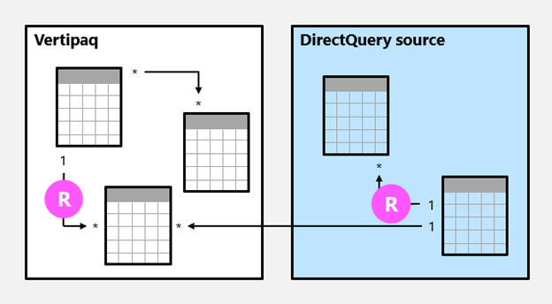

For import models, where all data is stored in the VertiPaq cache, Power BI creates a data structure for each regular relationship at data refresh time. The data structures consist of indexed mappings of all column-to-column values, and their purpose is to accelerate joining tables at query time.

At query time, regular relationships permit table expansion to happen. Table expansion results in the creation of a virtual table by including the native columns of the base table and then expanding into related tables. For import tables, table expansion is done in the query engine; for DirectQuery tables it’s done in the native query that’s sent to the source database (as long as the **Assume referential integrity** property isn't enabled). The query engine then acts upon the expanded table, applying filters and grouping by the values in the expanded table columns.

**Note**

Inactive relationships are expanded also, even when the relationship isn't used by a calculation. Bi-directional relationships have no impact on table expansion.

For one-to-many relationships, table expansion takes place from the "many" to the "one" sides by using LEFT OUTER JOIN semantics. When a matching value from the "many" to the "one" side doesn't exist, a blank virtual row is added to the "one" side table. This behavior applies only to [regular relationships](https://learn.microsoft.com/en-us/power-bi/transform-model/desktop-relationships-understand), not to [limited relationships](https://learn.microsoft.com/en-us/power-bi/transform-model/desktop-relationships-understand).

Table expansion also occurs for one-to-one intra source group relationships, but by using FULL OUTER JOIN semantics. This join type ensures that blank virtual rows are added on either side, when necessary.

Blank virtual rows are effectively unknown members. Unknown members represent referential integrity violations where the "many" side value has no corresponding "one" side value. Ideally these blanks shouldn’t exist. They can be eliminated by cleansing or repairing the source data.

Here’s how table expansion works with an animated example.



In this example, the model consists of three tables: **Category**, **Product**, and **Sales**. The **Category** table relates to the **Product** table with a one-to-many relationship, and the **Product** table relates to the **Sales** table with a one-to-many relationship. The **Category** table contains two rows, the **Product** table contains three rows, and the **Sales** tables contains five rows.

There are matching values on both sides of all relationships meaning that there aren’t any referential integrity violations. A query-time expanded table is revealed. The table consists of the columns from all three tables. It's effectively a denormalized perspective of the data contained in the three tables. A new row is added to the **Sales** table, and it has a production identifier value (9) that has no matching value in the **Product** table. It's a referential integrity violation. In the expanded table, the new row has (Blank) values for the **Category** and **Product** table columns.

**Limited relationships**

A model relationship is limited when there's no guaranteed "one" side. A limited relationship can happen for two reasons:

* The relationship uses a many-to-many cardinality type (even if one or both columns contain unique values).
* The relationship is cross source group (which can only ever be the case for composite models).

In the following example, there are two limited relationships, both marked as **L**. The two relationships include the many-to-many relationship contained within the VertiPaq source group, and the one-to-many cross source group relationship.

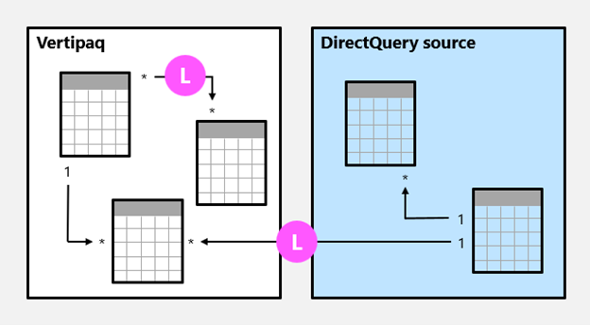

For import models, data structures are never created for limited relationships. In that case, Power BI resolves table joins at query time.

Table expansion never occurs for limited relationships. Table joins are achieved by using INNER JOIN semantics, and for this reason, blank virtual rows aren’t added to compensate for referential integrity violations.

There are additional restrictions related to limited relationships:

* The RELATED DAX function can't be used to retrieve the "one" side column values.
* Enforcing RLS has topology restrictions.

**Note**

In Power BI Desktop model view, it's not always possible to determine whether a model relationship is regular or limited. A many-to-many relationship will always be limited, as will be a one-to-many relationship when it's a cross source group relationship. To determine whether it's a cross source group relationship, you'll need to inspect the table storage modes and data sources to arrive at the correct determination.

**Precedence rules**

Bi-directional relationships can introduce multiple, and therefore ambiguous, filter propagation paths between model tables. The following list presents precedence rules that Power BI uses for ambiguity detection and path resolution:

1. Many-to-one and one-to-one relationships, including limited relationships
2. Many-to-many relationships
3. Bi-directional relationships, in the reverse direction (that is, from the "many" side)

**Performance preference**

The following list orders filter propagation performance, from fastest to slowest performance:

1. One-to-many intra source group relationships
2. Many-to-many model relationships achieved with an intermediary table and that involve at least one bi-directional relationship
3. Many-to-many cardinality relationships
4. Cross source group relationships

**Next unit: Exercise: Work with model relationships**

**Exercise: Work with model relationships**

Completed100 XP

* 45 minutes

This unit includes a lab to complete.

Use the free resources provided in the lab to complete the exercises in this unit. You will not be charged **for the lab environment**; however, you may need to bring your own subscription depending on the lab.

Microsoft provides this lab experience and related content for educational purposes. All presented information is owned by Microsoft and intended solely for learning about the covered products and services in this Microsoft Learn module.

Launch lab

**Important**

A virtual machine (VM) containing the client tools you need is provided, along with the exercise instructions. Use the button above to open the VM. A limited number of concurrent sessions are available - if the hosted environment is unavailable, try again later.

In this exercise, you will work with model relationships specifically to address the need for role-playing dimensions. It will involve working with active and inactive relationships, and also Data Analysis Expressions (DAX) functions that modify relationship behavior.

When you finish the exercise, end the lab to close the VM. Don't forget to come back and complete the knowledge check to earn points for completing this module!

**Note**

To complete this exercise on your own computer, you need a Microsoft *school* or *work* account to do this. If you don't have one, you can [**use the M365 Developer Program**](https://learn.microsoft.com/en-us/office/developer-program/microsoft-365-developer-program).

Launch the exercise and follow the instructions.

[](https://go.microsoft.com/fwlink/?linkid=2260160)

**Next unit: Knowledge check**

[**Previous**](https://learn.microsoft.com/en-us/training/modules/create-power-bi-model-relationships/5-understand-relationship-evaluation/)

**Summary**

Completed100 XP

* 3 minutes

By far, the most common model relationship is the one-to-many relationship. It fits with well with star schema design principals. Dimension tables are the “one” side, and your fact tables are the “many” side.

Once you gain mastery of model relationships and how to set them up, you’re on your way to develop more complex and efficient models. You can develop models with many-to-many relationships, and work with role-playing dimensions by activating inactive relationships.

While you add relationships at model design time, model calculations can navigate relationships, modify relationship behavior, and even create virtual relationships.

“”” <https://learn.microsoft.com/en-us/training/modules/create-power-bi-model-relationships/7-summary#completion> “”

**Administer a Microsoft Fabric environment**

**Administer a Microsoft Fabric environment**

* **34 min**
* **Module**
* **7 Units**

**Feedback**

**Intermediate**

**Administrator**

**Database Administrator**

**Microsoft Fabric**

**Microsoft Fabric is a SaaS solution for end-to-end data analytics. As an administrator, you can configure features and manage access to suit your organization's needs.**

**Learning objectives**

**In this module, you'll learn how to:**

* **Describe Fabric admin tasks**
* **Navigate the admin center**
* **Manage user access**
* **Govern data in Fabric**

[**Start**](https://learn.microsoft.com/en-us/training/modules/administer-fabric/1-introduction/)**Add**

**Prerequisites**

**Understand the Microsoft Fabric platform and its capabilities and administrative tasks. Introductory knowledge of PowerShell is helpful, but not required.**

**This module is part of these learning paths**

* [**Administer and govern Microsoft Fabric**](https://learn.microsoft.com/training/paths/microsoft-fabric-admin-governance/)
* [**Get started with Microsoft Fabric**](https://learn.microsoft.com/training/paths/get-started-fabric/)
* [**Implement and manage an analytics solution**](https://learn.microsoft.com/training/paths/implement-and-manage-an-analytics-solution/)

**Module assessment**

**Assess your understanding of this module. Sign in and answer all questions correctly to earn a pass designation on your profile.**

[**Take the module assessment**](https://learn.microsoft.com/training/modules/administer-fabric/6-knowledge-check/)

* [**Introduction**](https://learn.microsoft.com/en-us/training/modules/administer-fabric/1-introduction)**2 min**
* [**Understand the Fabric Architecture**](https://learn.microsoft.com/en-us/training/modules/administer-fabric/2-fabric-architecture)**6 min**
* [**Understand the Fabric administrator role**](https://learn.microsoft.com/en-us/training/modules/administer-fabric/3-admin-role-tools)**10 min**
* [**Manage Fabric security**](https://learn.microsoft.com/en-us/training/modules/administer-fabric/4-manage-security)**5 min**
* [**Govern data in Fabric**](https://learn.microsoft.com/en-us/training/modules/administer-fabric/5-govern-fabric)**5 min**
* [**Knowledge check**](https://learn.microsoft.com/en-us/training/modules/administer-fabric/6-knowledge-check)**3 min**
* [**Summary**](https://learn.microsoft.com/en-us/training/modules/administer-fabric/7-summary)

**Introduction**

**Completed100 XP**

* **2 minutes**

**Administering a Microsoft Fabric environment involves a range of tasks that are essential for ensuring the efficient and effective use of the Fabric platform within an organization.**

**As a Fabric administrator (admin), you need to know:**

* **Fabric architecture**
* **Security and governance features**
* **Analytics capabilities**
* **Various deployment and licensing options**

**You also need to be familiar with the Fabric admin portal and other administrative tools, and be able to configure and manage the Fabric environment to meet the needs of your organization.**

**Fabric admins work with business users, data analysts, and IT professionals to deploy and use Fabric to meet business objectives and comply with organizational policies and standards.**

**By the end of this module, you'll have an understanding of the Fabric administrator role and the tasks and tools involved in administering Fabric.**

**Next unit: Understand the Fabric Architecture**

[**Next**](https://learn.microsoft.com/en-us/training/modules/administer-fabric/2-fabric-architecture/)

**Understand the Fabric Architecture**

**Completed100 XP**

* **6 minutes**

**Microsoft Fabric is a Software-as-a-Service platform, which provides a simple and integrated approach while reducing administrative overhead. Fabric provides an all-in-one analytics solution for enterprises that covers everything from data movement to data science, real-time analytics, and business intelligence. It offers a comprehensive suite of services, including:**

* **Data warehousing**
* **Data engineering**
* **Data integration**
* **Data science**
* **Real-time intelligence**
* **Business intelligence**

**All data in Fabric is stored in OneLake, which is built on Azure Data Lake Storage (ADLS) gen2 architecture. OneLake is hierarchical in nature to simplify management across your organization. There's only one OneLake per tenant and it provides a single-pane-of-glass file-system namespace that spans across users, regions, and even clouds.**

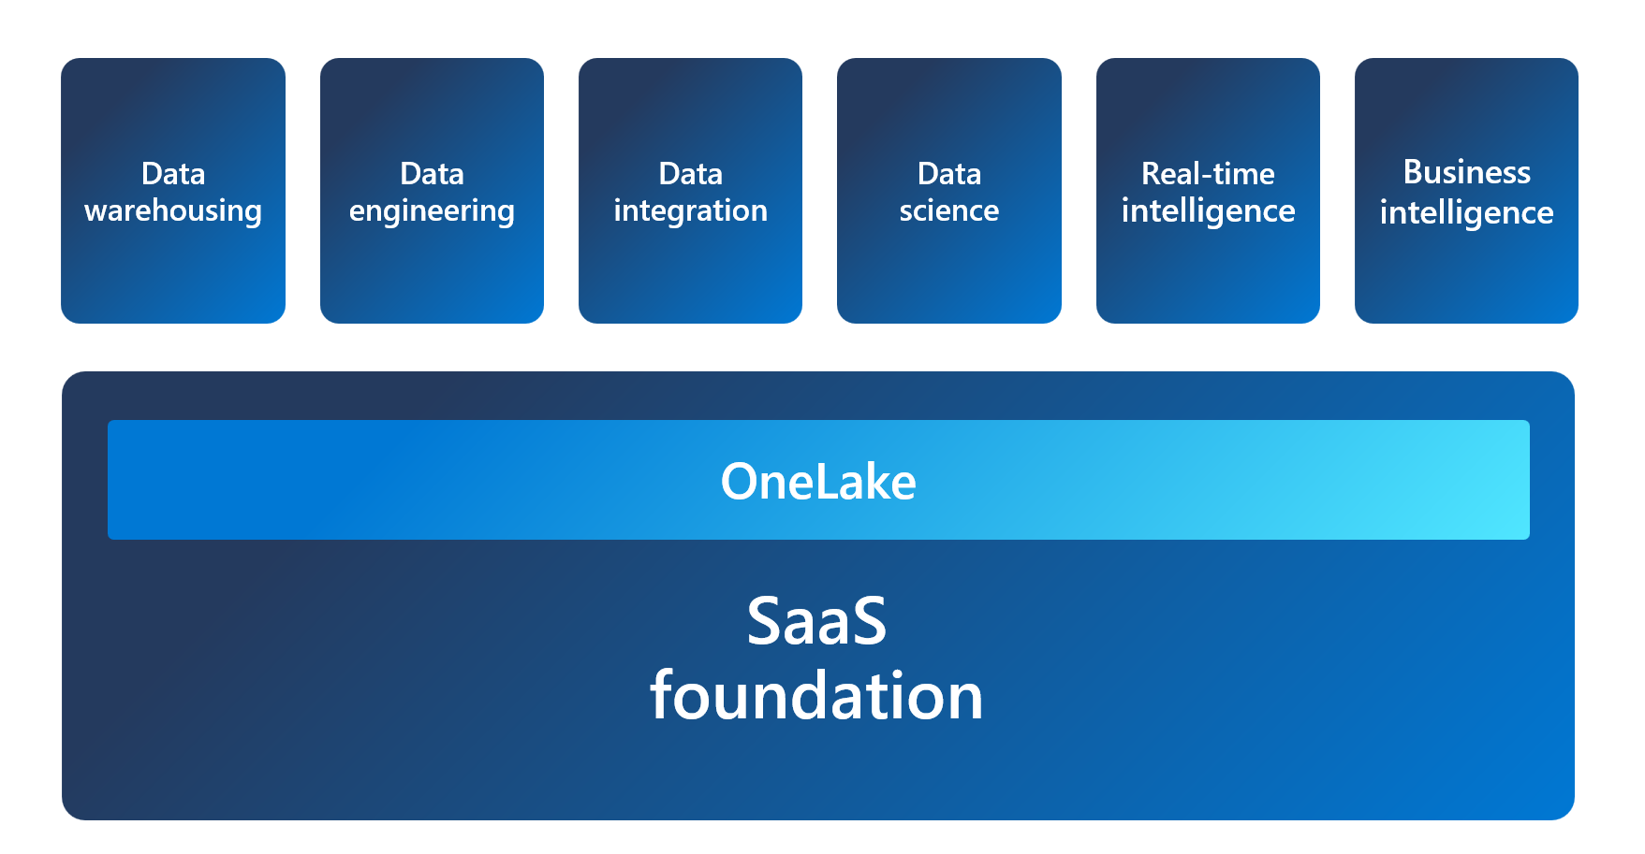

**Understand Fabric concepts**

**Tenant is a dedicated space for organizations to create, store, and manage Fabric items. There's often a single instance of Fabric for an organization, which is aligned with Microsoft Entra ID. The Fabric *tenant* maps to the root of OneLake and is at the top level of the hierarchy.**

**Capacity is a dedicated set of resources that is available at a given time to be used. A tenant can have one or more capacities associated with it. Capacity defines the ability of a resource to perform an activity or to produce output. Different items consume different capacity at a certain time. Fabric offers capacity through the Fabric SKU and Trials.**

**Domain is a logical grouping of workspaces. Domains are used to organize items in a way that makes sense for your organization. You can group things together in a way that makes it easier for the right people to have access to the right workspaces. For example, you might have a domain for sales, another for marketing, and another for finance.**

**Workspace is a collection of items that brings together different functionality in a single tenant. It acts as a container that uses capacity for the work that is executed, and provides controls for who can access the items in it. For example, in a sales workspace, users associated with the sales organization can create a data warehouse, run notebooks, create datasets, create reports, and more.**

**Items are the building blocks of the Fabric platform. They're the objects that you create and manage in Fabric. There are different types of items, such as data warehouses, data pipelines, datasets, reports, and dashboards.**

**Understanding Fabric concepts is important for you as an admin, because it helps you understand how to manage the Fabric environment.**

**Note**

**For more information, see the**[**Start a Fabric trial**](https://learn.microsoft.com/en-us/fabric/get-started/fabric-trial)**documentation.**

**Next unit: Understand the Fabric administrator role**

[**Previous**](https://learn.microsoft.com/en-us/training/modules/administer-fabric/1-introduction/)

**Understand the Fabric administrator role**

**Completed100 XP**

* **10 minutes**

**Now that you understand the Fabric architecture and what you and your colleagues might be doing with the product, let's look at the admin role and the tools you use to manage the platform.**

**There are several roles that work together to administer Microsoft Fabric for your organization. If you're a Microsoft 365 admin, a Power Platform admin, or a Fabric capacity admin, you're involved in administering Fabric. The Fabric admin role was formerly known as Power BI admin.**

**As a Fabric admin, you work primarily in the Fabric admin portal. You might also need to familiarize yourself with the following tools:**

* [**Microsoft 365 admin center**](https://learn.microsoft.com/en-us/microsoft-365/admin/admin-overview/admin-center-overview)
* [**Microsoft 365 Security & Microsoft Purview compliance portal**](https://learn.microsoft.com/en-us/microsoft-365/compliance/microsoft-365-compliance-center)
* [**Microsoft Entra ID in the Azure portal**](https://learn.microsoft.com/en-us/azure/active-directory/fundamentals/active-directory-whatis)
* [**PowerShell cmdlets**](https://learn.microsoft.com/en-us/powershell/power-bi/overview)
* [**Administrative APIs and SDK**](https://learn.microsoft.com/en-us/rest/api/power-bi/admin)

**Note**

**For specific details on the different admin roles and responsibilities, see the**[**What is Microsoft Fabric administration?**](https://learn.microsoft.com/en-us/fabric/admin/microsoft-fabric-admin)**documentation.**

**Describe admin tasks**

**As an admin, you might be responsible for a wide range of tasks to keep the Fabric platform running smoothly. These tasks include:**

**Security and access control: One of the most important aspects of Fabric administration is managing security and access control to ensure that only authorized users can access sensitive data. You can use role-based access control (RBAC) to:**

* **Define who can view and edit content.**
* **Set up data gateways to securely connect to on-premises data sources.**
* **Manage user access with Microsoft Entra ID.**

**Data governance: Effective Fabric administration requires a solid understanding of data governance principles. You should know how to secure inbound and outbound connectivity in your tenant and how to monitor usage and performance metrics. You should also know how to apply data governance policies to ensure data within your tenant is only accessible to authorized users.**

**Customization and configuration: Fabric administration also involves customizing and configuring the platform to meet the needs of your organization. Possibilities include configuring private links to secure your tenant, define data classification policies, and adjust the look and feel of reports and dashboards.**

**Monitoring and optimization: As a Fabric admin, you need to know how to monitor the performance and usage of the platform, optimize resources, and troubleshoot issues. Examples include configuring monitoring and alerting settings, optimizing query performance, managing capacity and scaling, and troubleshooting data refresh and connectivity issues.**

**Specific tasks vary depending on the needs of your organization and the complexity of your Fabric implementation.**

**Describe admin tools**

**You need to familiarize yourself with a few tools to effectively implement the tasks previously outlined. Fabric admins can perform most admin tasks using one or more of the following tools: the Fabric admin portal, PowerShell cmdlets, admin APIs and SDKs, and the admin monitoring workspace.**

**Fabric admin portal**

**Fabric's *admin portal* is a web-based portal where you can manage all aspects of the platform. You can centrally manage, review, and apply settings for the entire tenant or by capacity in the admin portal. You can also manage users, admins and groups, access audit logs, and monitor usage and performance.**

**Important**

**The Power BI admin portal is now the Fabric admin portal. See**[**What is the Microsoft Fabric admin portal?**](https://learn.microsoft.com/en-us/fabric/admin/admin-center)**for more information. The admin portal enables you to turn settings on and off. There are many settings located in the admin portal, but there's one setting that we'd like to call out which may change how you and your users experience Fabric.**

**The Fabric on/off switch, located in tenant settings lets organizations that use Power BI opt into Fabric. Here, you can enable Fabric for your tenant or allow capacity admins to enable Fabric.**

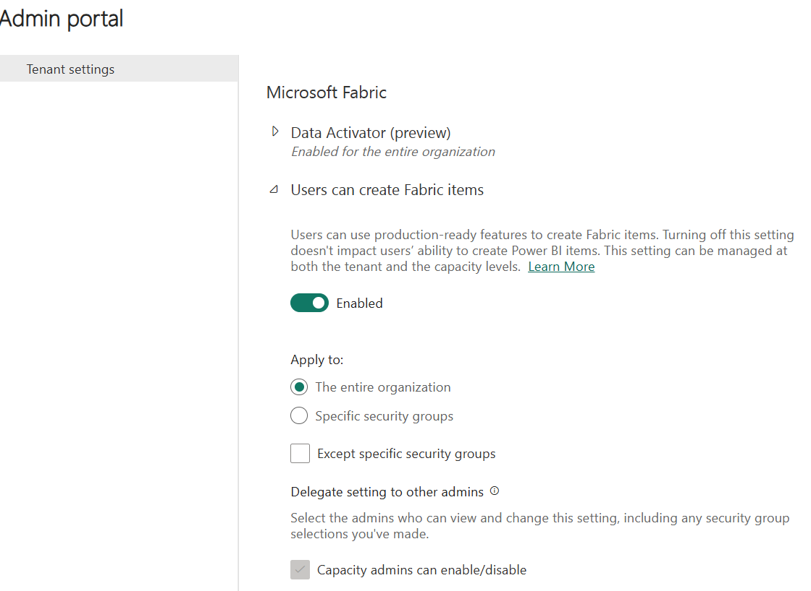

**PowerShell cmdlets**

**Fabric provides a set of**[***PowerShell cmdlets***](https://learn.microsoft.com/en-us/powershell/scripting/powershell-commands)**that you can use to automate common administrative tasks. A PowerShell cmdlet is a simple command that can be executed in PowerShell.**

**For example, you can use cmdlets in Fabric to systematically create and manage groups, configure data sources and gateways, and monitor usage and performance. You can also use the cmdlets to manage the Fabric admin APIs and SDKs.**

**Note**

**See**[**Microsoft Power BI Cmdlets for Windows PowerShell and PowerShell Core**](https://learn.microsoft.com/en-us/powershell/power-bi/overview)**for more resources on PowerShell cmdlets that work with Fabric.**

**Admin APIs and SDKs**

**An admin *API and SDK* are tools that allow developers to interact with a software system programmatically. An API (Application Programming Interface) is a set of protocols and tools that enable communication between different software applications. An SDK (Software Development Kit) is a set of tools and libraries that helps developers create software applications that can interact with a specific system or platform. You can use APIs and SDKs to automate common administrative tasks and integrate Fabric with other systems.**

**For example, you can use the APIs and SDKs to create and manage groups, configure data sources and gateways, and monitor usage and performance. You can also use the APIs and SDKs to manage the Fabric admin APIs and SDKs.**

**You can make these requests using any HTTP client library that supports OAuth 2.0 authentication, such as Postman, or you can use PowerShell scripts to automate the process. For more information, see**[**Microsoft Power BI REST APIs**](https://learn.microsoft.com/en-us/rest/api/power-bi/)**.**

**Admin monitoring workspace**

**Fabric tenant admins have access to the new *admin monitoring workspace*. You can choose to share access to the workspace or specific items within it with other users in your organization. The admin monitoring workspace includes the Feature Usage and Adoption dataset and report, which together provide insights on the usage and performance of your Fabric environment. You can use this information to identify trends and patterns, and troubleshoot issues.**

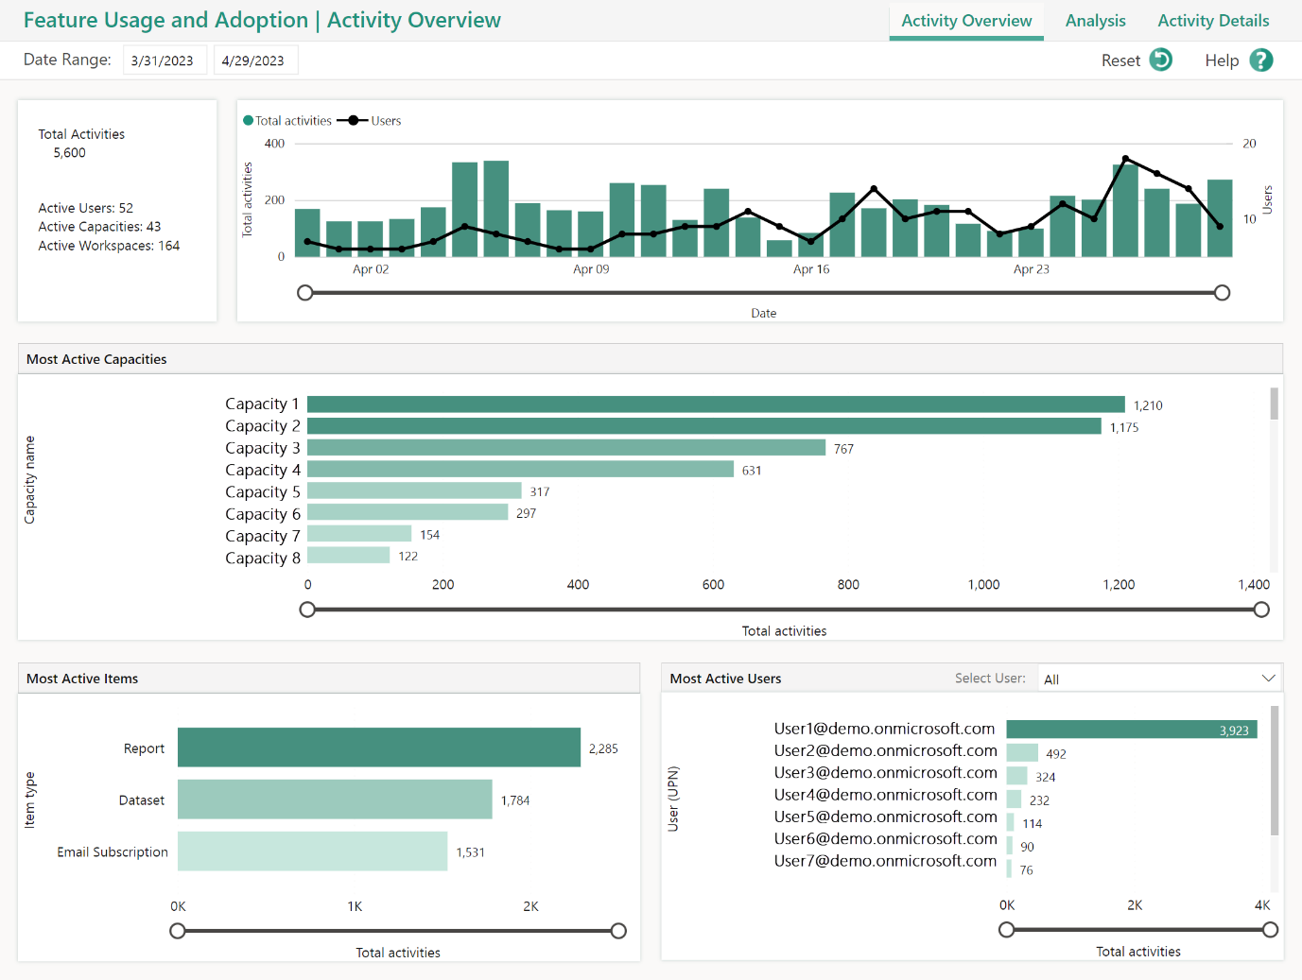

**Note**

**For more information about what is included in the Admin Monitoring Workspace, see**[**What is the Fabric admin monitoring workspace**](https://learn.microsoft.com/en-us/fabric/admin/monitoring-workspace)**.**

**Next unit: Manage Fabric security**

**Manage Fabric security**

**Completed100 XP**

* **5 minutes**

**If you already use Power BI in your organization, then Fabric security should feel familiar. Your role as an admin is to manage security for the Fabric environment, including managing users and groups, and how users interact with Fabric in terms of sharing and distribution of content.**

**Manage users: assign and manage licenses**

**User licenses control the level of user access and functionality within the Fabric environment. Administrators ensure licensed users have the access they need to data and analytics to do their jobs effectively. They also limit access to sensitive data and ensure compliance with data protection laws and regulations.**

**Managing licenses allows administrators to monitor and control costs by ensuring that licenses are allocated efficiently and only to users who need them. This can help to prevent unnecessary expenses and ensure that the organization is utilizing its resources effectively.**

**Having the appropriate procedures in place to assign and manage licenses helps to control access to data and analytics, ensure compliance with regulations, and optimize costs.**

**License management for Fabric is handled in the Microsoft 365 admin center. For more information about managing licenses, see**[**Assign licenses to users**](https://learn.microsoft.com/en-us/microsoft-365/admin/manage/assign-licenses-to-users?view=o365-worldwide&preserve-view=true)**.**

**Note**

**The *license type* in workspace settings is related to the user licenses listed here. Consumers can see reports depending on the user license and the workspace license. For detailed information, see the**[**Microsoft Fabric licenses**](https://learn.microsoft.com/en-us/fabric/enterprise/licenses#workspace)**documentation.**

**Manage items and sharing**

**As an admin, you can manage how users interact with Fabric in terms of sharing and distribution of content. You can manage how users share content with others, and how they distribute content to others. You can also manage how users interact with items, such as data warehouses, data pipelines, datasets, reports, and dashboards.**

**Items in workspaces are best distributed through a workspace app or the workspace directly. Granting the least permissive rights is the first step in securing the data. Share the read only app for access to the reports or grant access to the workspaces for collaboration and development. Another aspect of managing and distributing items is enforcing such best practices.**

**You can manage sharing and distribution both internally and outside of your organization, in compliance with your organization's policies and procedures.**

**Note**

**For more information, see the**[**Security in Microsoft Fabric**](https://learn.microsoft.com/en-us/fabric/security/security-overview)**documentation.**

**Next unit: Govern data in Fabric**

**Govern data in Fabric**

**Completed100 XP**

* **5 minutes**

**Fabric includes built-in governance features to help you manage and control your data. *Endorsement* is a way for you as an admin to designate specific Fabric items as trusted and approved for use across the organization.**

**Admins can also make use of the *scanner API* to scan Fabric items for sensitive data, and the *data lineage* feature to track the flow of data through Fabric.**

**Endorse Fabric content**

**Endorsement is a key governance feature that builds trust in your data assets by marking Fabric items as reviewed and approved. Endorsed items display a badge, signaling to users that these assets are reliable. Endorsement helps users trust the data, and it also helps you as an admin manage the overall growth of items across your environment.**

**Promoted Fabric content appears with a Promoted badge in the Fabric portal. Workspace members with the contributor or admin role can promote content within a workspace. The Fabric admin can promote content across the organization.**

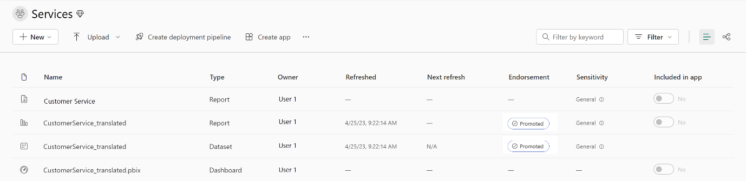

**Certified content requires a more formal process that involves a review of the content by a designated reviewer. Content appears with a Certified badge in the Fabric portal. Admins manage the certification process and can customize it to meet the needs of your organization.**

**If you aren't an admin, you need to request item certification from an admin. You can do request certification by selecting the item in the Fabric portal, and then selecting Request certification from the More menu.**

**Note**

**For more detailed information on the content endorsement process, see**[**Promote or certify content**](https://learn.microsoft.com/en-us/fabric/get-started/endorsement-promote-certify)**.**

**Scan for sensitive data**

***Metadata scanning* facilitates governance of data by enabling cataloging and reporting on all the metadata of your organization's Fabric items. The *scanner API* is a set of Admin REST APIs that allows you to scan Fabric items for sensitive data. Use the scanner API to scan data warehouses, data pipelines, datasets, reports, and dashboards for sensitive data. The scanner API can be used to scan both structured and unstructured data.**

**Important**

**Before metadata scanning can be run, it needs to be set up in your organization by an Admin. For more information, see the**[**Metadata scanning overview**](https://learn.microsoft.com/en-us/fabric/governance/metadata-scanning-overview)**.**

**Track data lineage**

***Data lineage* is the ability to track the flow of data through Fabric, also known as *impact analysis*. Data lineage allows you to see where data comes from, how it's transformed, and where it goes. The lineage view in workspaces helps you understand the data that is available in Fabric, and how it's being used.**

**Tip**

**Fabric can be included in your Microsoft Purview environment for a complete data governance solution for your entire data estate.**

**Next unit: Knowledge check**

**“”””** [**https://learn.microsoft.com/en-us/training/modules/administer-fabric/7-summary#completion**](https://learn.microsoft.com/en-us/training/modules/administer-fabric/7-summary#completion) **“”**

**Get certified in Microsoft Fabric—for free**

**For a limited time, the Microsoft Fabric Community team is offering free DP-600 exam vouchers to the first 5,000 eligible applicants who apply by no later than December 10, 2024. To be eligible, you must meet all requirements, including completion of all modules in the Microsoft Learn Challenge | Ignite Edition: The next generation of analytics with Microsoft Fabric. Exams must be completed by the end of the year when vouchers expire. Learn more at https://aka.ms/IamReady/DP600.**

**“””** [**https://learn.microsoft.com/en-us/collections/8wy3ioj77zzgyd**](https://learn.microsoft.com/en-us/collections/8wy3ioj77zzgyd) **“”**